**Table of Content**

Introduction……………………………………………………………………………………………………………………... 2

System Analysis and requirements

**Client Module**

Login/Register………………………………………………………………………………………………………. 3

Checking Flight availability and schedule………………………………………………………………. 4

Purchasing of tickets…………………………………………………………………………………………….. 5

Check In………………………………………………………………………………………………………………… 6

**Manager Module**

Managing flight schedules…………………………………………………………………………………….. 7

Managing flight teams………………………………………………………………………………………….. 8

Monitoring of boarding……………………………………………………………………………………….… 9

System and Database Design

Overall System Design…………………………………………………………………………………….. 10 - 11

Overall Database Design…………………………………………………………………………………. 12 - 13

User Interfaces

Client Module…………………………………………………………………………………………………. 14 - 25

Manager Module……………………………………………………………………………………………. 26 - 37

Conclusion………………………………………………………………………………………………………………………. 38

References………………………………………………………………………………………………………………………. 39

Appendices…………………………………………………………………………………………………………………40 - 106

**THE DEVELOPMENT OF AIRLINE MANAGEMENT SYSTEM FOR AIRASIA**

**INTRODUCTION**

In this assignment, we are given a task by our lecturer – Mr.Tang, to develop an airline management system for Air Asia, both for the clients and the managers. Air Asia is an airline company that was established in 1993 and officially started on 18 Nov 1996. Air Asia is one of the award winning and largest budget airlines In Asia. It is recognized by it’s lowest fare, quality services and their tagline called: “Now Everyone Can Fly”. Globally, Air Asia serves 51 national and international destinations with 108 routes and operates 400 flights daily in Malaysia.

Therefore, in this system, we will be providing customers with four business processes and the management staff with three business processes. For customers, there are login/register, checking flight availability/schedules, purchasing of tickets, check in. For the management staffs, there are managing flight schedules, managing flight teams and monitoring of boarding. In our system, the programming languages that we are going to use are PHP, HTML and CSS.

Regarding to this report, we will be splitting it into three main sections: system analysis and requirements that will explain all the business processes, system and database design that will explain our overall design for our system and user interfaces that will show how customers or staff use our system.

**SYSTEM ANALYSIS AND REQUIREMENTS**

**CLIENT MODULE**

**Registration**

The registration system is a business process to let the customer register to a new

customer account. Firstly, users need to go to the sign-up page. On the sign-up page, the user is must fill up all the information detail. The detail are Name, Passport ID, Nationally, Contact number, Email, Address, Relationship Status, Age, IC number, and password.

After customer submitted their information, the customer information will upload

to the “customer” database and check the passport id whether the user is existed or not. If

the passport id is existed, the database will reject the customer registration and display an

error message to the user.

If the passport id doesn’t not exist, the registration system will display a sign-up successful

page to the customer, and the customer information will upload to the database. The sign

up successful page has a button to bring customers back to the login page.

Figure below shows the IPO Chart for Registration system

|  |  |  |
| --- | --- | --- |
| Input | Processing | Output |
| Customer name  Passport ID  Nationally  Contact  Email  Address  Relationship status  Age  IC number  Password | The database will check the Passport ID is existed or not, if not it will store in the database. | Sign-up successful page |

**Figure 1**. IPO Chart for Registration system

**Checking flight availability and schedule**

Viewing flight availability and schedule is a process that the customer can check with all of

the availability of flight schedule before their proceed with the payment in our website.

Firstly, in the Customer Purchase Homepage the program will display all of the data with

table format and these data are retrieved from the database which is Depart Airport, Arrive Airport, Depart Datetime, Estimate Duration and Availability so that the Customer can check with the real-time Schedule in case the boarding of management did some changes on flight schedule.

Also, we have provided a function that if boarding of management have set one of the

Schedule Availability to NOT AVAILABLE then the “Purchase Now!” link button will

disappear immediately and Customer will not able to purchase that ticket.

Figure below shows the PO chart for viewing flight availability and schedule

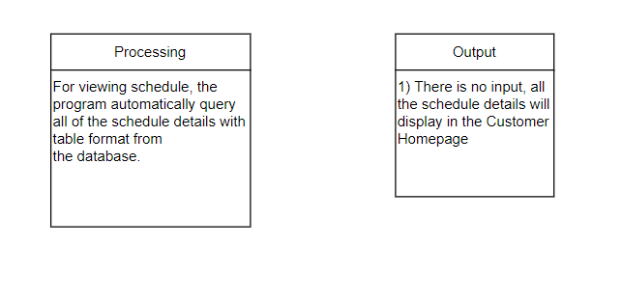

**Figure 2.** PO chart for viewing flight availability and schedule

**Purchasing of Flight Ticket**

Purchasing of Flight Tickets is a consumer buying process that allow consumer to

purchase flight tickets in our website.

Firstly, in the Customer Purchased Ticket Page the program will display the purchased

ticket data with table format and all of these data are queried from the database. We provided

a function for customer to Check-in, after the customer purchased ticket the status will shows

not-check-In. If the customer clicked Check-in link button then the column of status will shows

“checked-in”.

Secondly, in the Purchase Page the program will display both of data are queried from

the database which is depart airport and arrive airport that the customer selected from

previous page. Besides, we provided two radio buttons for customer to select any class and

the Payment Option that the customer wanted then the data will use the Post method to send

it to the next page. Apart from that, we also provided three text boxes for customer to type

the Seat, IC Number and their own Name and the data will use the same method to send to

the next page.

Thirdly, in the Confirmation Page the program retrieved all of the data from post

method, session and database and display it. Moreover, if the user selects the economy class,

then the program will query the ticket price from the database and display it. But if the user

has selected business class on the purchase page then the program will query the ticket price

from the database and add another RM500 on it.

Lastly, in the Last Page the program will display Purchase is Completed and the

program will automatically insert all of the data from previous page into the database. Besides,

we provided feature that the ticket id, passport id, date, ticket price data will be store into the

XML files for Manager to check with the ticket details easily.

Figure below shows the IPO CHART for purchasing of tickets

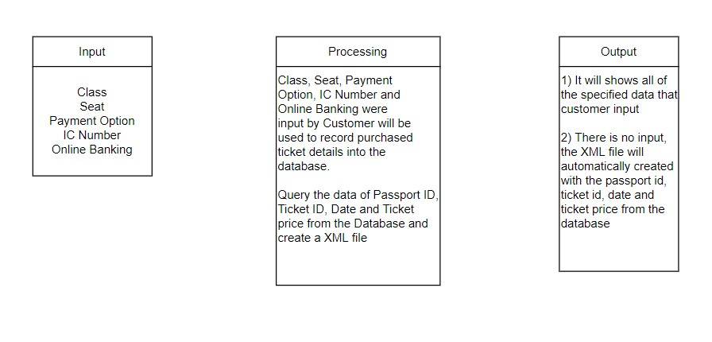

**Figure 3.** IPO Chart for purchasing of ticket

**Check in**

The check in process is to allow customer to confirm their flight details before their plane take off. In this process, the customer can see all the tickets they have bought in a table. In that table, customers can roughly check the details, like the IC number, full name, seat number, class and etc.

In this business process, we also provide customer a link to view the flight schedule of the purchased tickets. This allows customers to be more aware and clear about their flight details before their flight.

The last part of this business process is the check in. When the ticket is not checked in yet, customer can press check in and it will lead them to a page where it will show all their ticket details (we will get specific data that is necessary from the flight tickets and flight schedule table in the database). If customer confirms their flight and it’s details, they can choose to press check in now. After that, their ticket status will be changed to checked-in.

On the contrary, if the status of the ticket is checked in, there will be no check in button for customers to press.

The figure below shows the IPO chart for check in

|  |  |  |
| --- | --- | --- |
| Input | Processing | Output |
| none | View schedule: The program  will query specific data that  is necessary from the flight  schedule table  Check in: The program will  query specific data that is  necessary for the customers  from the flight ticket and the  flight schedule table using  selected unique ID | Check in successful page.  The flight schedule and flight  ticket details will be shown. |

**Figure 4**. IPO Chart for Registration system

**Manager Module**

**Managing flight schedules**

Flight Schedule is a business process that allows staff to check the status of the flight schedules, either for a particular schedule and teams or all the schedule and teams.

Firstly, we provided the add new schedule function to add the new schedule ID with the information of the flight schedule. The staff can add the new flight schedule record while the flight schedule record is not enough and the oldest want was expired. It benefits to the customer so that they can have a selection to see the schedule.

Secondly, we provided an update schedule function to update the new schedule ID. The staff can update the schedule while the depart date & time is expired. They can update the information of the flight schedule in the form and then it will display and store in the database after they click submit. It provides benefit to the customer because they can see the latest flight schedule records.

Furthermore, all the processes need to have the correct manager ID & Password to store and display the newest processes in the database. If they enter the incorrect manager ID & Password the processes will not stored and display in the new flight schedule records.

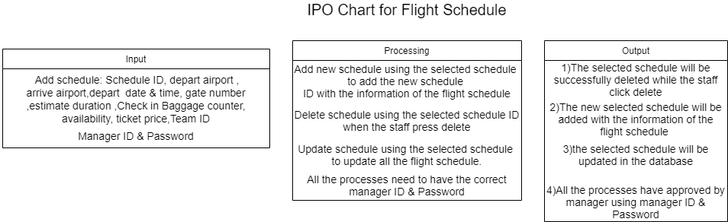Figure 5 below shows the IPO chart of this business process

**Figure 5.** IPO chart for flight schedule

**Managing flight teams**

Flight Teams is a business process that allows staff to check the status of the flight teams, either for a particular team or all the teams.

Moreover, we provided an edit team function to edit the team ID to make changes to that particular flight team. It provides some advantage to the staff like if the crew is sick or have some issues they can change the team.

Besides that, we also provided the add team function to add the new team ID with the information of the flight team so that they can display the new flight schedule to the customer to see. Without the flight team, the flight schedule cannot display because a flight needs to have a pilot, co-pilot and flight attendants.

Furthermore, all the processes need to have the correct manager ID & Password to store and display the newest processes in the database. If they enter the incorrect manager ID & Password the processes will not store and display in the database.

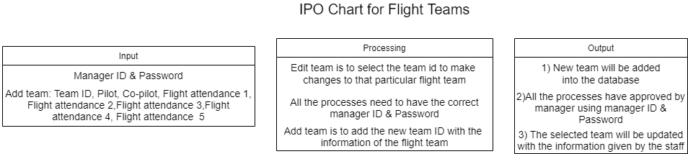Figure 6 below shows the IPO chart of this business process

**Figure 6.** IPO chart for flight teams

**Monitoring of Boarding**

Monitoring of Boarding is a business process that allows staff to check the status of the boarding, either for a particular flight or all the flights.

Firstly, in the boarding management home page, the program will automatically query ALL the data from the ‘flight tickets’ table and display them in a table. This will allow real time updates of the record in the database. In the table, the staff are able to view different schedules to know the details of the particular flight.

Secondly, we provided the ‘Search’ function to search for a particular flight schedule using the schedule’s unique schedule ID. This search function benefits staff in a way that will ease the boarding management process. Let’s say the staff only wants to see all the tickets that are bought for a particular schedule only, then they can use the search function to get the data they needed.

Thirdly, we also provided the ‘Search’ function to search for a particular customer using their unique passport ID. In a scenario when the depart time of a plane is after 30 minutes and one or more customers haven’t check in yet, the staff can quickly search for their details using their passport ID to contact them using the details that they have provided.

Figure 7 below shows the IPO chart of this business process.

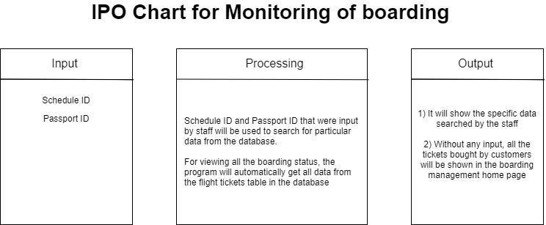

**Figure 7.** IPO chart for monitoring of boarding

**SYSTEM AND DATABASE DESIGN**

**OVERALL SYSTEM DESIGN**

When a user decides to use this program, the first thing they need to do is sign in. In this program, there are two types of account, one customer account and another staff account.

Firstly, we will talk about the customer account. In the sign in page, if customers don’t have an account, they can choose to register for an account by providing their personal details. After having an account, they can go back to the sign in page and sign in into their account. After giving the correct ID and password, the customers will be led to a client homepage.

The client homepage will first start with viewing all the available schedules. If the ticket is available, customers can purchase the ticket by clicking a button, then it will lead them to a page where it asks for their desired class, seat and payment option. After filling up the first page, they will be led into the next page where the program will show all the ticket details, including the ticket ID that is automatically generated by the program. In this page, the customers then can press the confirm button to confirm their purchase, then it will lead them to the last page that tells the customer they have purchased successfully. In this last page, a few data regarding to the payment will be saved in a XML file, together with all the ticket data that will be saved into the database table called ‘flight tickets’. If the customers want to purchase another ticket, they can buy again through the home page. On the contrary, if the schedule is not available, there will not be a button for customers to press and purchase.

In the client page, it will also have another main page called purchased tickets.

Secondly, the staff account. Staff account are already pre-created in the database, staff can’t register their own account to prevent abusive creation of staff accounts by anonymous people. After giving the correct staff ID and password, the staff will be led to a staff homepage.

The staff homepage will first start with flight schedule records. In this page, all the flight schedules will be shown in a table. In this page, two business processes are combined together: managing flight schedules and managing flight teams.

For managing flight schedules, staff can add, update or delete schedule records by filling up forms. By adding, updating or deleting, staff must input the correct manager ID and password to do so. For managing flight tickets, staff can only update or add records. If the staff wants to know the team’s details, he/she can press into the update form to check their details. For adding and updating flight team, staffs will also need to input the correct manager ID and password to authorize these actions.

In the staff page, it will also have another main page called boarding management. Through this page, staffs can monitor the boarding (check in) of all the customers. In this page, all the tickets that are bought by the customers will be shown in a table. If a staff wants to know more about the schedule, he/she can view the particular schedule. If a staff wants to see the boarding status of a specific flight schedule, he/she can use the search function to search for it using a unique schedule ID. If a staff wants to contact the customers that have not checked in yet, he/she also can use the search function to search for specific customer’s details by giving the customer’s passport ID. In this boarding management, staff can only view data, but not adding, updating nor deleting any data because the customers have already paid for their tickets.

For both client and staff pages, users can choose to log out of their current account, then it will lead them to the sign in page, so that they can use another account if they want to.

Figure 8 below shows the overall system design.

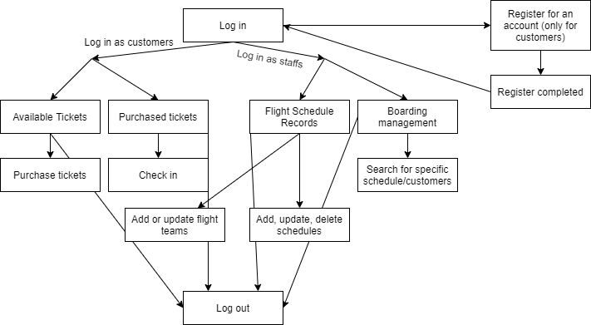

**Figure 8.** Structured Diagram for System Design

**Overall database design**

Our database name is called sample2 (1), it contains 6 tables: customers, flight_schedule, flight_team, flight_tickets, manager and staff.

Customers table, it’s primary key is Passport ID. This table is used when customers decide to create a new account. All the data given by the customers in the registration form will be saved into this table. Another use of this table is to verify the user account during sign in. Other than that, it is also used when staff decides to search for customer details using their unique Passport ID in the boarding management business process.

Flight schedule table, it’s primary key is Schedule ID. This table is used to store data of all the schedules available. In the flight schedule management page, a staff can view, add, update and delete all records from this table. This table is also used when customers view the available schedule before they decide to purchase the ticket. This table has Team ID as a foreign key so that the staff can edit the flight team table in the flight schedule management page.

Flight team table, it’s primary key is Team ID. This table is solely used by staff only, customers cannot access this table. In the flight schedule management page, staff can update or add team records from this table.

Flight tickets table, it’s primary key is Ticket ID. This table will store the data of the ticket together with the selected Schedule ID (foreign key) after customers successfully purchase a certain schedule. In the boarding management, staff then can view all the flight tickets. Staff also can search for a specific schedule using the Schedule ID that are saved in this table.

Manager and staff table, there are no primary keys for these two tables. This is because manager’s data will only be used when verifying authorization to make any changes to the table while staff’s data is only used to log in to a staff account and display their name.

Figure 9 below shows the ERD diagram for the database design and all the tables in it

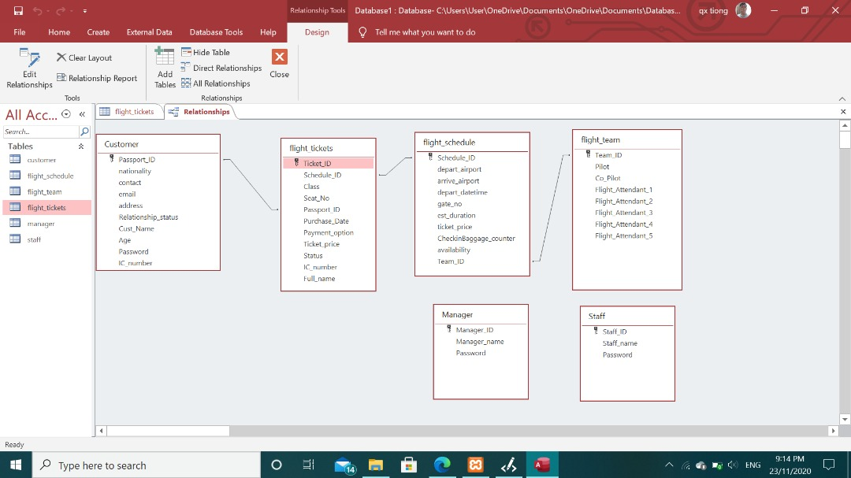

**Figure 9.** ERD diagram for database design

**User Interfaces**

**Client Module**

In the login page, users need to choose their category which is staff or customer. If the user selected a customer, the user needs to fill up the passport id and password. If the user selected staff, the user must fill up the username and password.

After filling the account of request, the user presses the sign-in button that will lead to the customer homepage or staff homepage.

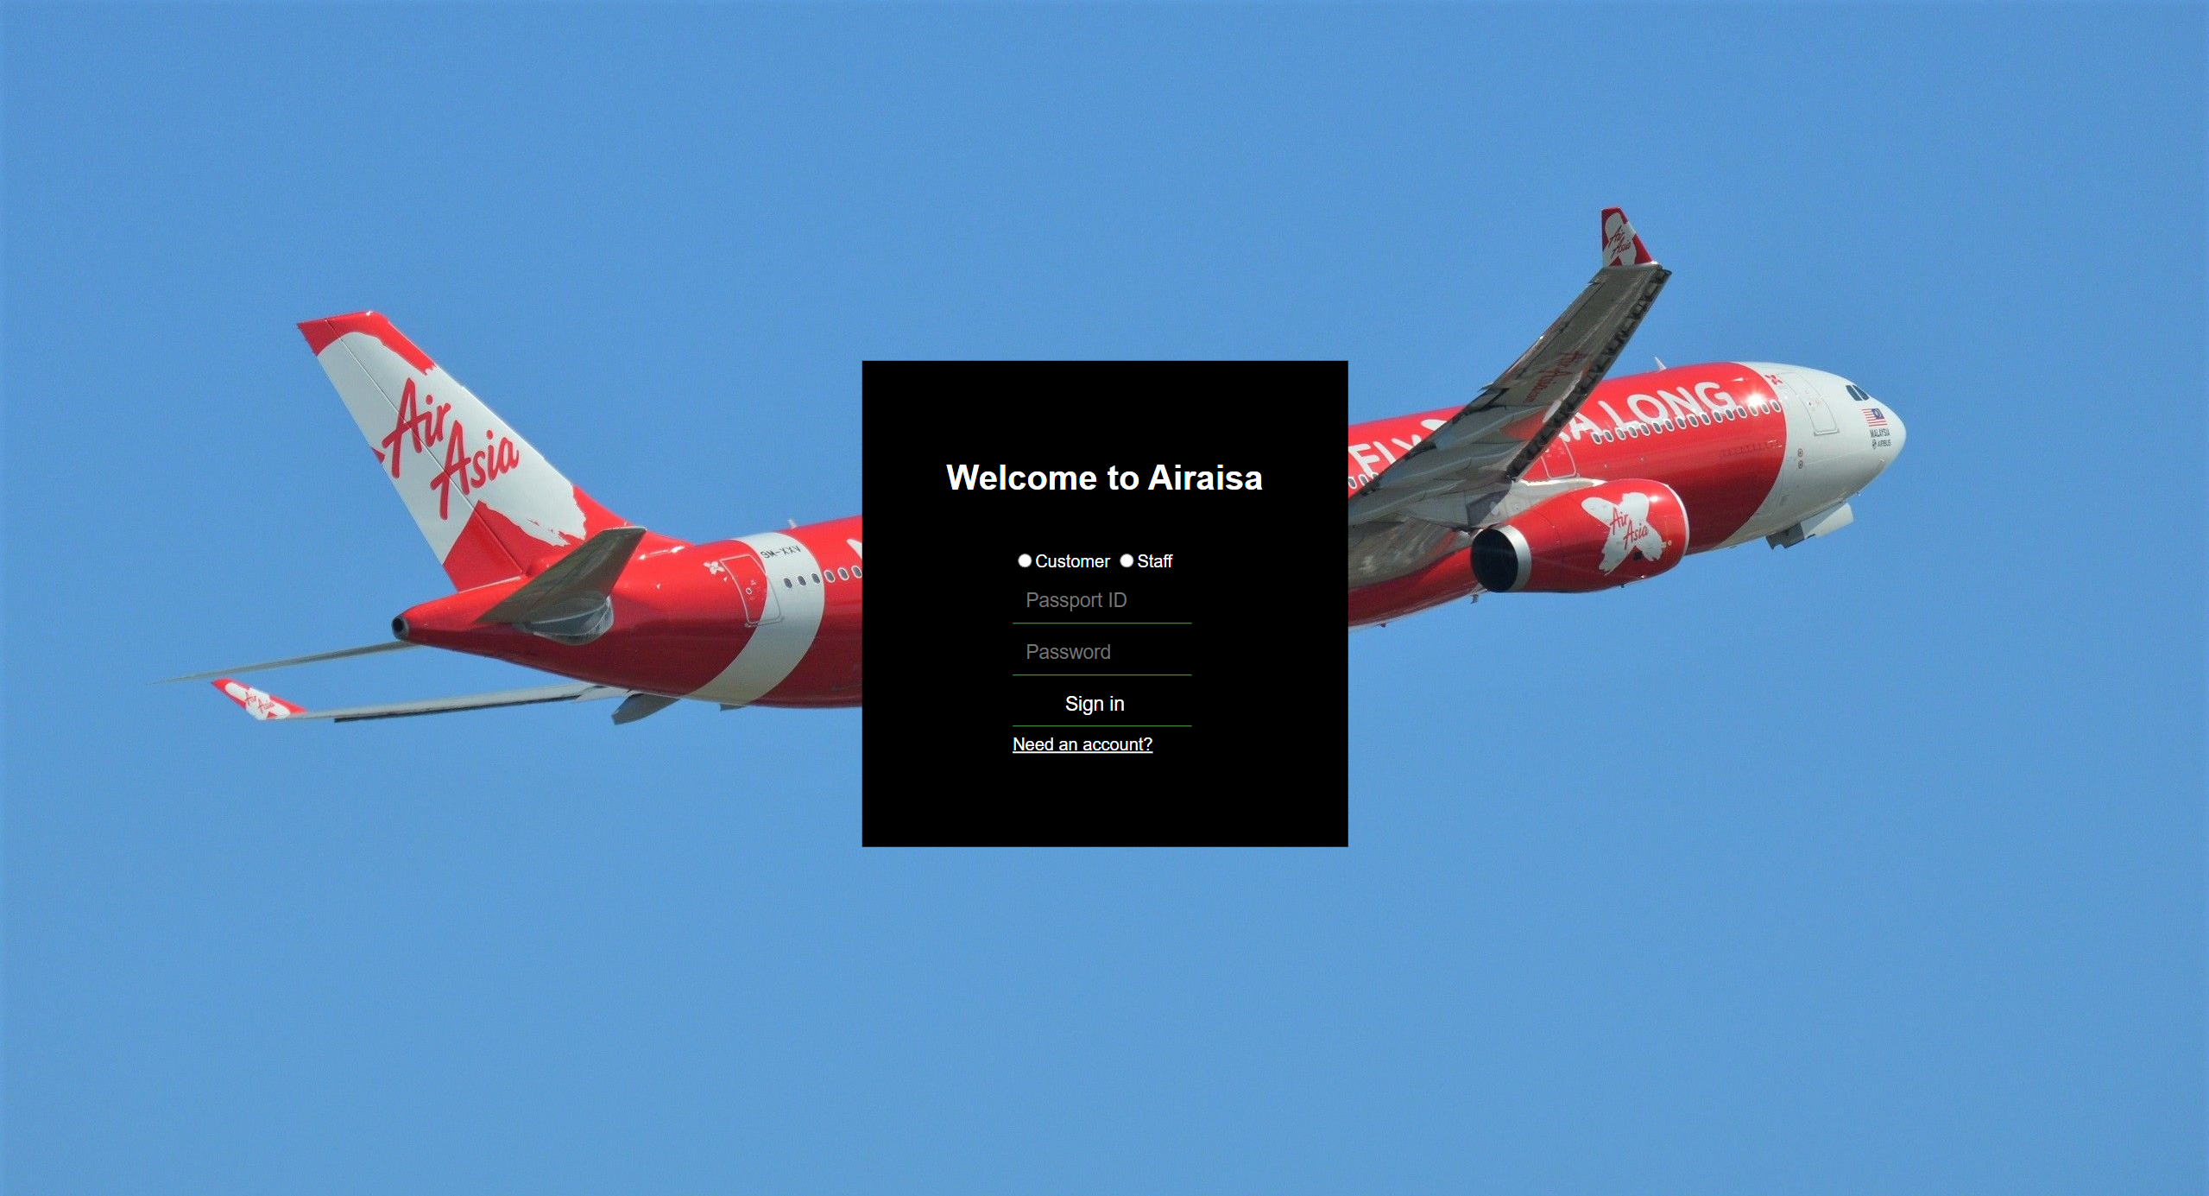

**Figure 10.1** User interface of Login page

In this login page, if the users are fill-up wrong request, the login page will display an error

message to users. If the customer does not have an account, the customer can press the button called “Need an account ??”. The button will lead the customer to sign up page.

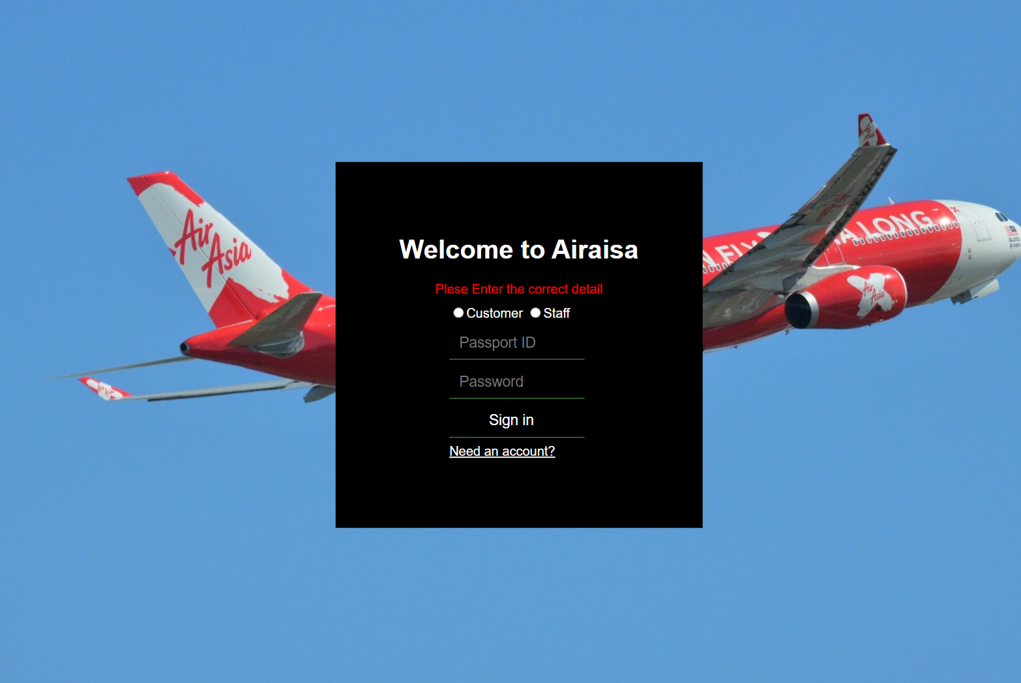

**Figure 10.2** Login page of display error message

In this registration page is only the user who is a customer can register. The customer user

must fill up all the requests. The requests are Name, Passport ID, Nationally, Contact number,

Email, Address, Relationship Status, Age, IC number, and password. After fill-up all the

requests, the customer user can press sign-up to create an account. After that, the sign-up

page will lead customers to a sign-up successful page.

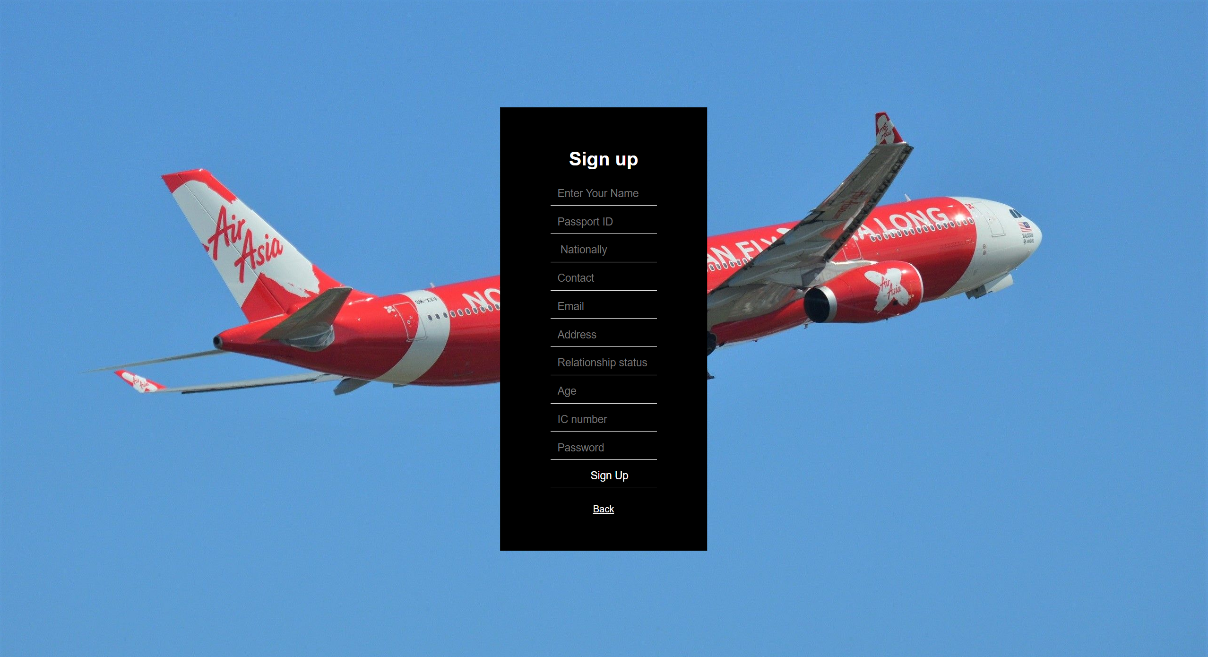

**Figure 10.3** Sign-up Page

In the registration page, the customer user has filled in an existed passport ID. The registration

page will display an error message to the customer user.

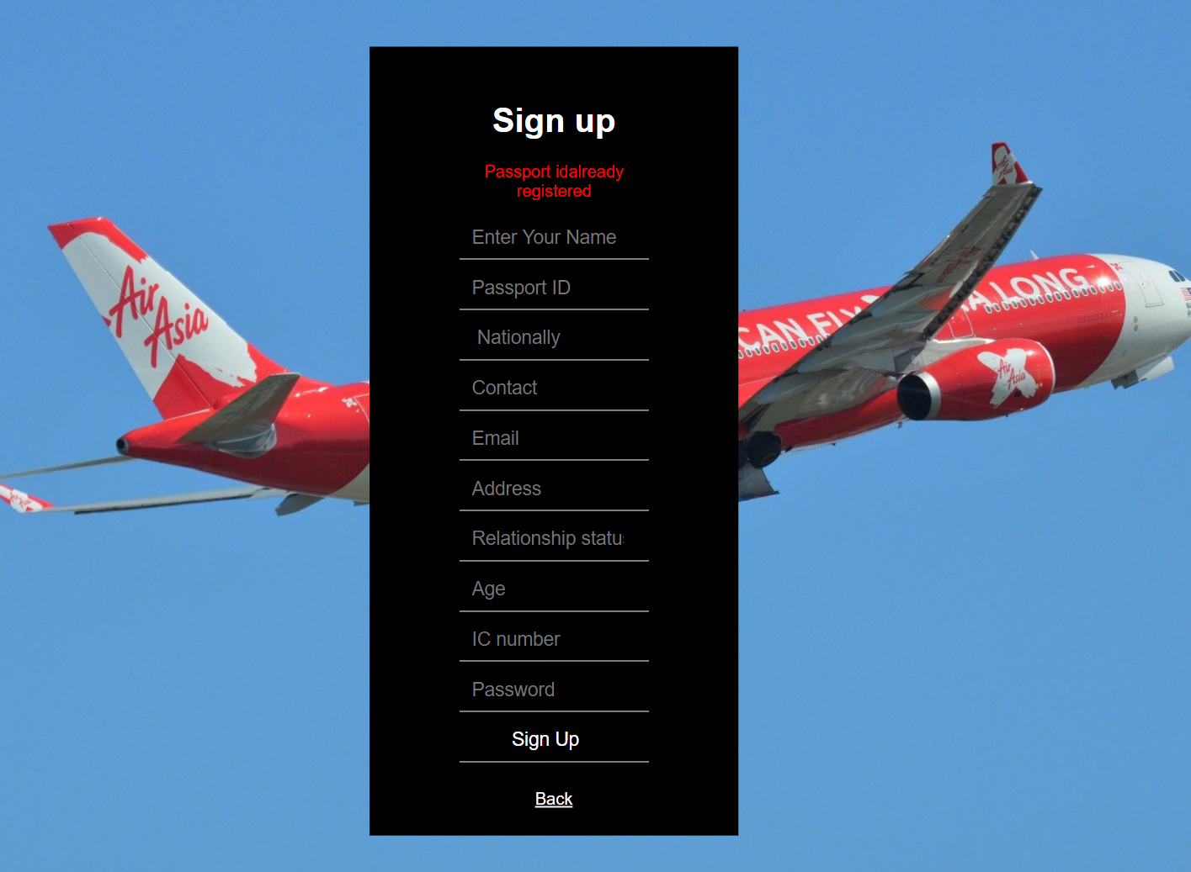

**Figure 10.4** Login page of display error message

In this successful registration page, it reminds the customer that he has successfully registered

the account and has a button to let the customer use to back the login page.

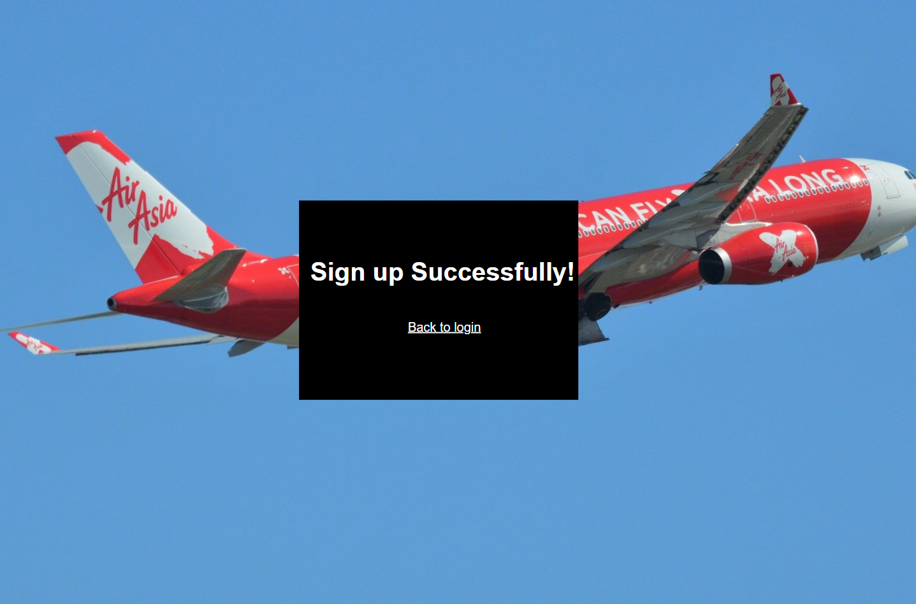

**Figure 10.5** Sign-up Successful Page

After the Customer Logged In, it will link to the Homepage. On this Homepage, there is table

for user to check with the All of the flight Schedule. User can select one of the schedules and

make a purchase on that flight ticket. There are two tabs button that user can select which is

Available Schedule and Check Availability. If user click purchase ticket tab button the program

will redirect to the Purchased Ticket Page **Figure 11.2**. If user click the button LOGOUT it will

lead the user to back to the Login Page. Lastly, If the user clicked the link of Purchase Now! It

will lead user to the Purchase Page **Figure 11.5**.

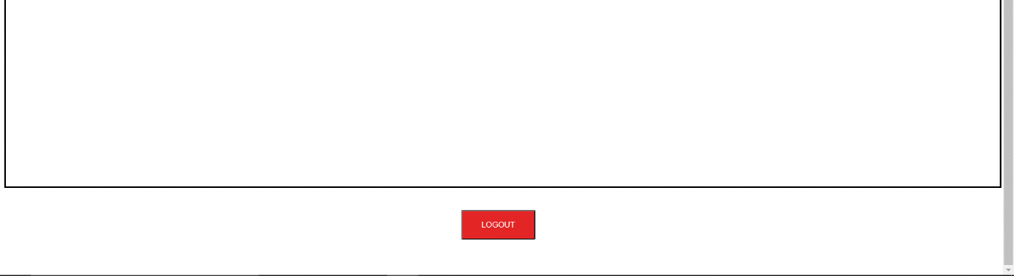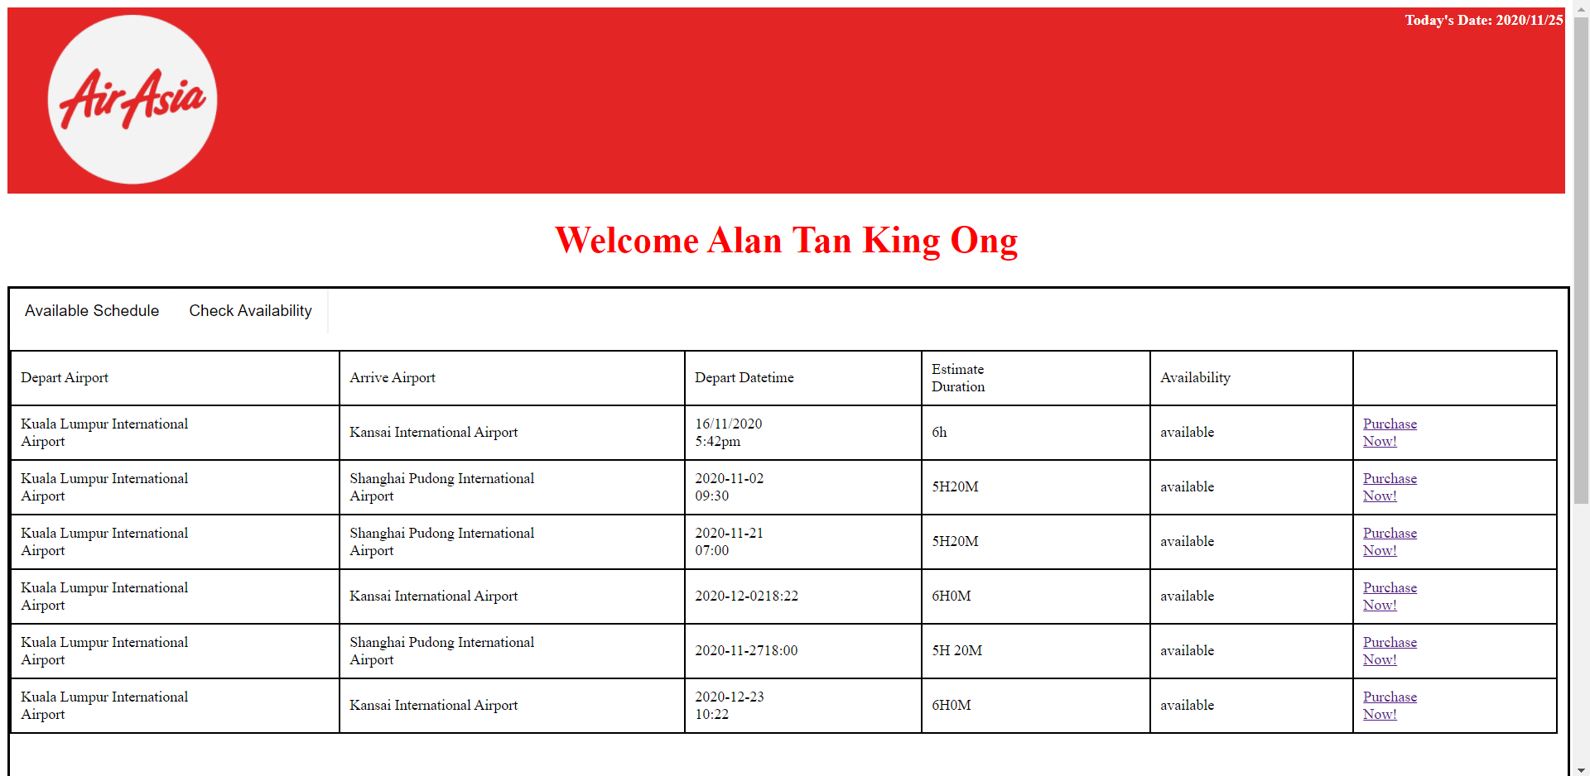

**Figure 11.1 Customer Homepage**

On this Purchased Tickets Page, User can easily check all the ticket details that the user has

bought tickets previously. There is a “View Schedule” link button for user to check all the

Schedule Details once user clicked the link button the program will lead user to the Schedule

Details Page **Figure 11.3**. Also, there is a “Check-In” link button for user to Check-in their

purchased tickets. After user click that link button, the program will bring user to the Check-

In Details Page **Figure 11.4**.

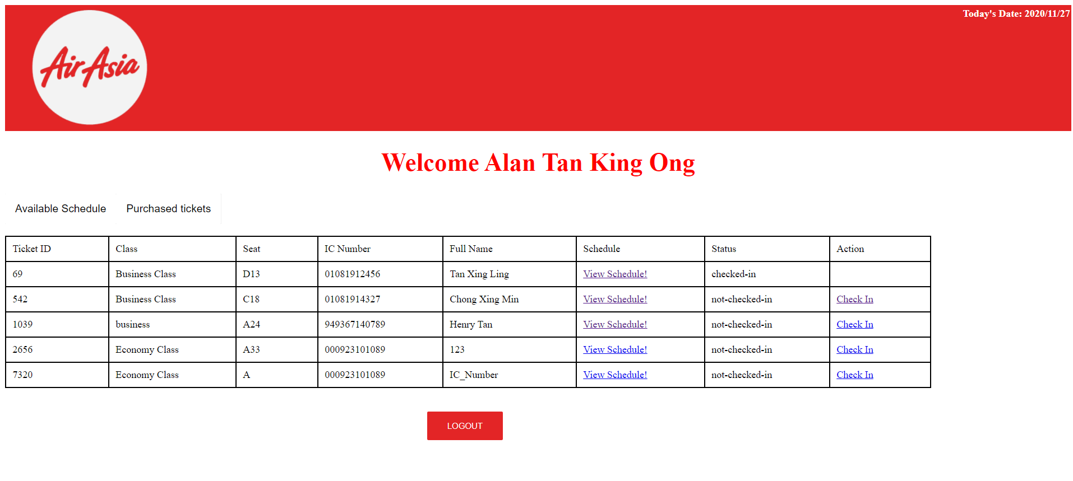

**Figure 11.2 Purchased Tickets Page**

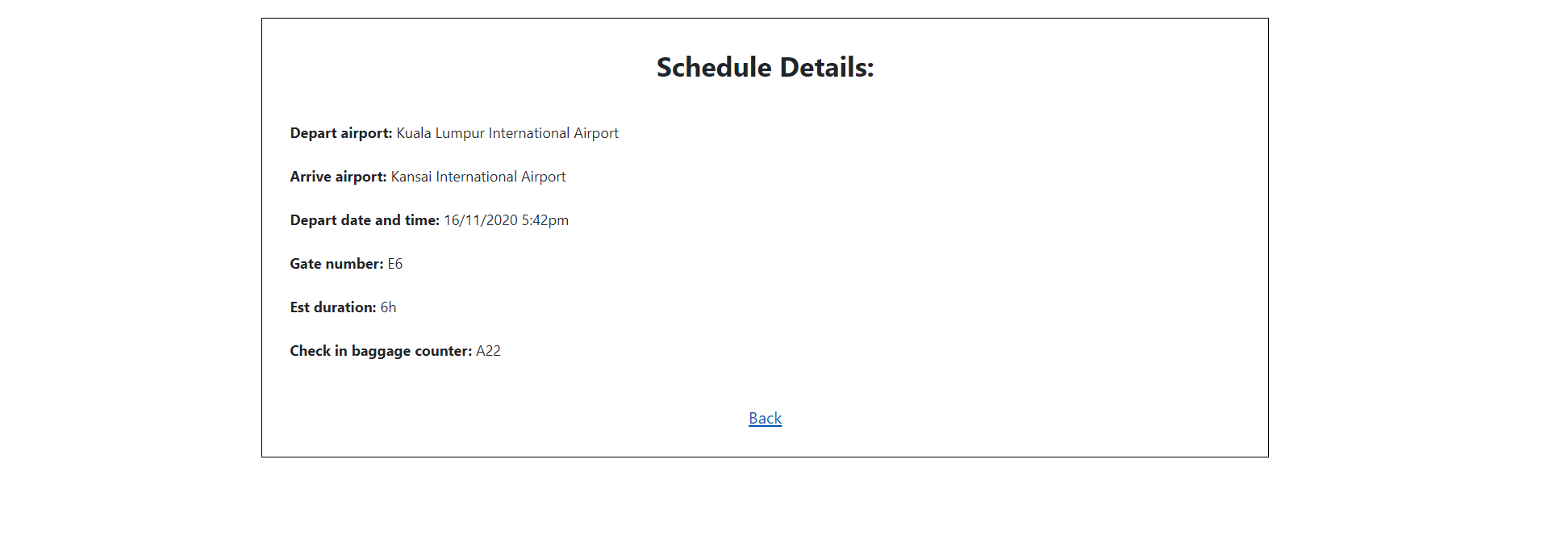

**Figure 11.3 Schedule Details Page**

On this Check in Details Page, User can check every single Check in Details and user should

double confirm with these details before the user click Check in Button.

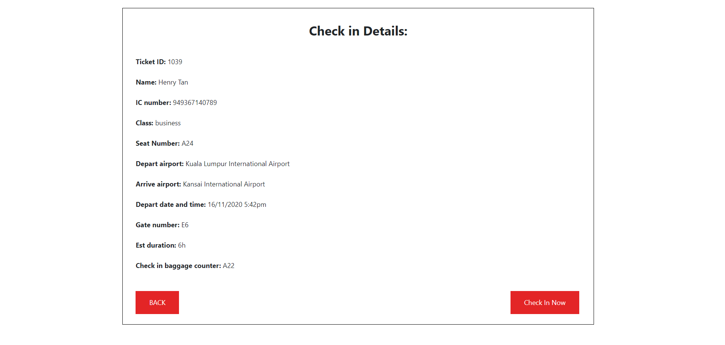

**Figure 11.4 Check-in Page**

In this Purchase Page, User can select any class, choose any seat, choose their own payment

option, Type IC Number and Type Name for the business record purpose. Also, there are two

buttons for user to click which is BACK and NEXT. If user clicked the back button it will bring

user to the Homepage **Figure 11.1**. If the user clicked the NEXT button it will redirect to the

Confirmation Page **Figure 11.6**.

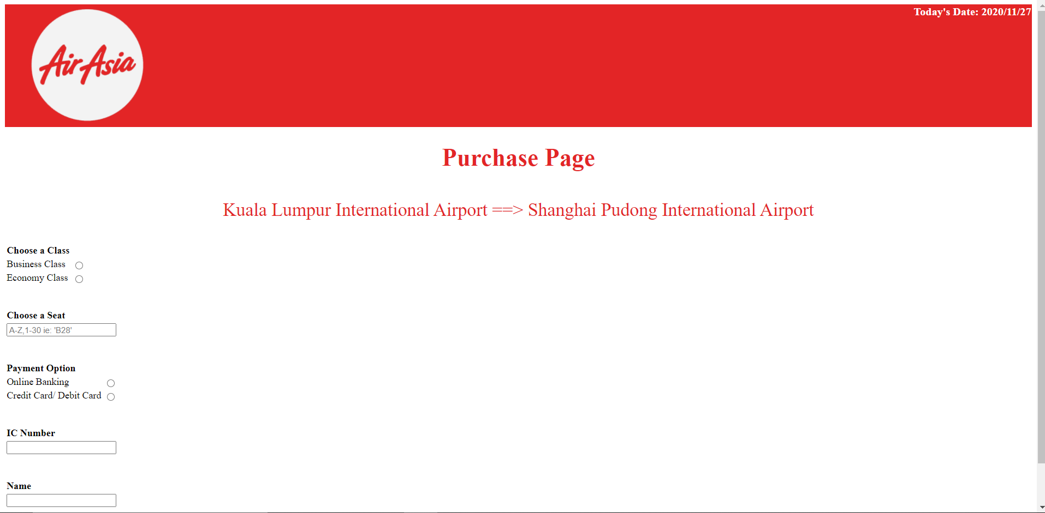

**Figure 11.5 Purchase Page**

In the Confirmation Page, User can double confirm with their information in case there is typed

error or selection error before the user proceed to next page. If user Clicked the “Confirm”

button it will lead the user to the **Purchase Completed Page** **Figure 11.7**.

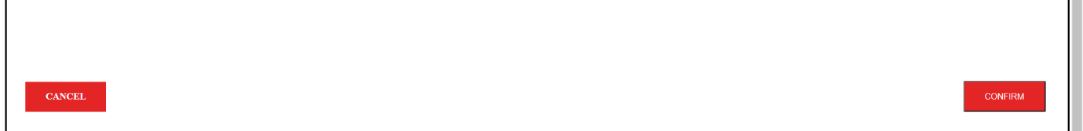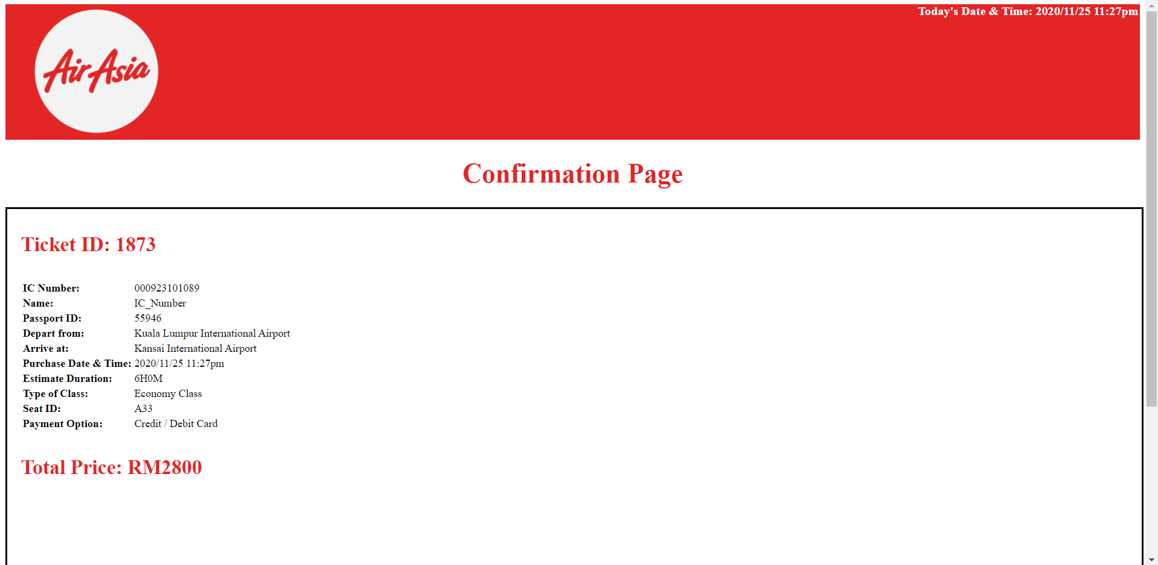

**Figure 11.6 Confirmation Page**

In this Purchase Completed Page, User can see that the word Purchase is Completed means

that user knows the purchase is already successfully. After that, the passport id, ticket id, ticket

price and date will store into the XML files which is “customerpayment.xml”. If the User clicks

BACK TO THE HOMEPAGE button it will brings the user to the Homepage.

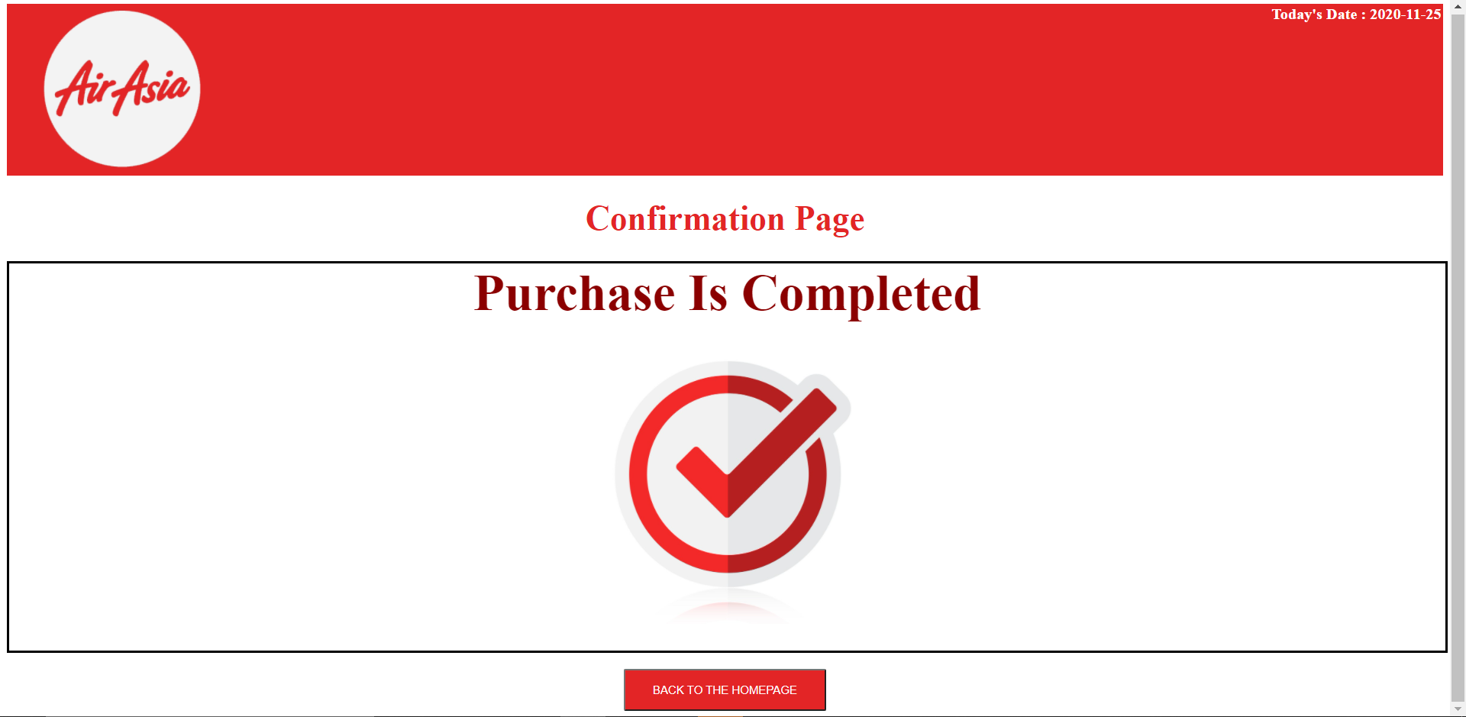

**Figure 11.7 Purchase Completed Page**

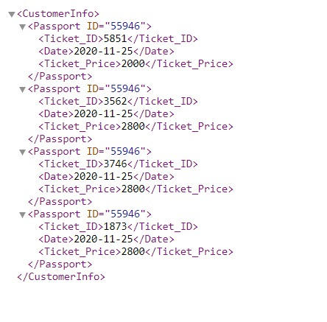

**Figure 11.8 XML file for customer payment**

Meanwhile, in the homepage (available tickets), there will be a tab button for customer to press on and it will lead them to a page called “purchased tickets”. This page will show all the tickets that the customer bought.

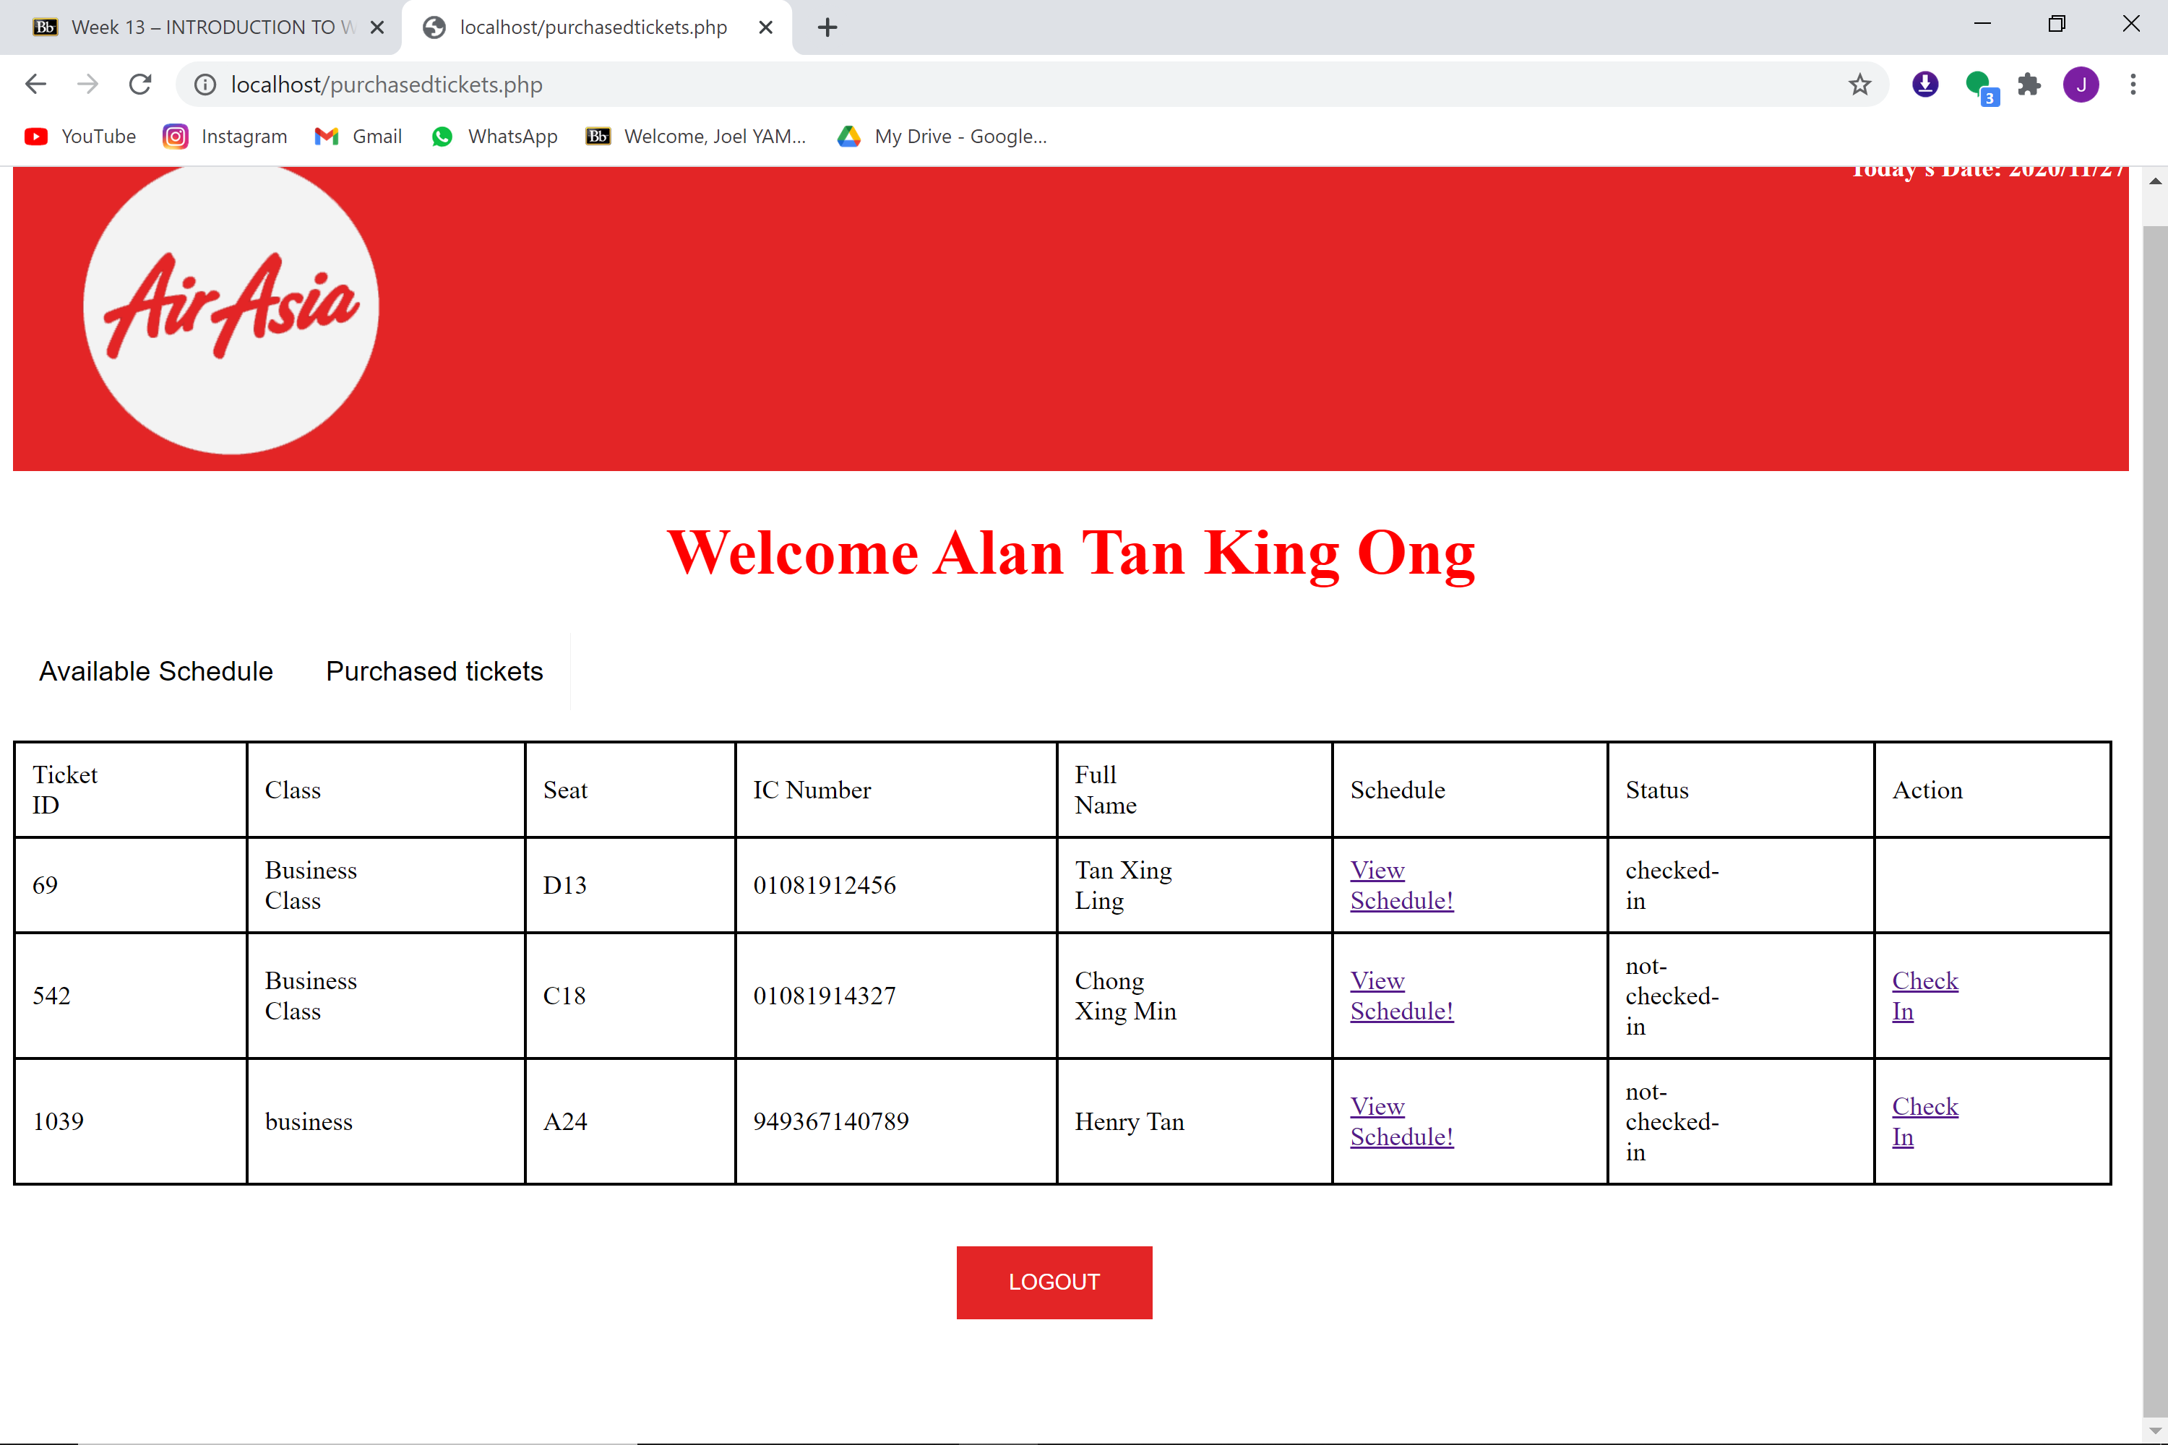

**Figure 12** Purchased ticket page

From this page, customer can choose to “view schedule” to check the details of the flight.

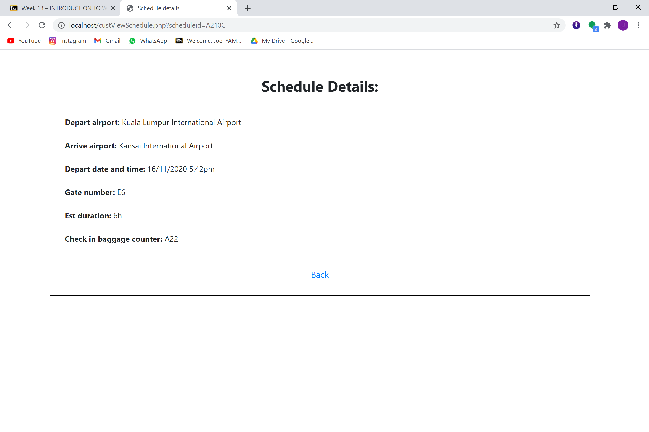

**Figure 12.1** Schedule details page with a back button

Other than that, there is a “check in” button for customer to click on. When they click on it, the full details of the ticket will be shown to customer, they can choose to take a picture of it or screenshot it for future preferences.

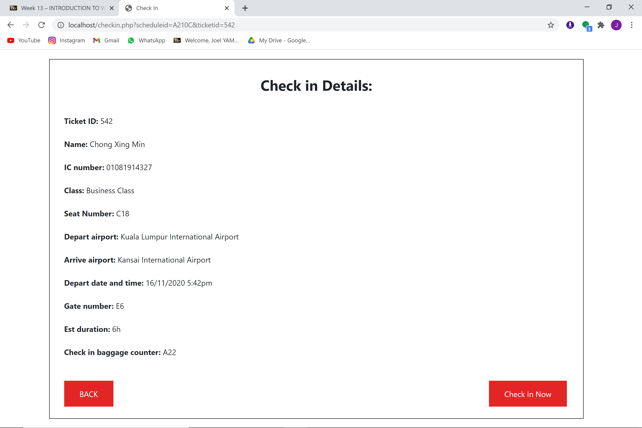

**Figure 12.2** Check in details with a back and check in now button.

Once customer has confirm with the details, they can press check in now, and it will bring them to a page that shows them a “check in successfully” message.

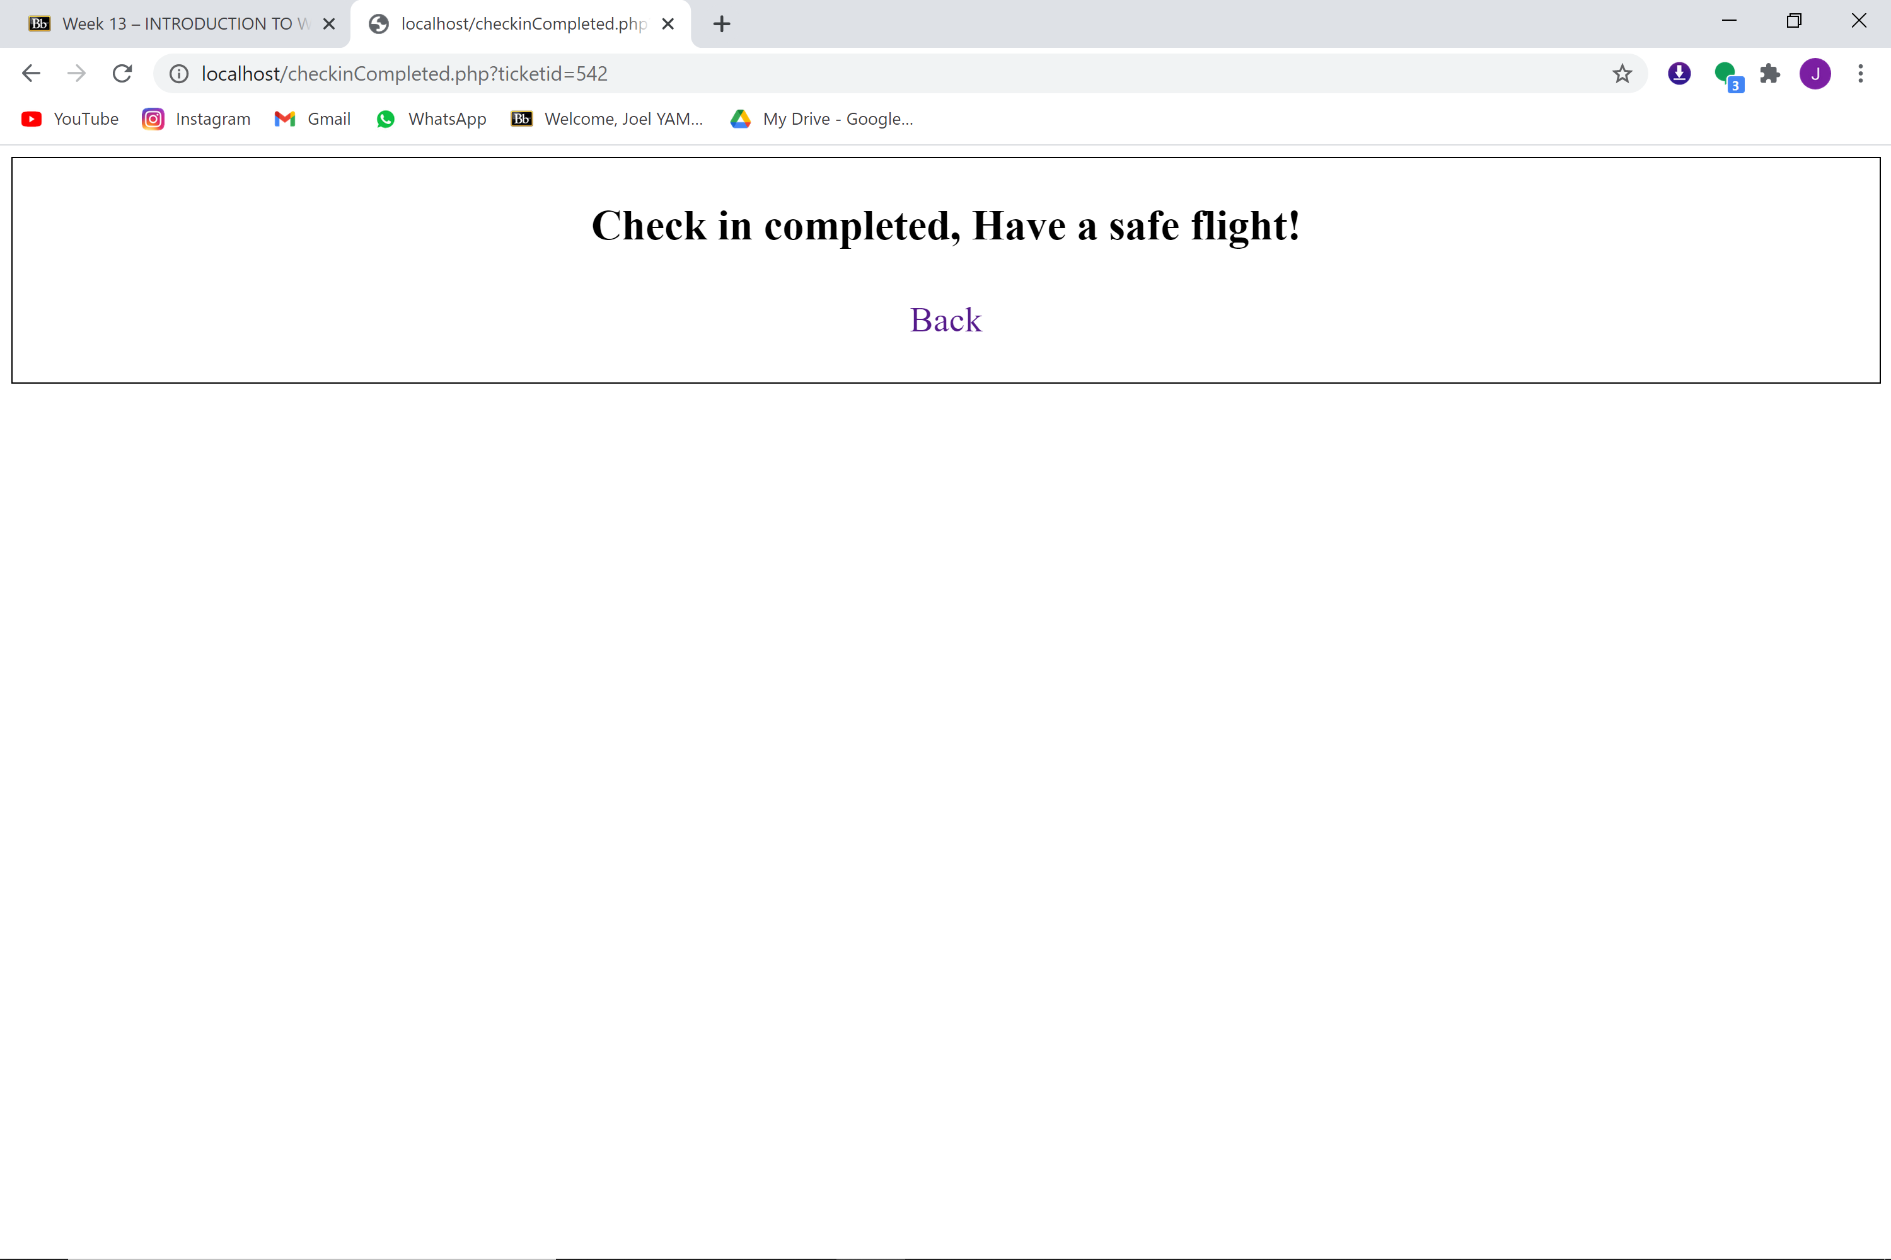

**Figure 12.3** Message to show “check in successfully”

Back to the “purchased ticket” homepage, there will not be a button for customer to press if the ticket has already been checked in

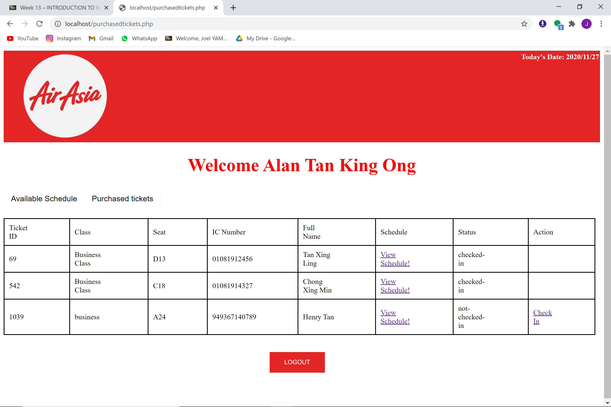

**Figure 12.4** Purchased ticket page

Lastly, there will always be a log out button for customer to sign out of their account.

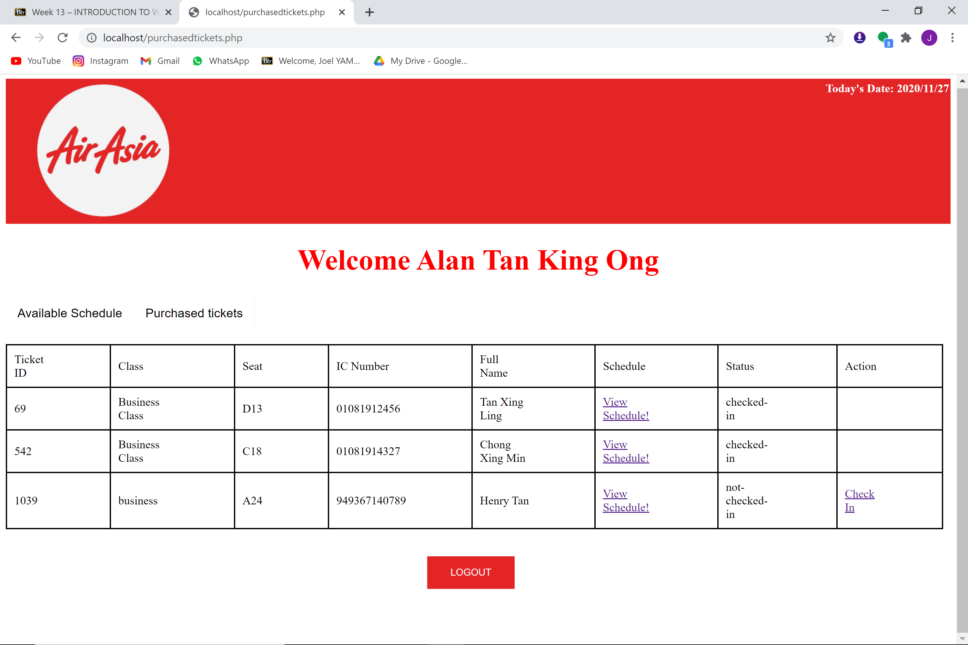

**Figure 12.5** Log out button

**Manager module**

To access the manager module (staff module), staff have to choose staff in the sign in page, and give the correct ID and password. In this case, I will use 9999 as ID and 99999 as password, the data is stored in the database.

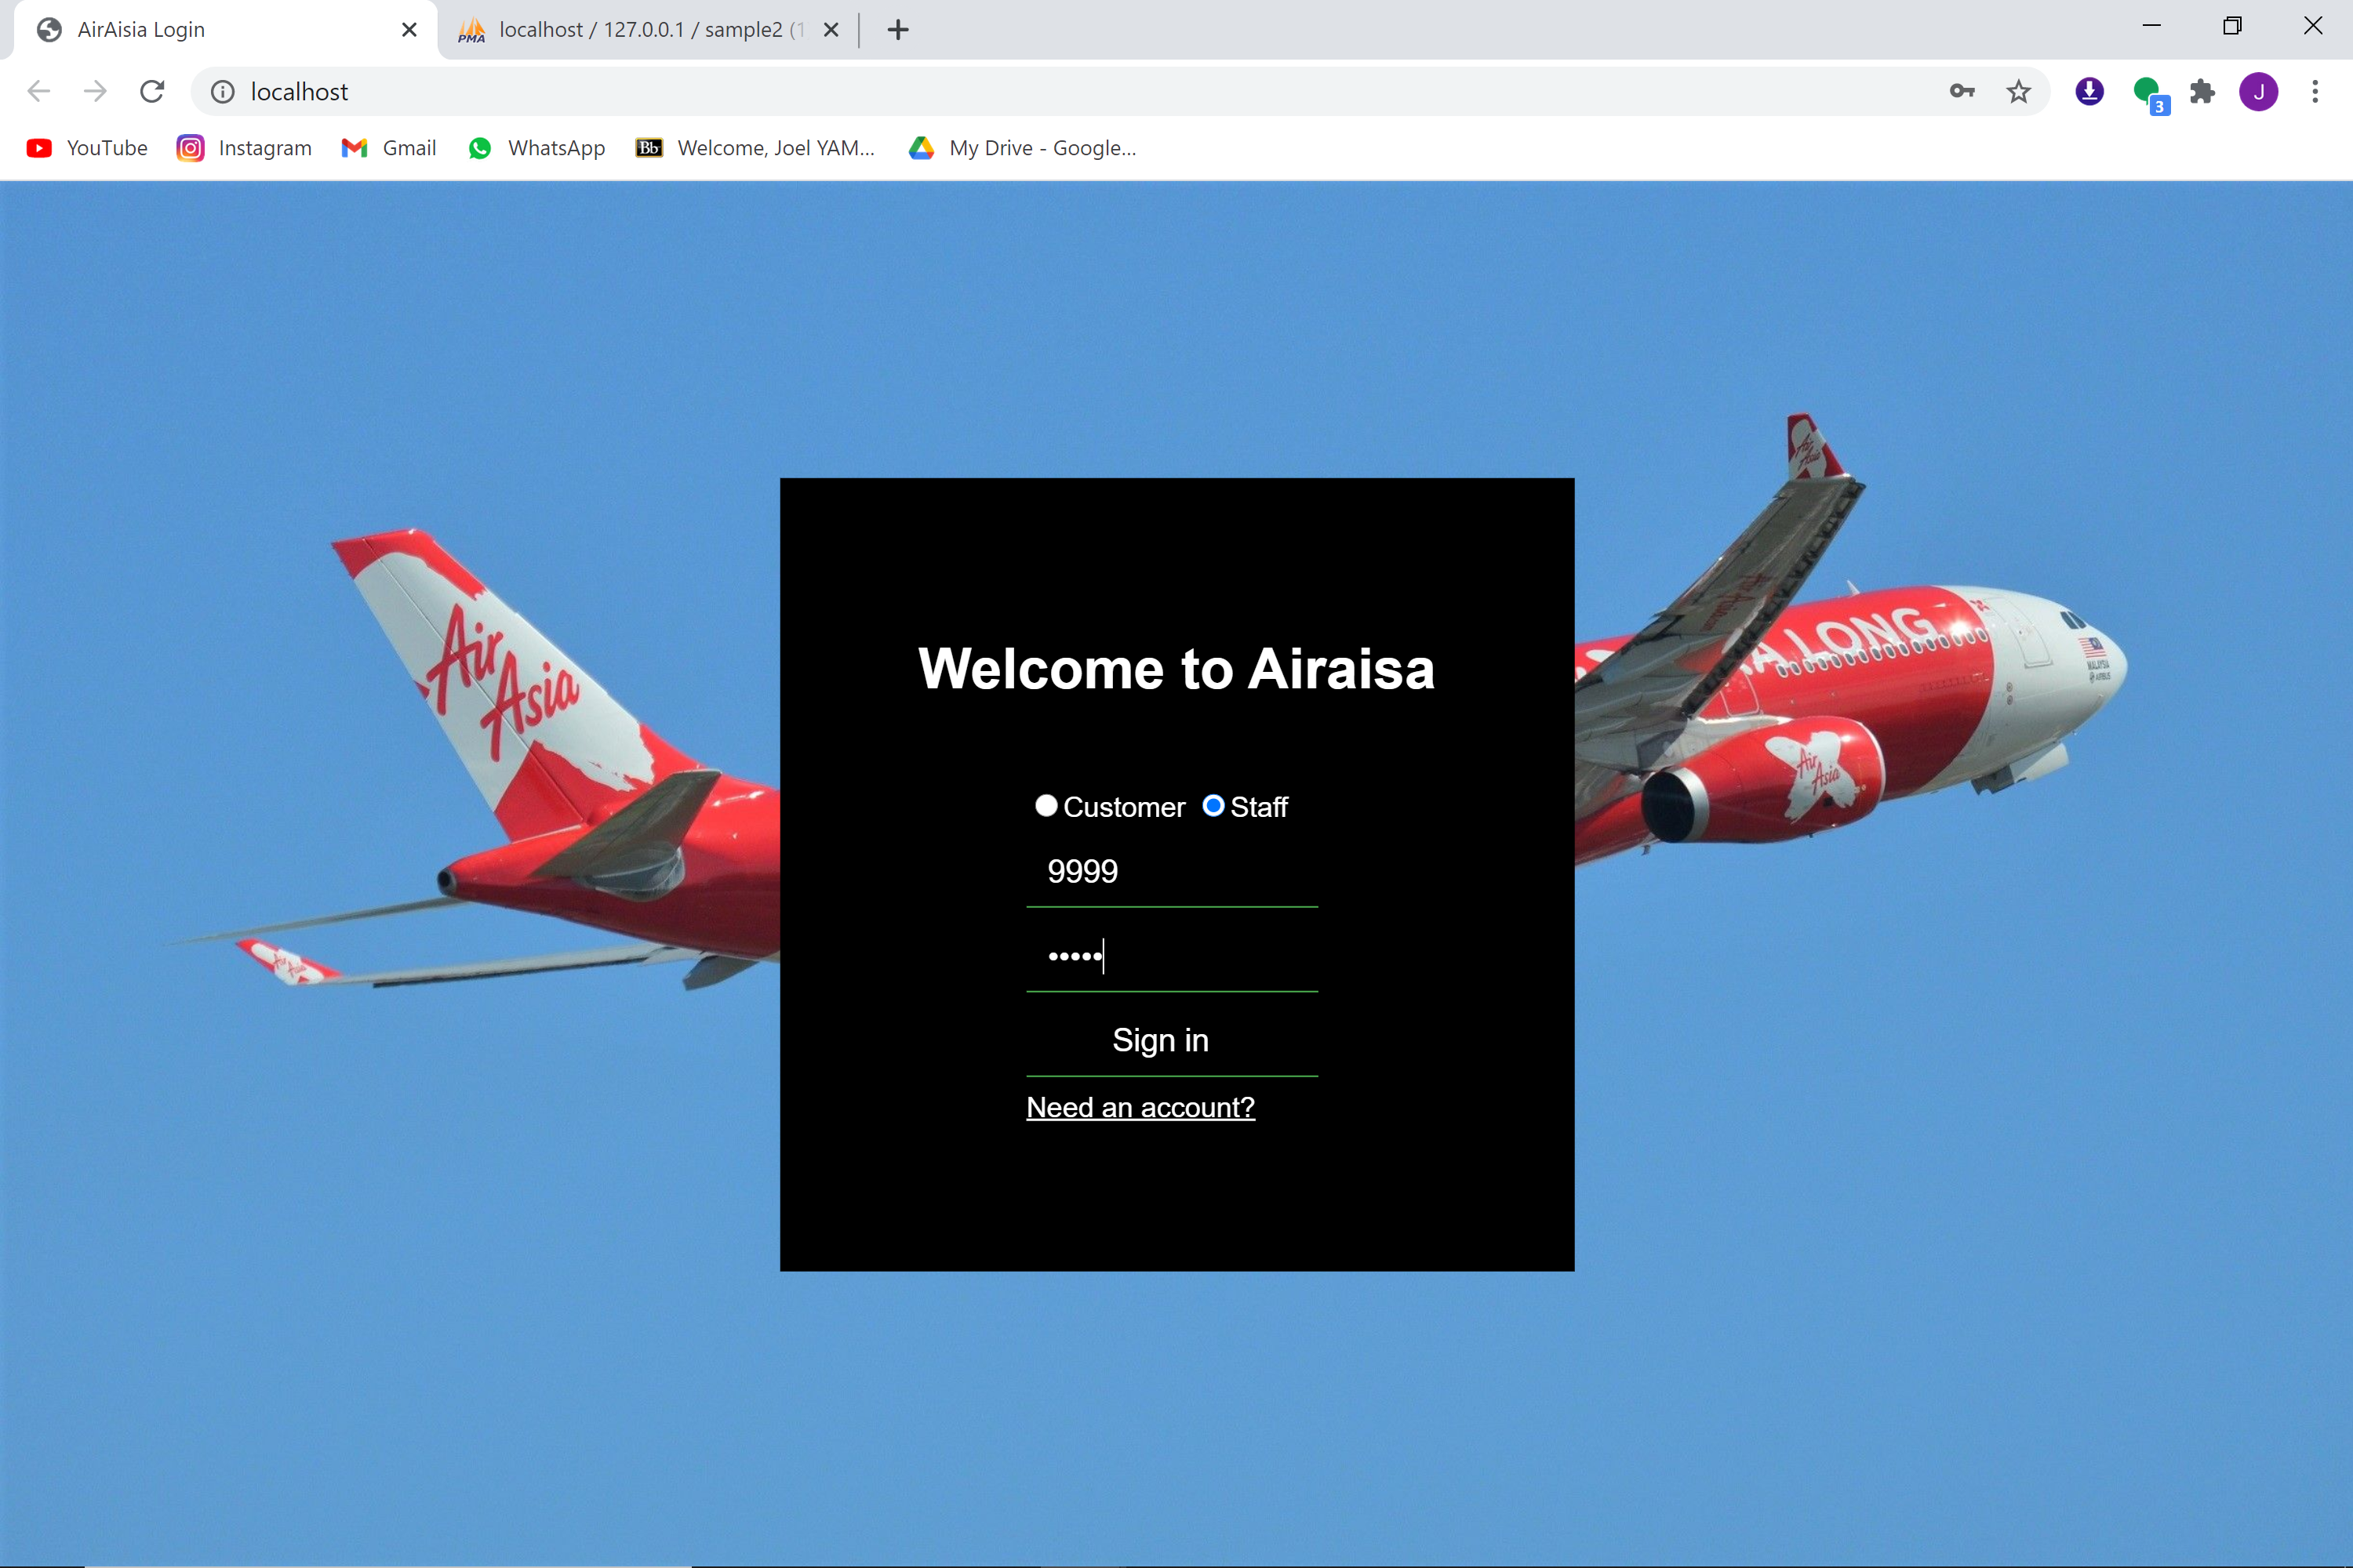

**Figure 13** Sign in page

After giving the correct ID and password, it will lead staff to the home page (flight schedule record) with the staff’s name at the top.

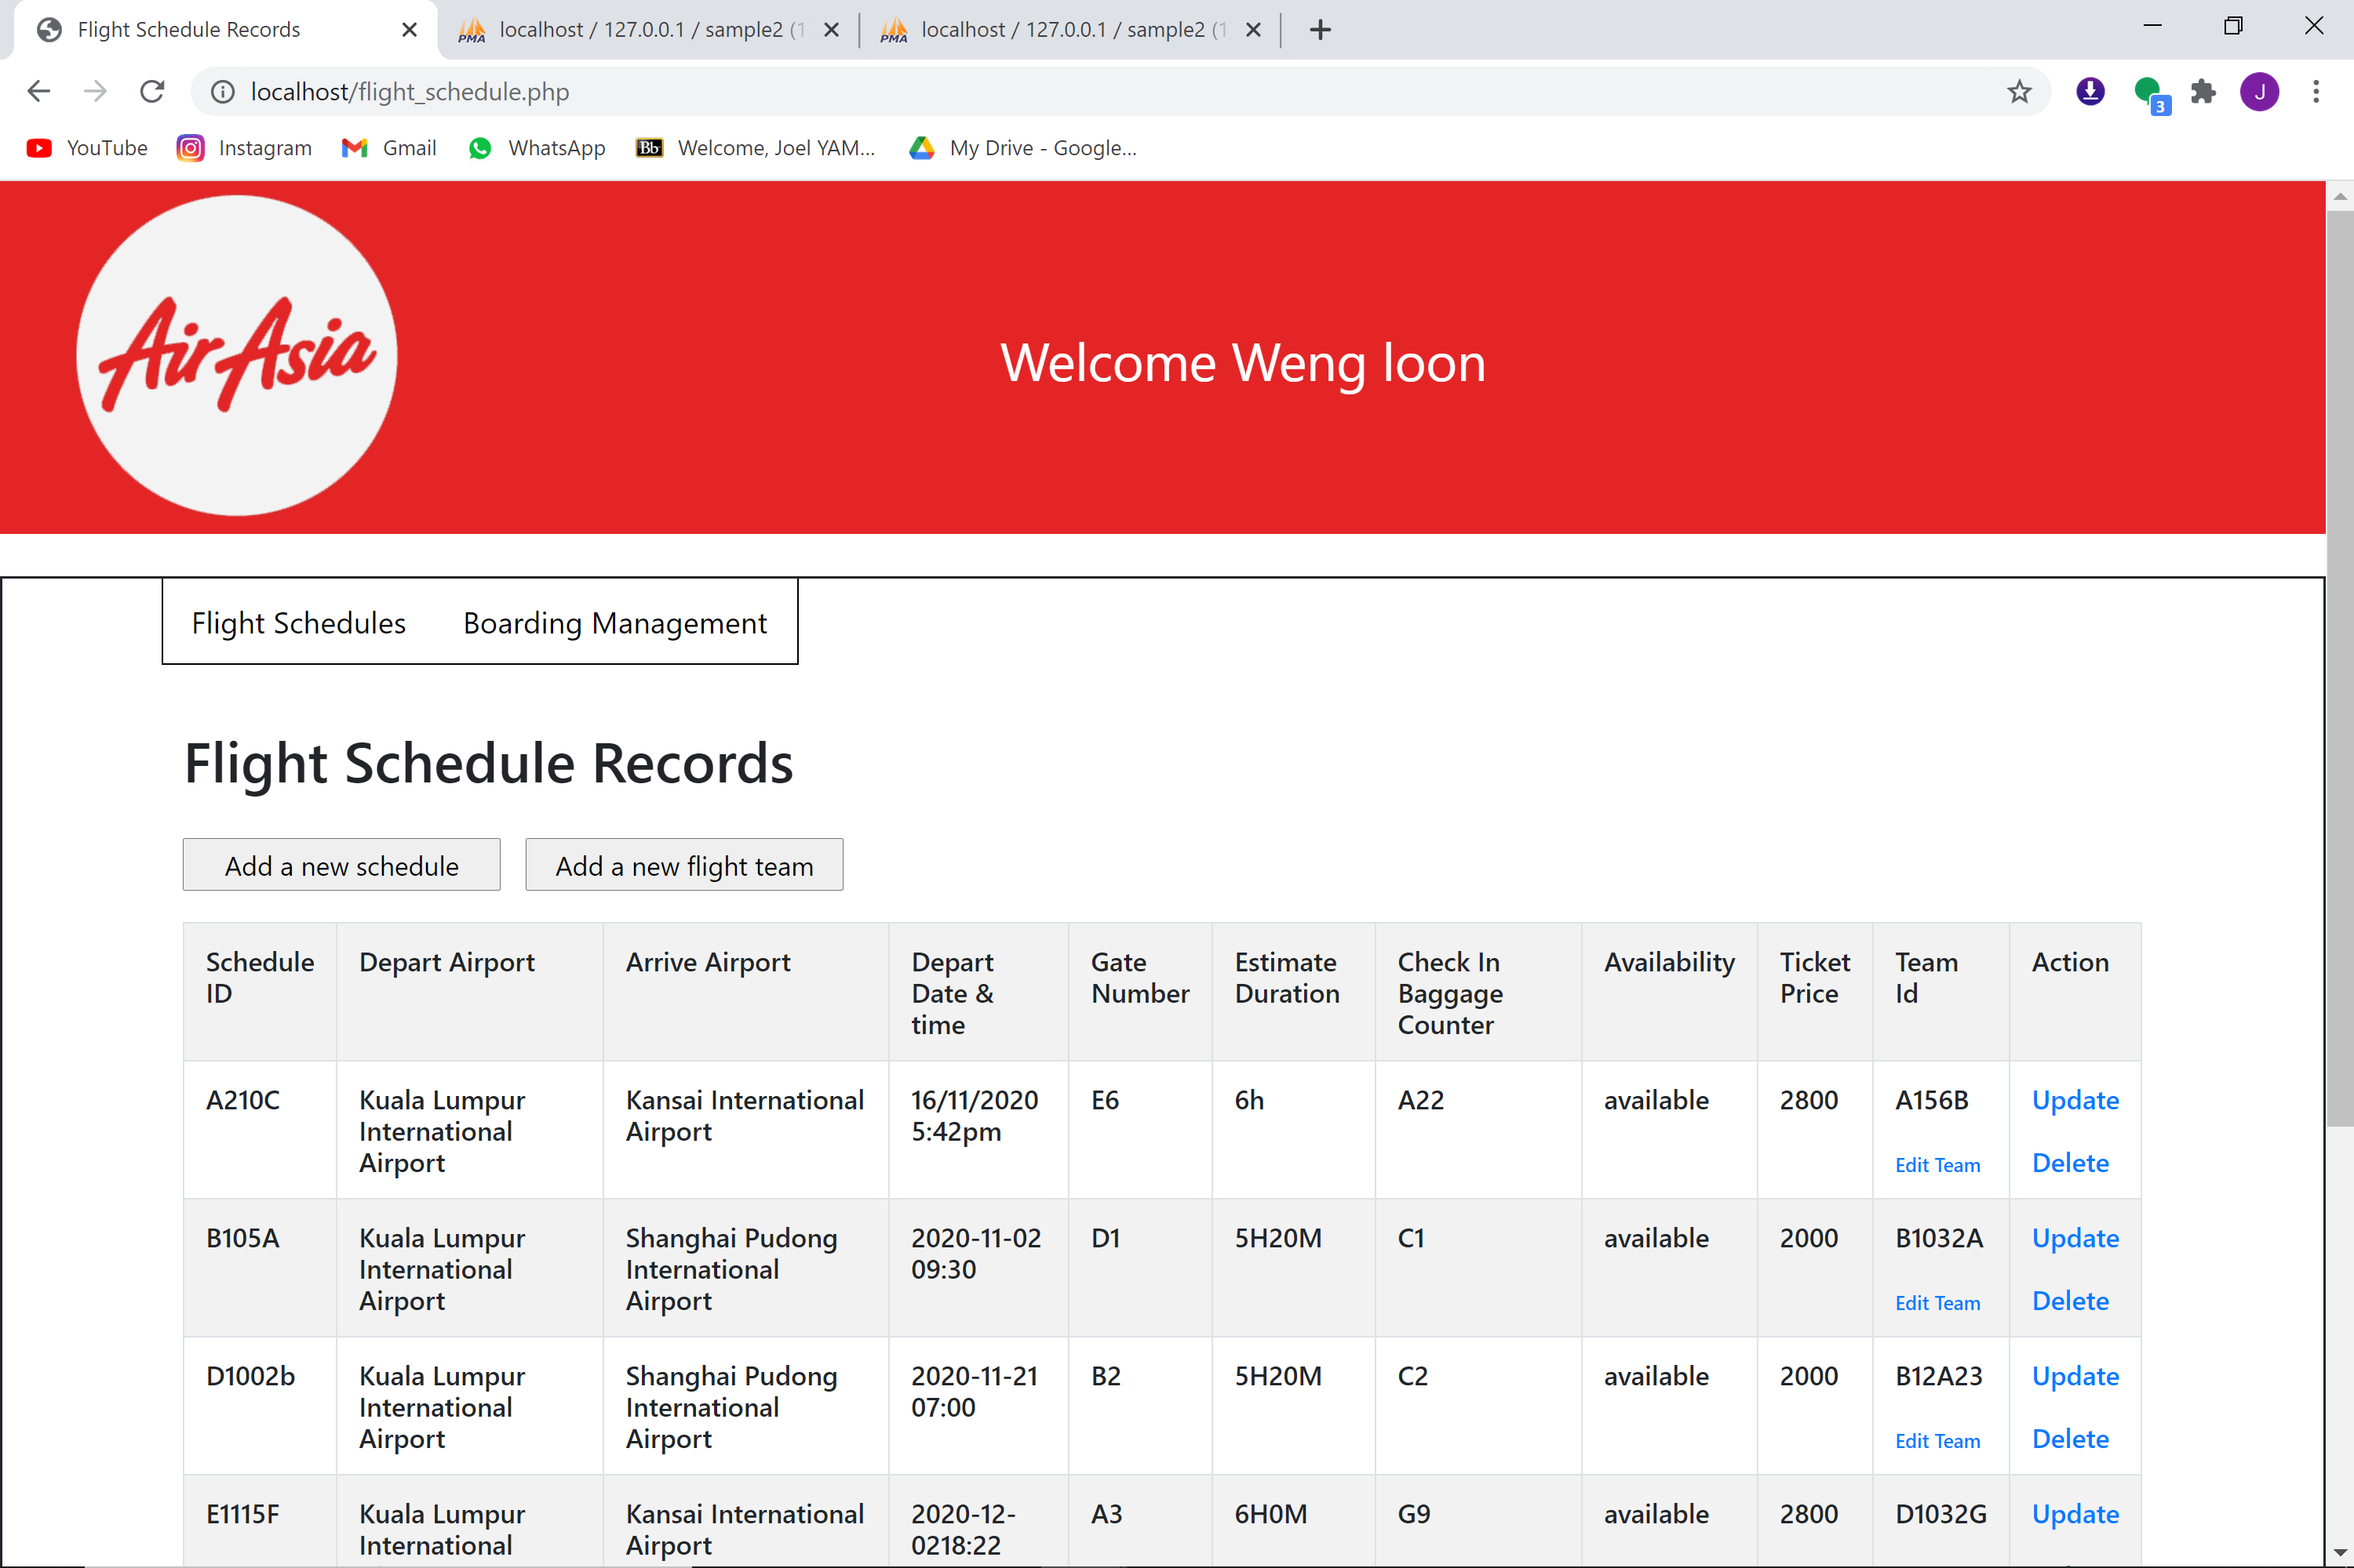

**Figure 13.1** Home page (Flight Schedule Record)

In the home page (flight schedule record), staff can press on the buttons that will lead them

to different pages and different functions.

If staff presses on the add a new schedule button, it will lead the staff to this Add

Flight Schedule record page, Staff can add a new flight schedule record. After

they enter the correct manager ID & Password, the program will create a new flight

schedule record results as shown below.

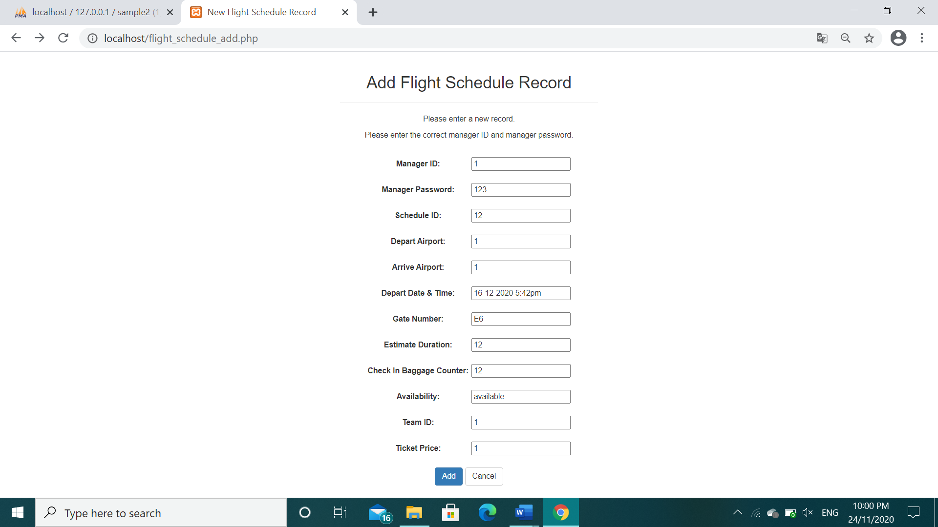

**Figure 13.2A** Add flight schedule record page

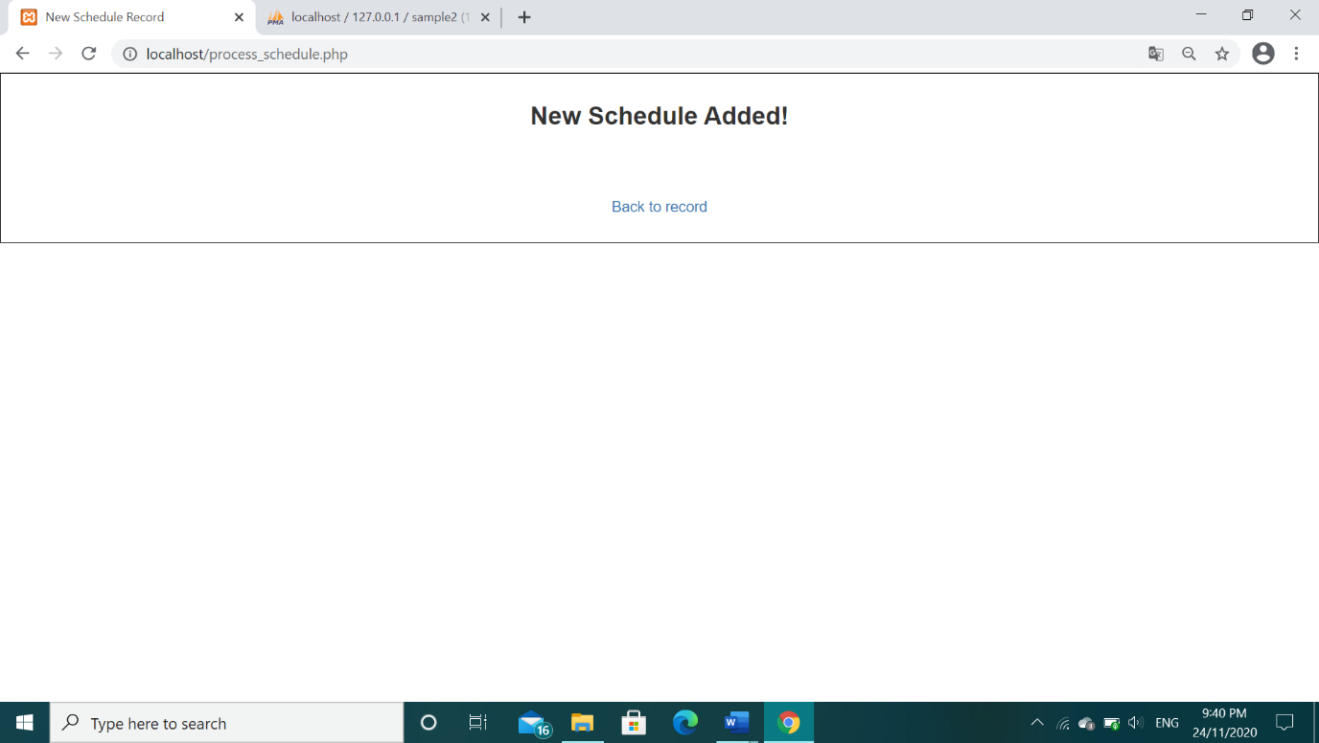

**Figure 13.2B** New flight schedule record is added

The new schedule added will appear in the flight schedule record page

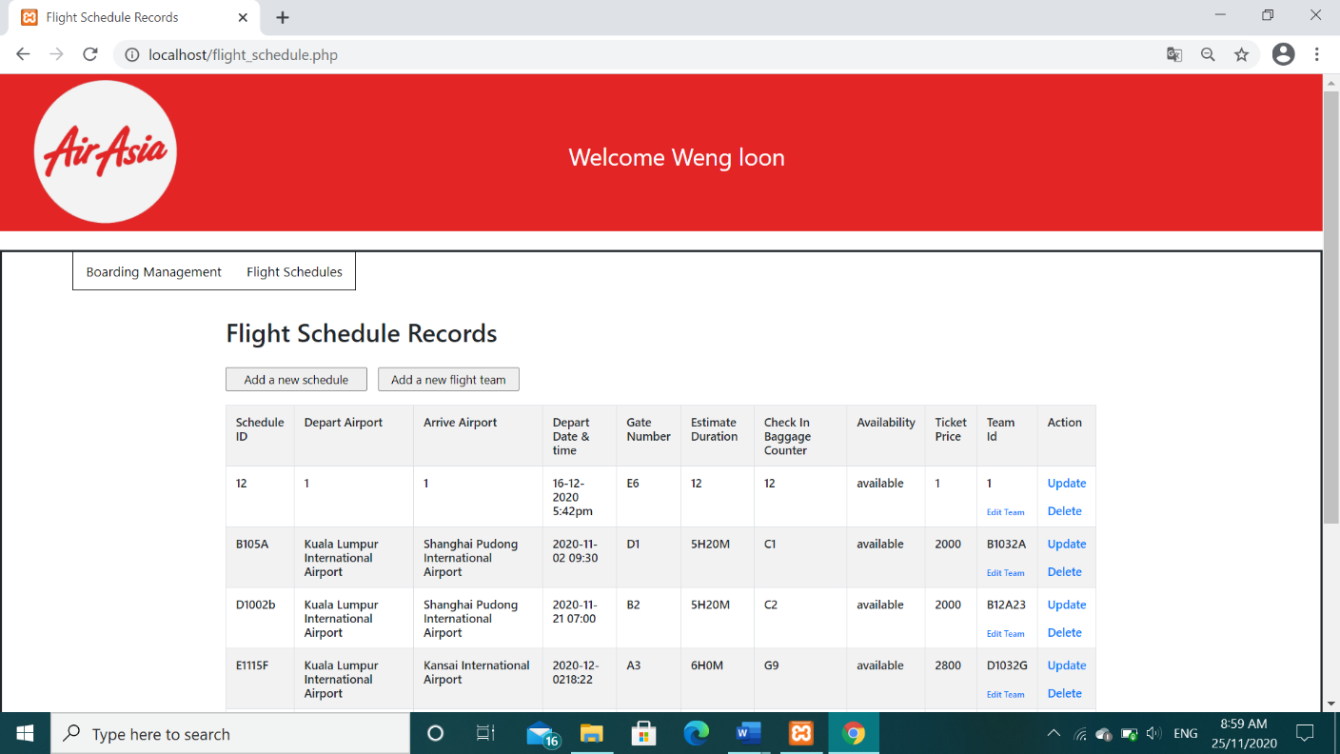

**Figure 13.2C** Flight schedule record after a new schedule is added

When staff presses on the update button at any of the schedule record, it will lead them this

Update Flight Schedule record page, Staff can update their flight schedule record. After they

enter the correct manager ID & Password, the program will update the flight schedule record

results as shown below.

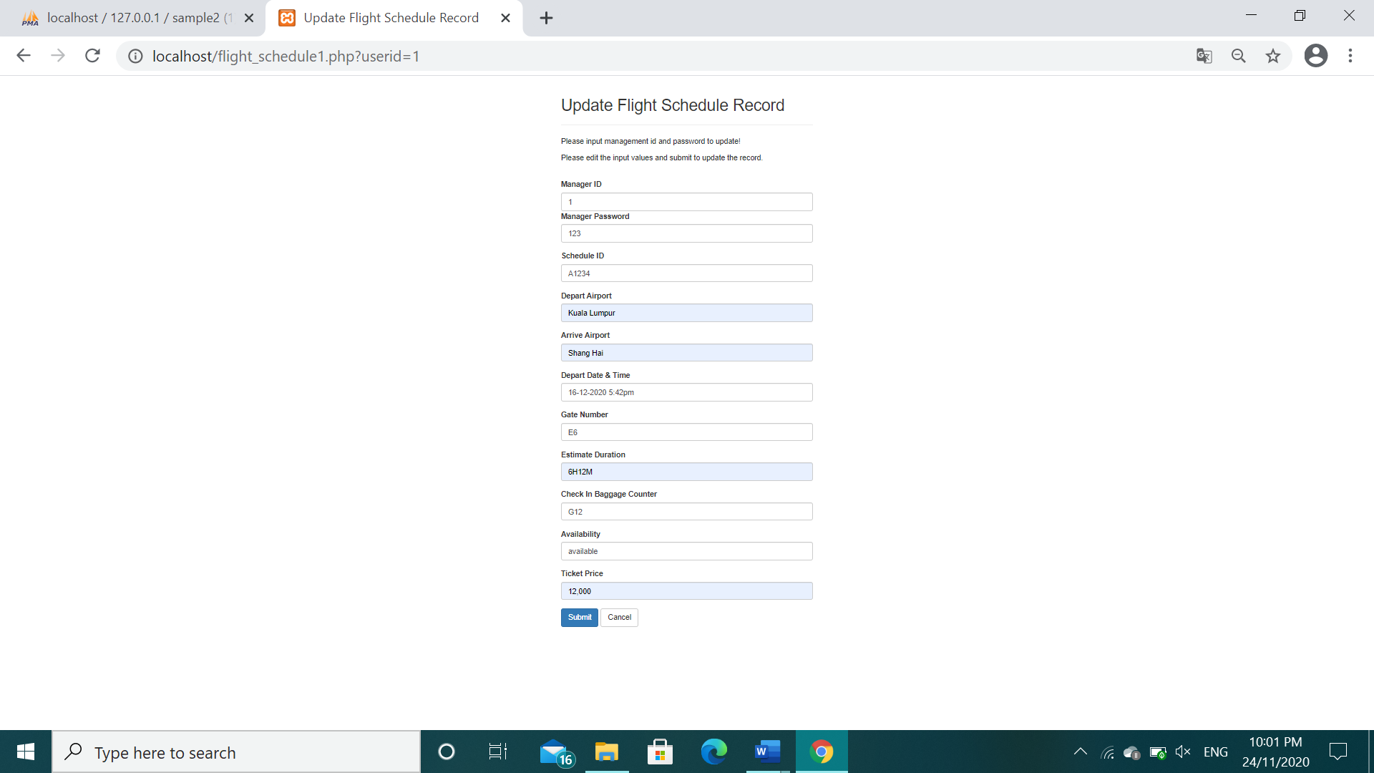

**Figure 13.3A** Update Flight schedule record page

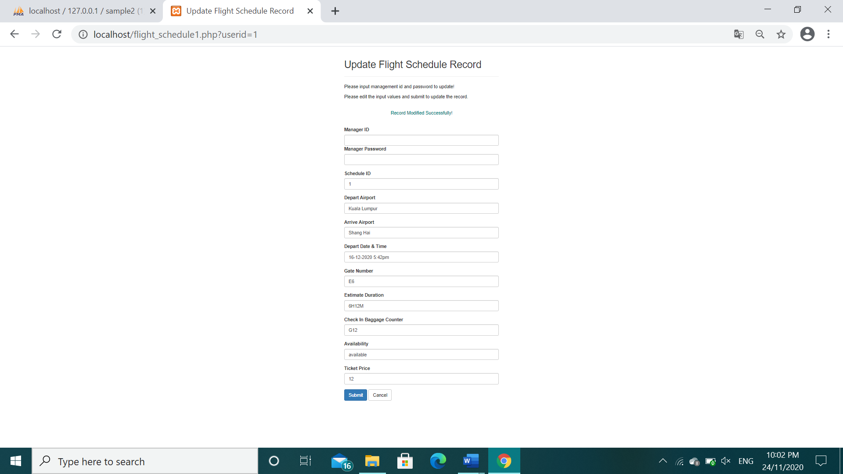

**Figure 13.3B** Record Modified Successfully shown

After a schedule record is updated successfully, it will update in the flight schedule page too

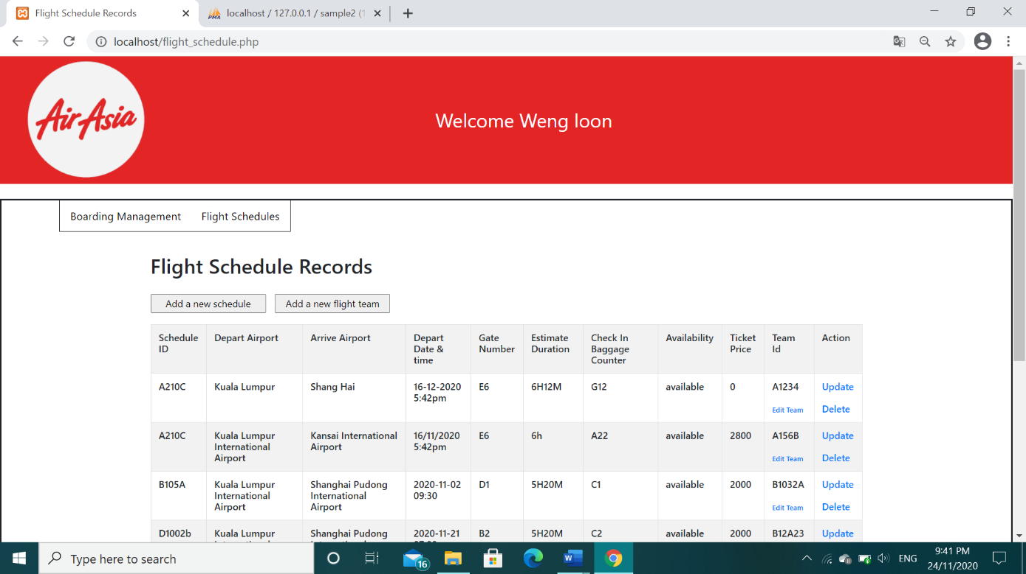

**Figure 13.3C** Flight schedule record after a schedule is updated

If staff presses on any of the delete button in the schedule record, it will lead them to

this delete Flight Schedule record page, Staff can delete their flight schedule record. After

they enter the correct manager ID & Password, the program will delete the flight schedule

record results as shown below.

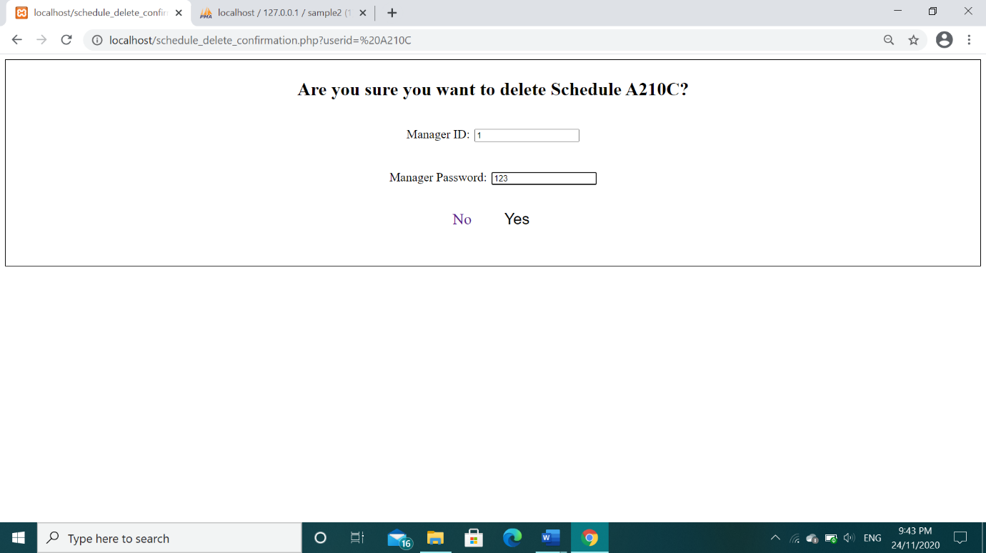

**Figure 13.4A** Delete Flight schedule record page

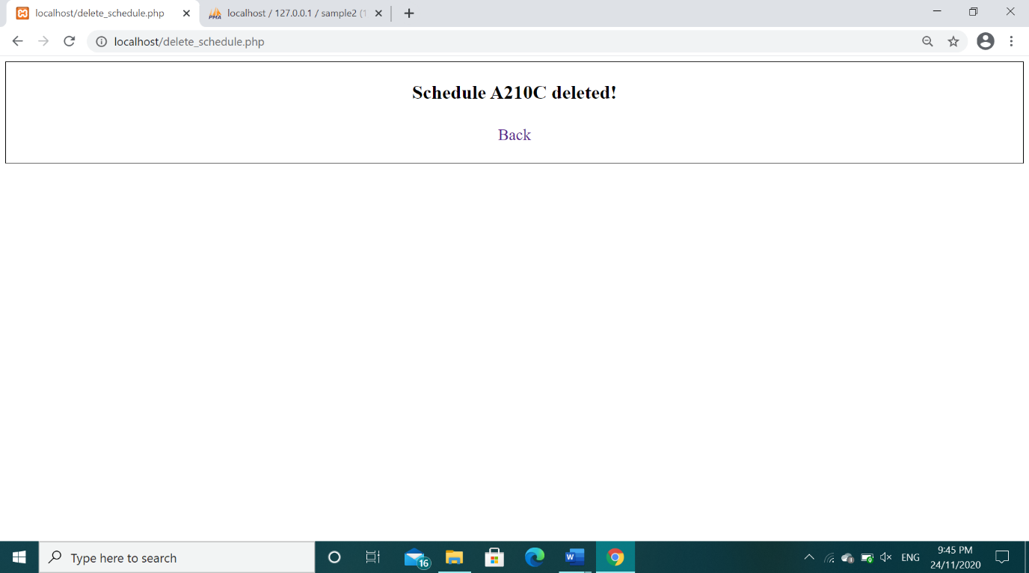

**Figure 13.4B** The flight schedule record is deleted

When the staff presses the add a new team button, It will lead the staff to this add flight team

record page, Staff can add a new flight team record. After they enter the correct manager

ID & Password, the program will create a new flight team record results as shown below.

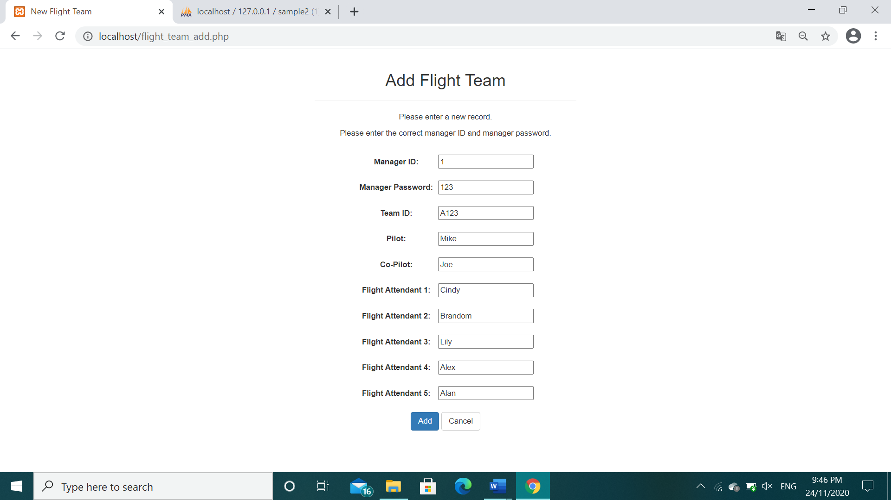

**Figure 13.5A** Add Flight team record page

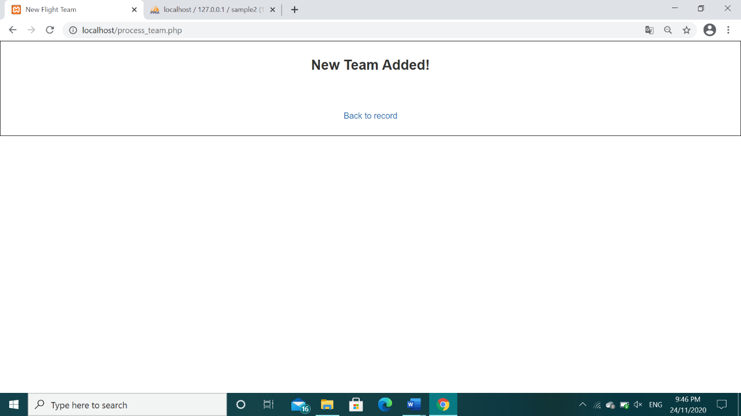

**Figure 13.5B** The flight team record is added

If the staff presses any of the edit team button that is located at the bottom of the team id,

it will bring the staff to this update flight team record page, Staff can update the flight team

record. After they enter the correct manager ID & Password, the program will update the

flight team record results as shown below.

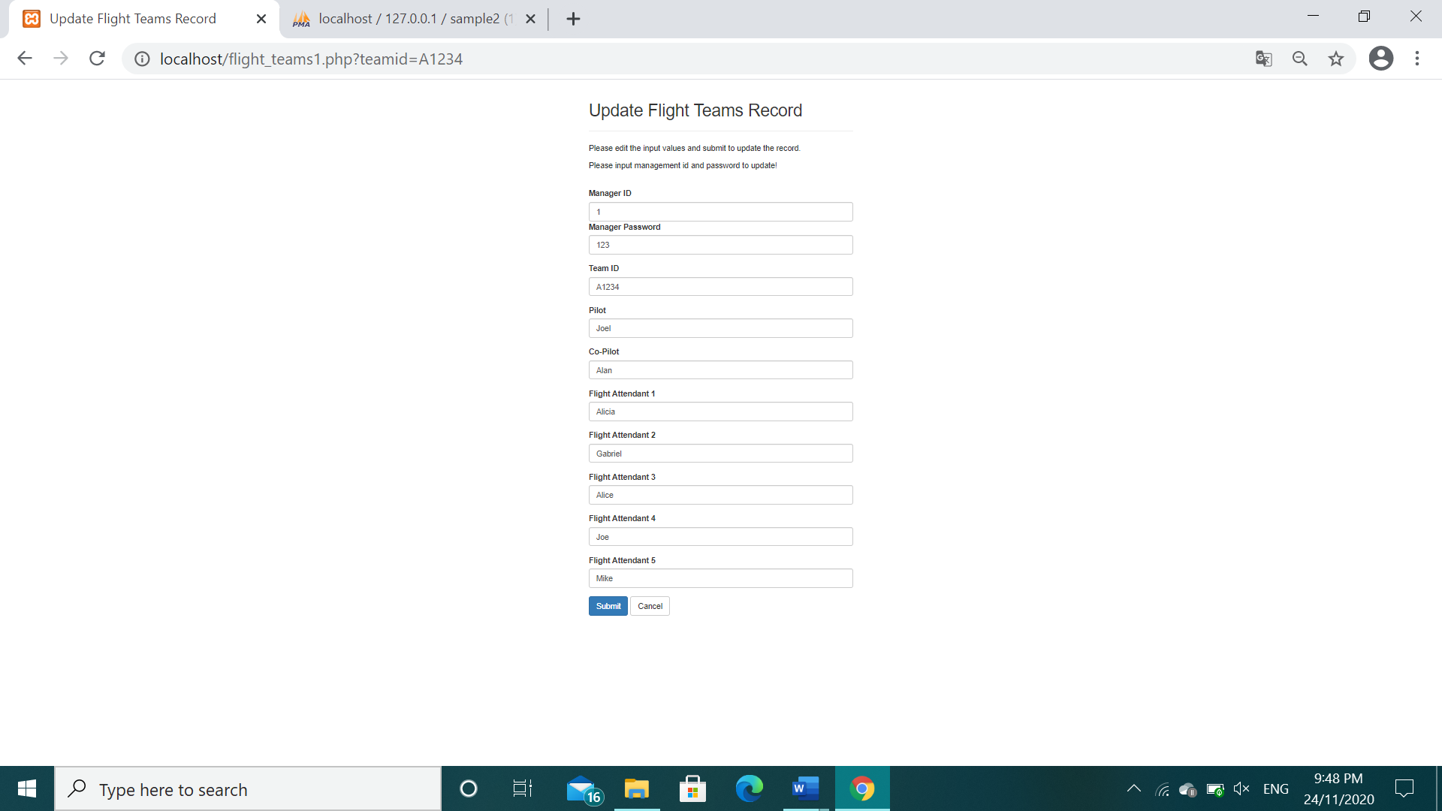

**Figure 13.6A** Update Flight team record page

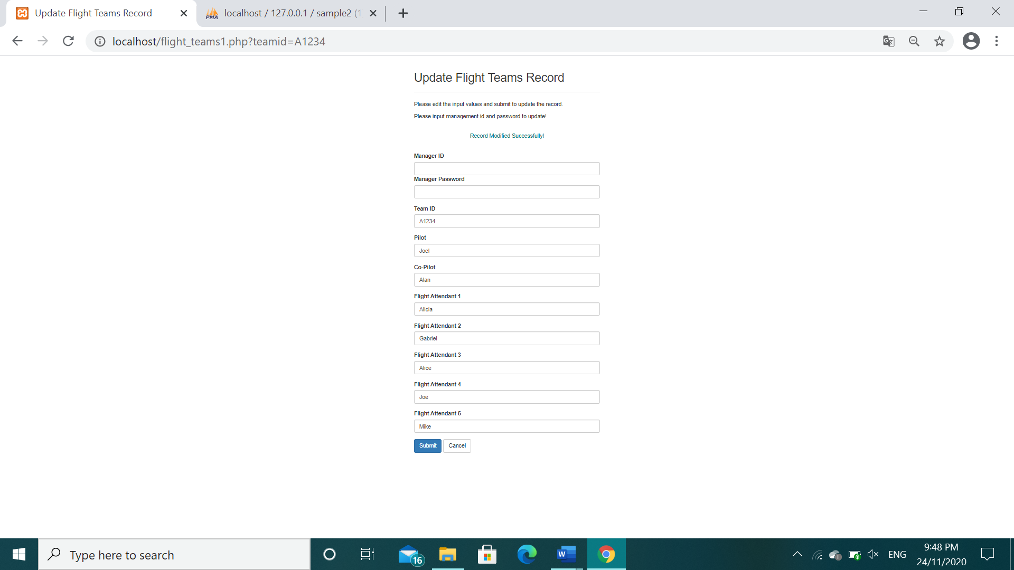

**Figure 13.6B** The flight team record is updated

Lastly, there is a log out button for staffs at the bottom of the flight schedule record main

page, it will bring them back to the sign in page.

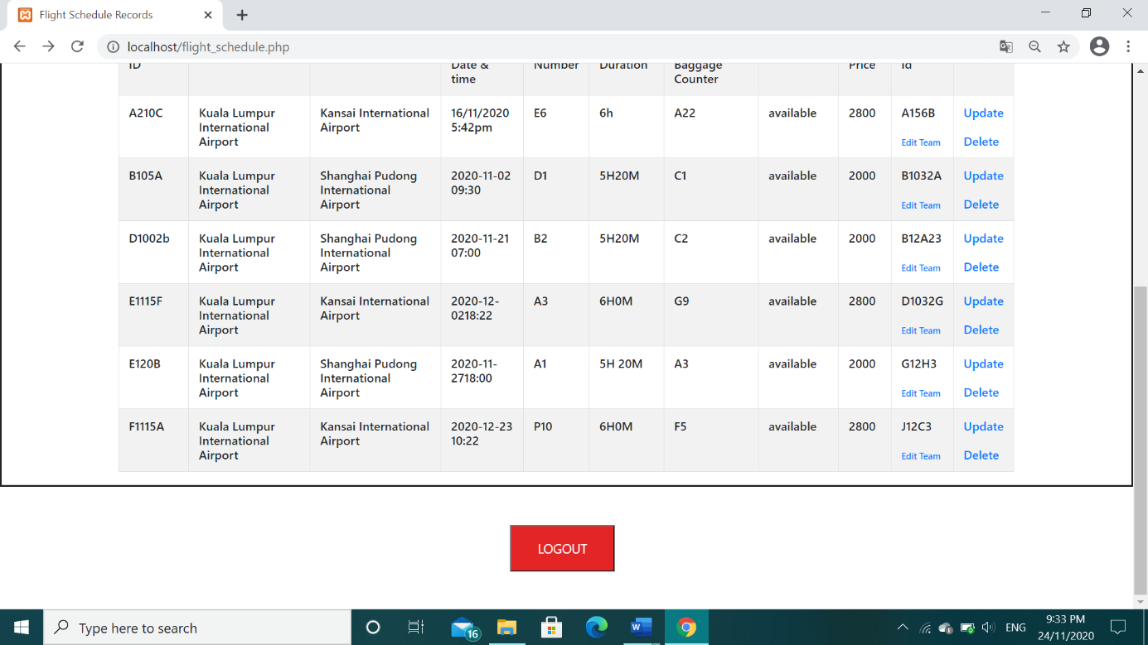

**Figure 13.7** Log out button

On top of all these, if the staff didn’t input the correct manager ID or password, it will show

him/her error messages as shown below. One small feature is that the input will still be there

even if the ID or password is wrong.

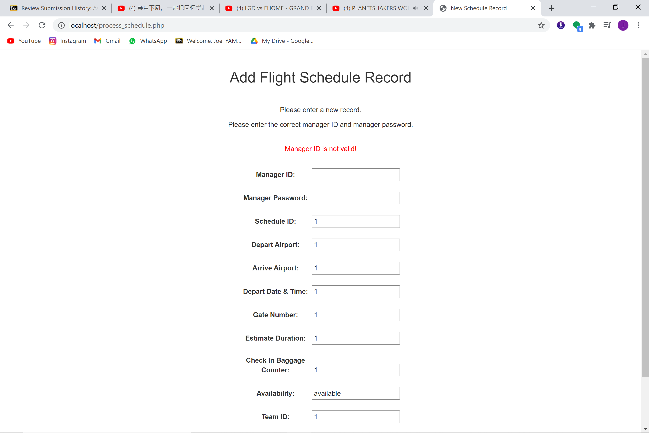

**Figure 13.8A** Wrong manager ID

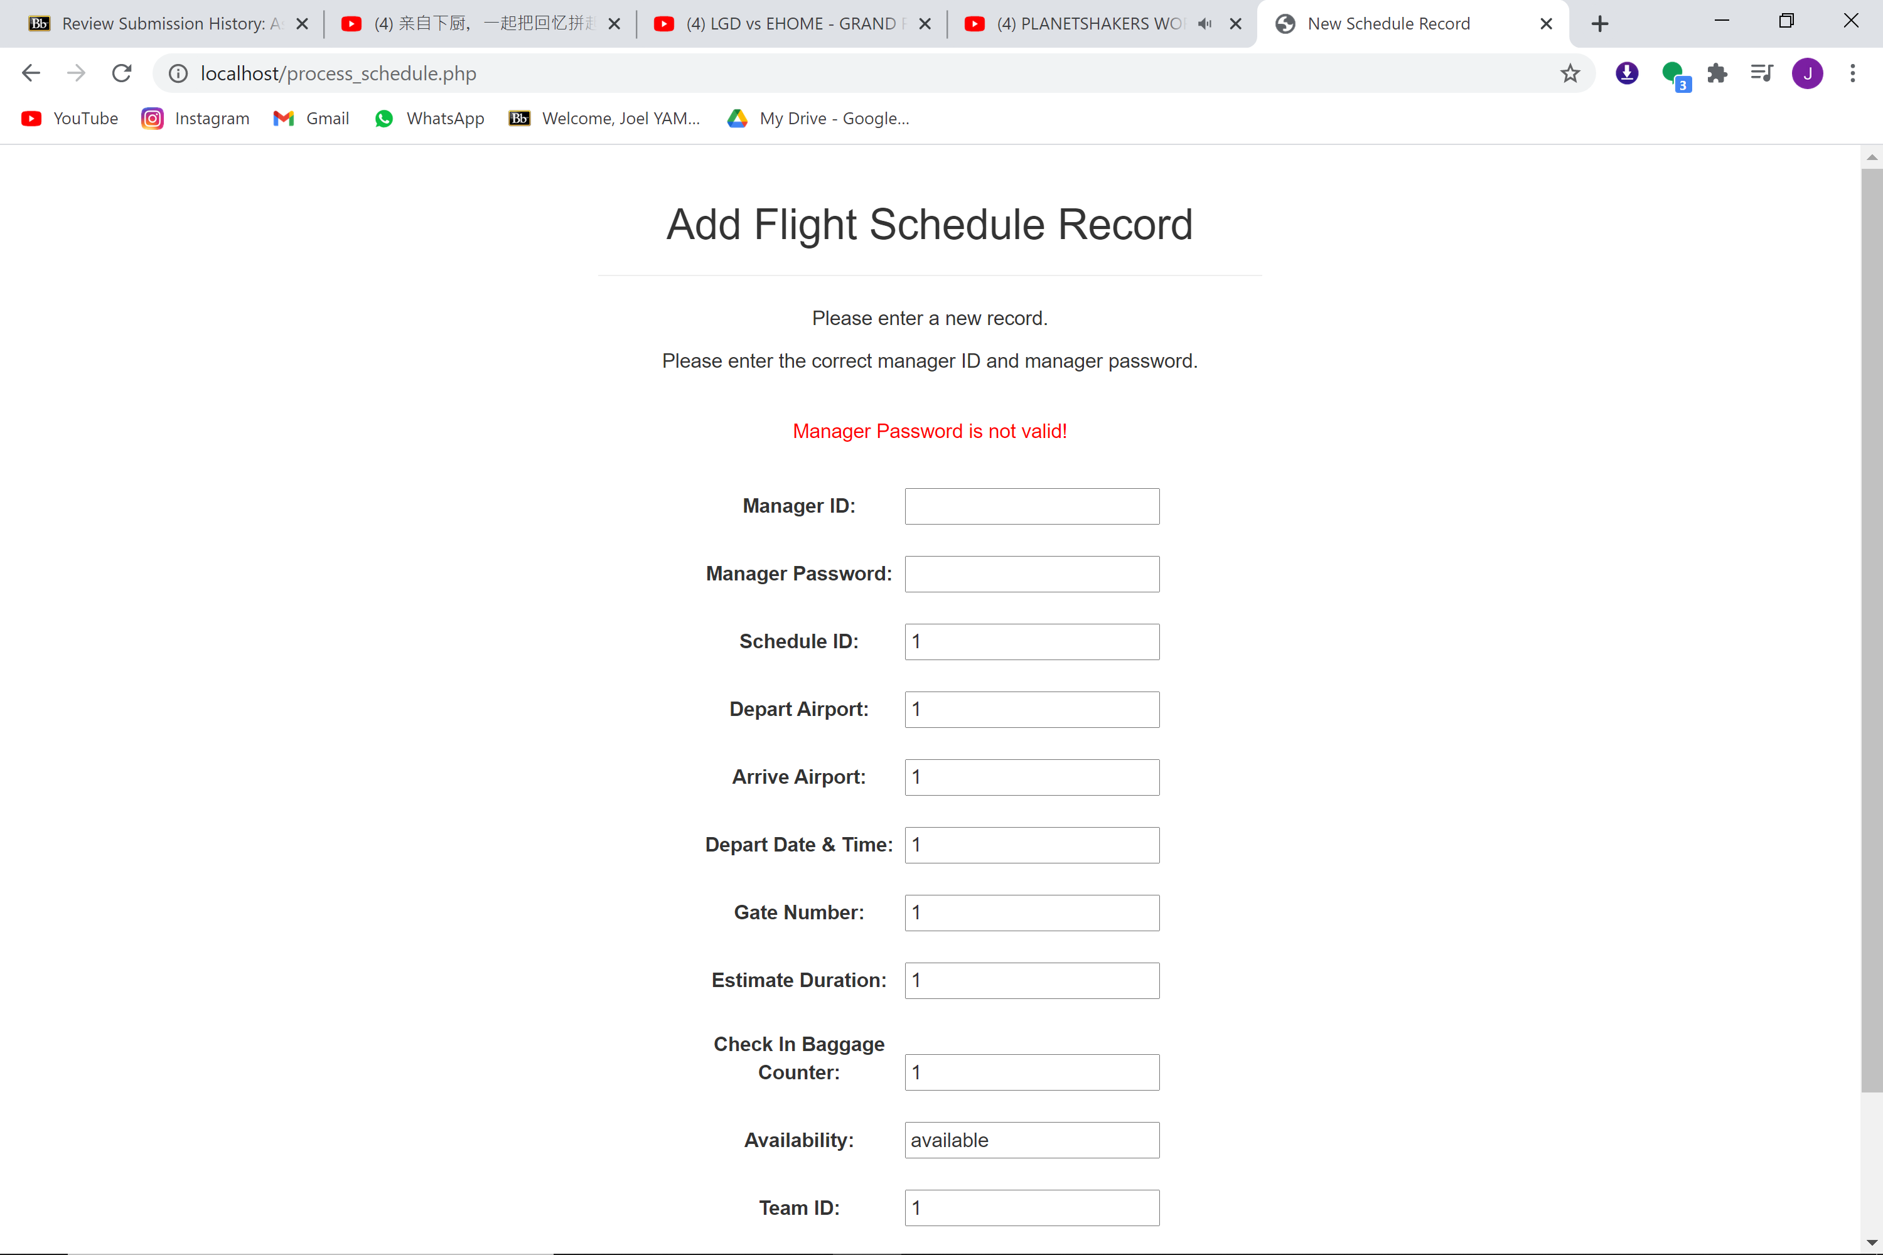

**Figure 13.8B** Wrong manager Password

Back in the home page (flight schedule record), there is a tab that can switched between two main pages. If I press on the Boarding Management, it will lead me to that page.

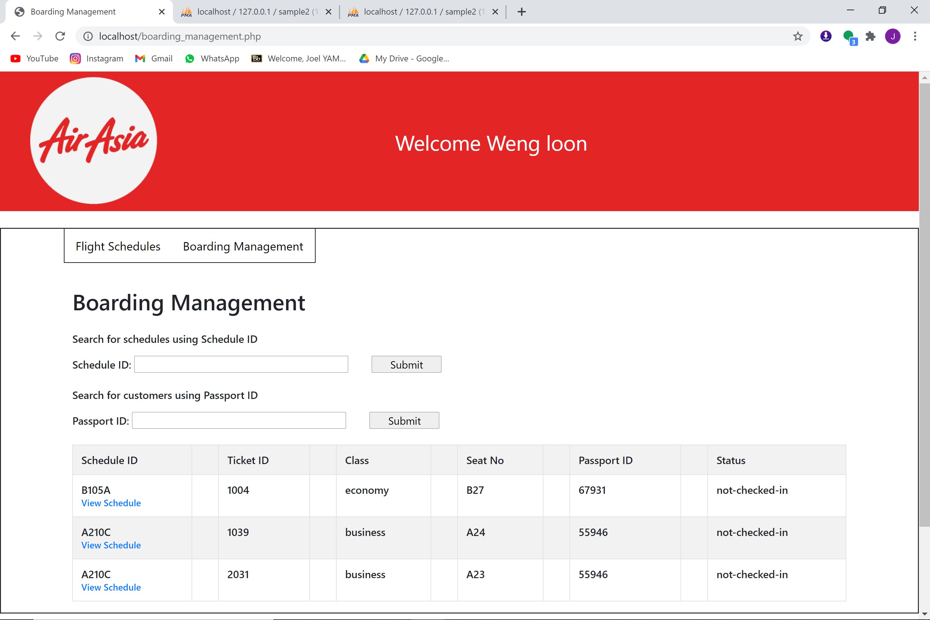

**Figure 14** Boarding Management page

In this Boarding Management page, Staff can search for specific schedule or customer using schedule ID and passport ID respectively. After they press search, the program will bring them to the search results as shown below.

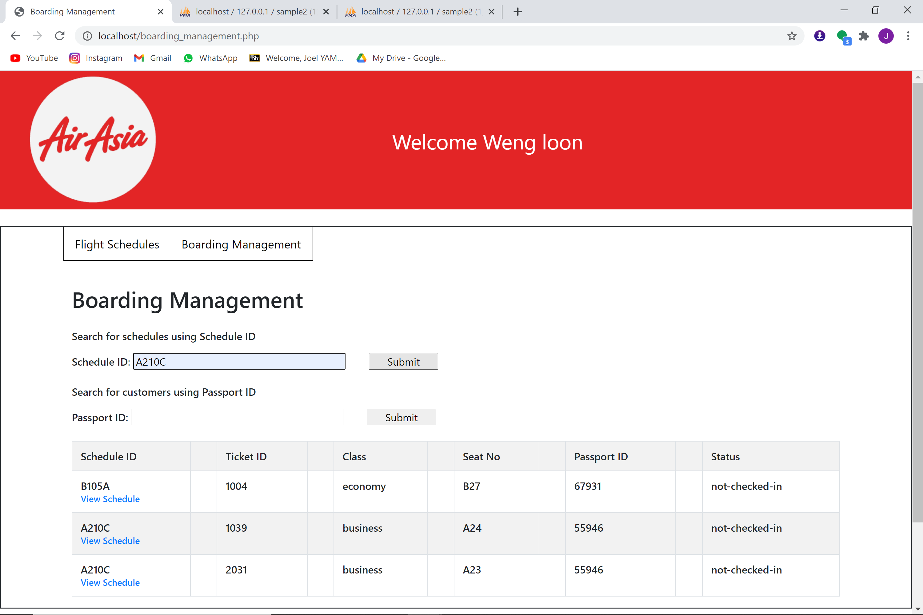

**Figure 14.2A** Search for specific schedule

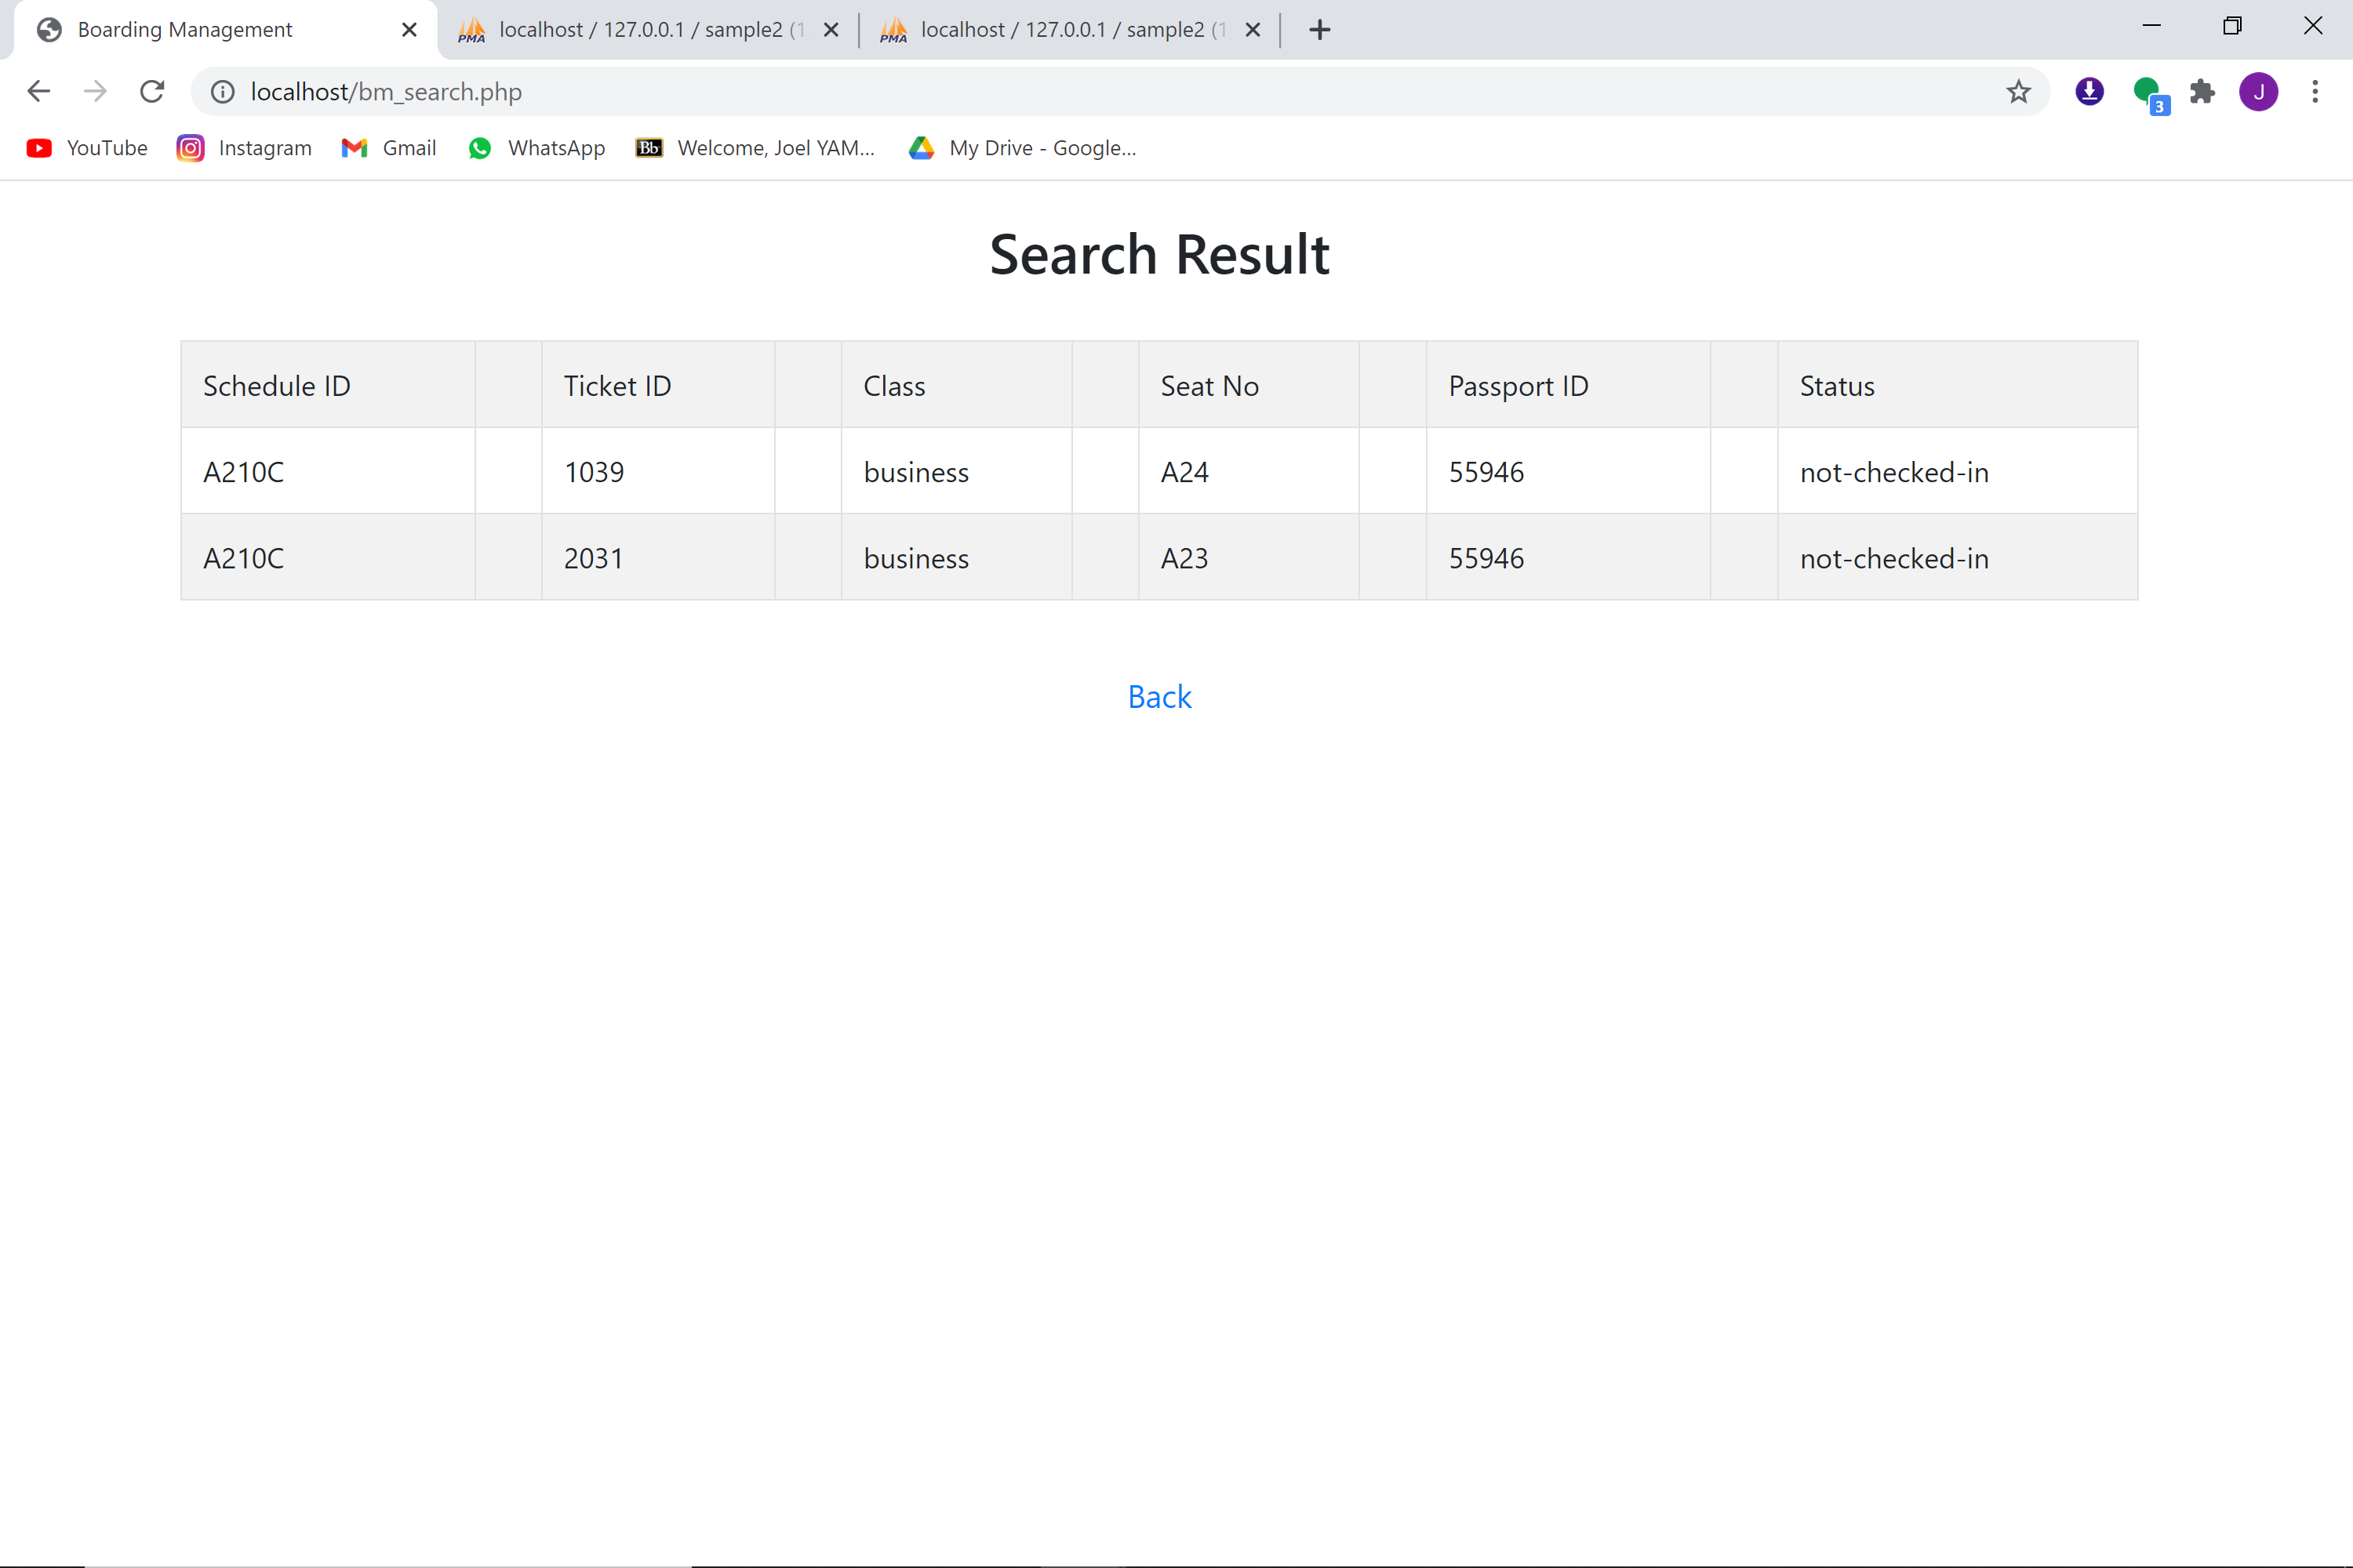

**Figure 14.2B** Schedule search result with a back button

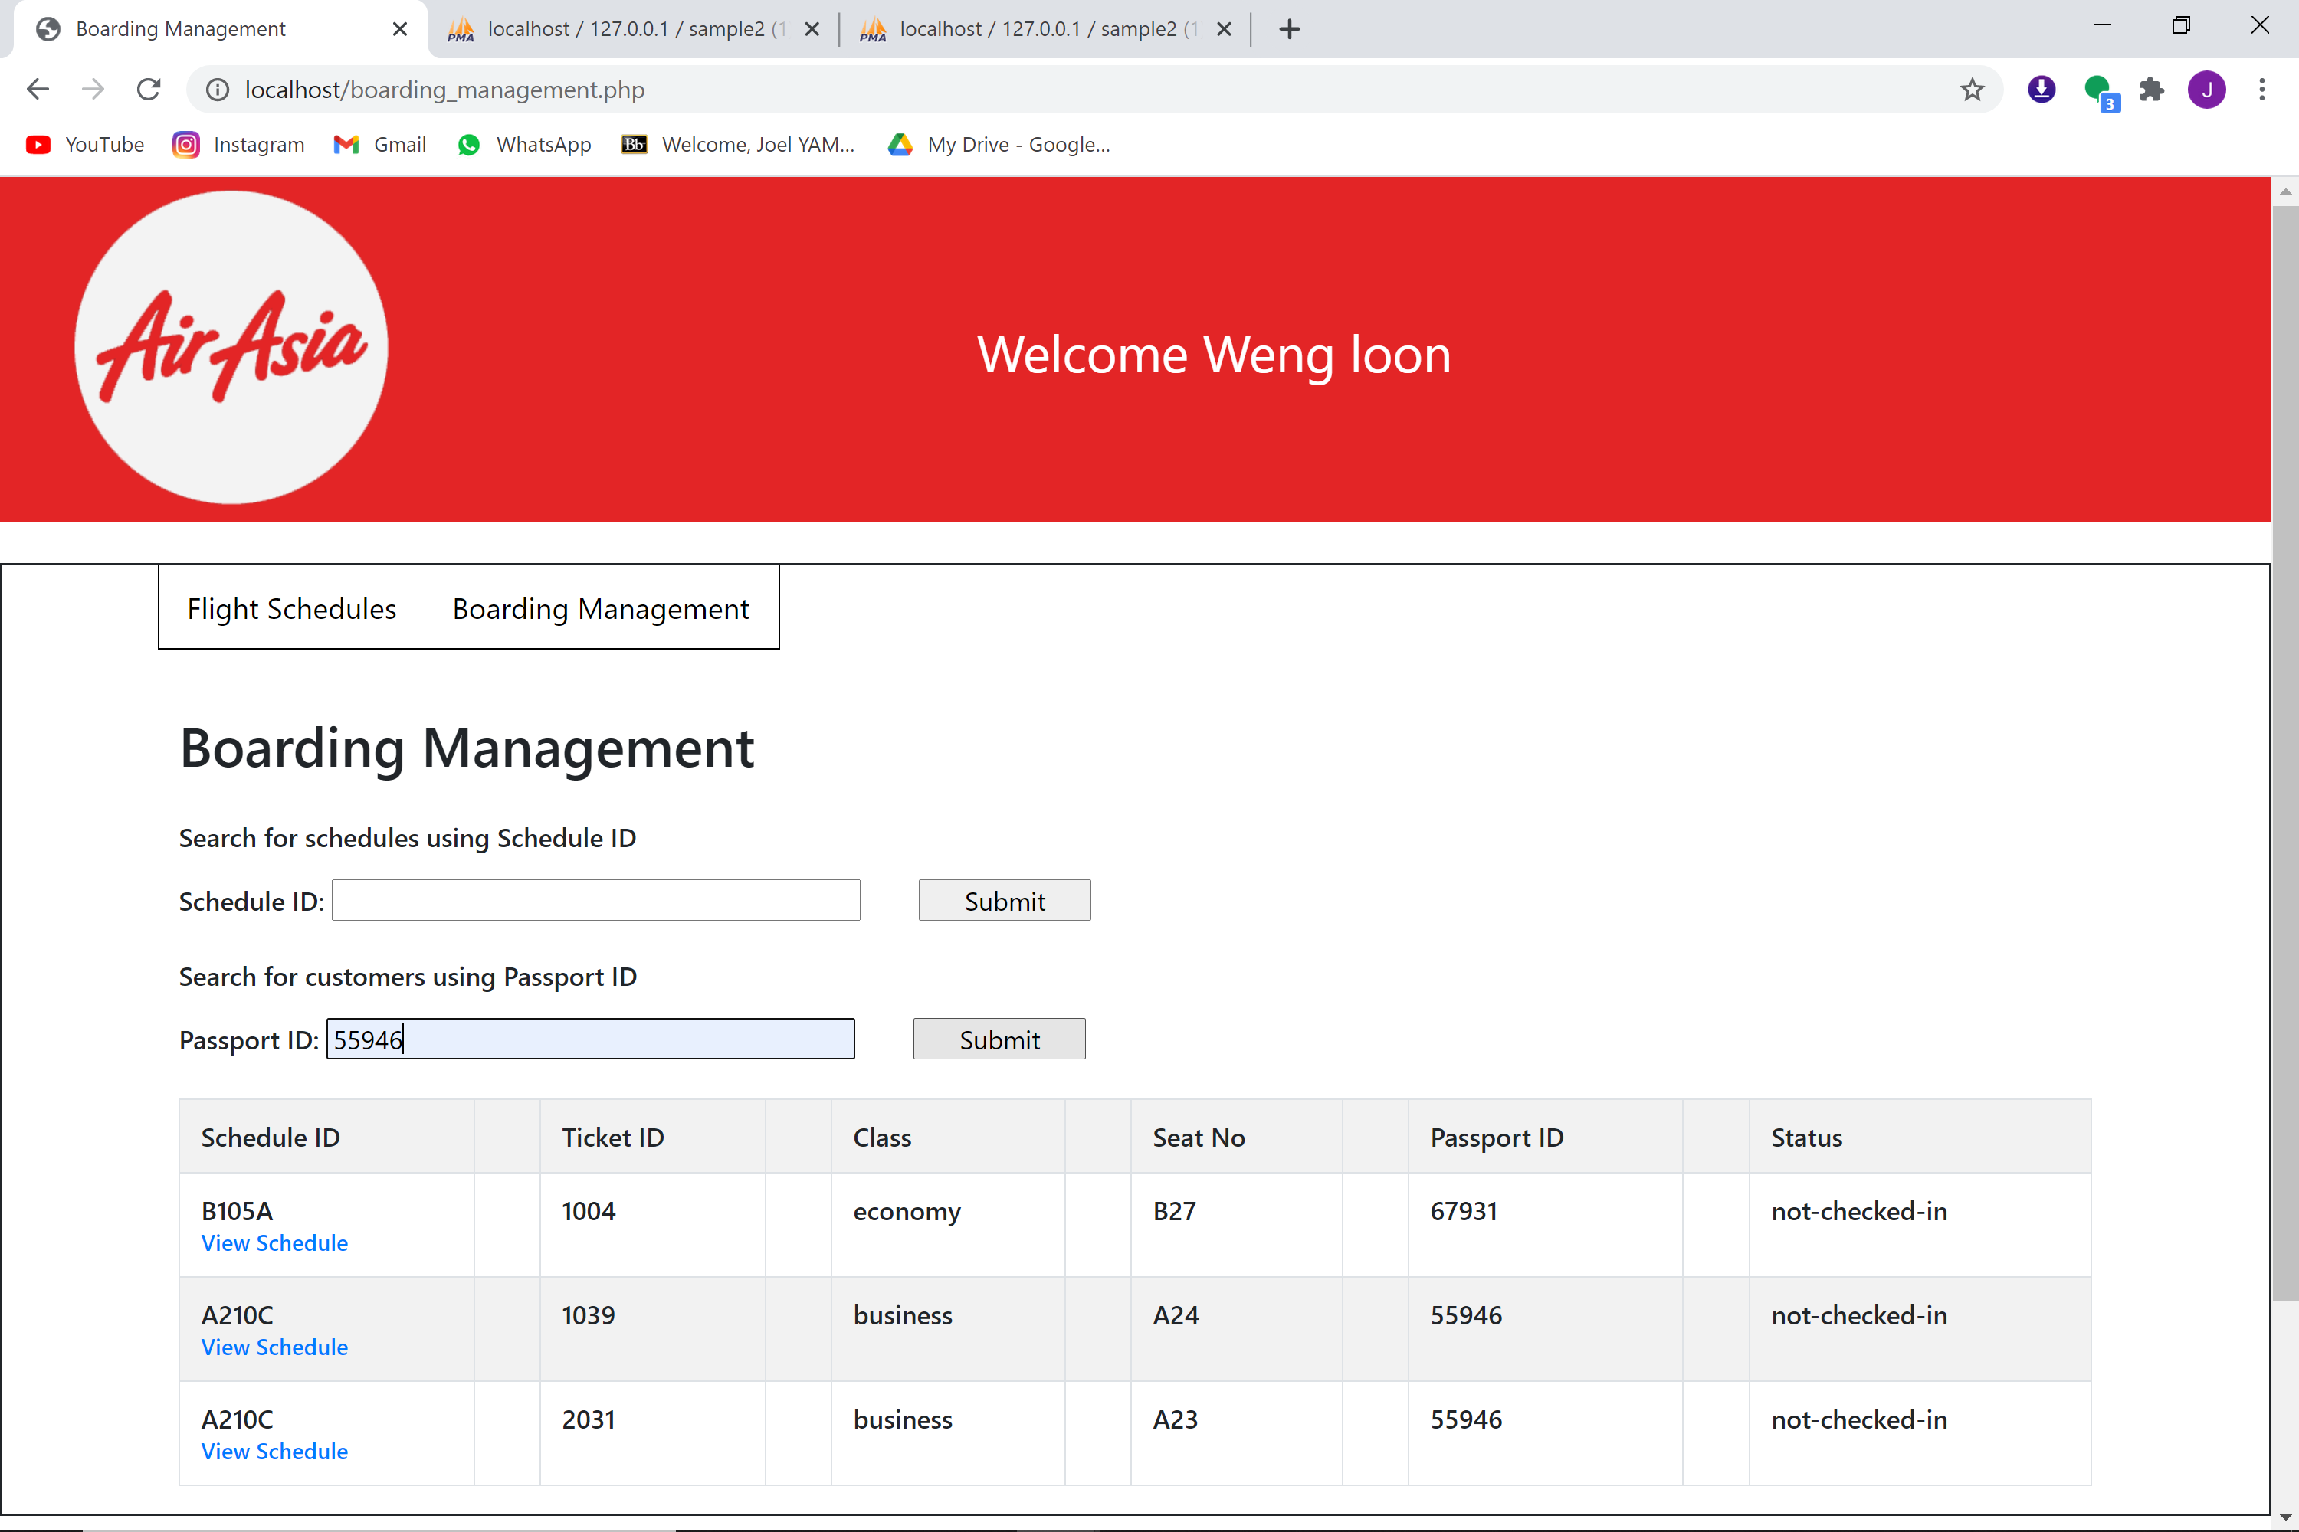

**Figure 14.3A** Search for specific customer

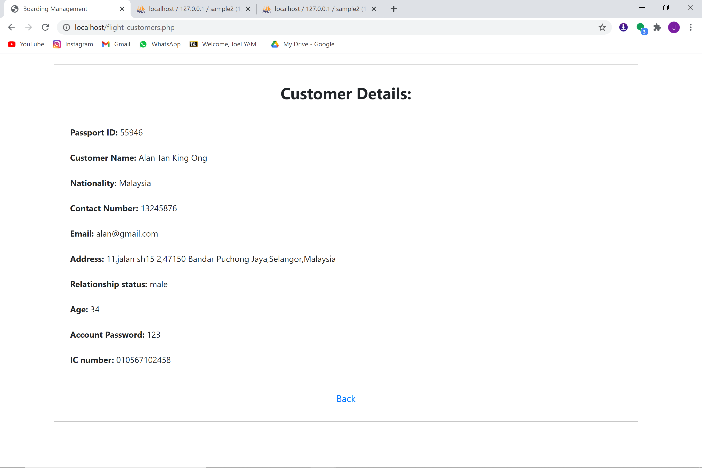

**Figure 14.3B** Customer search result with a back button

In the boarding management page, all the tickets bought by customers will be shown in a table. In the table, there is a “view schedule” button for staff to press, it will lead them to another page that shows all the details of the specific details in a table.

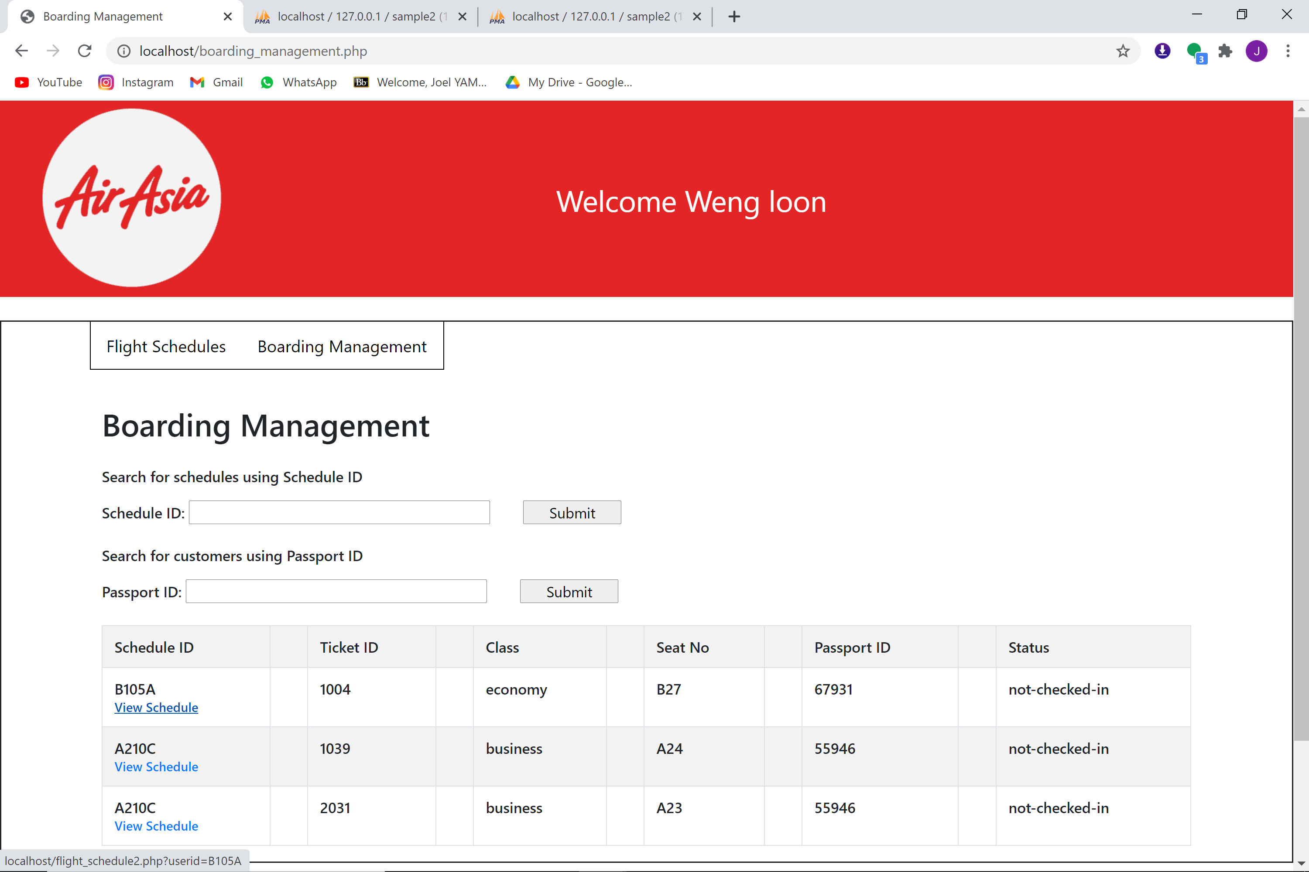

**Figure 14.4A** Boarding Management page

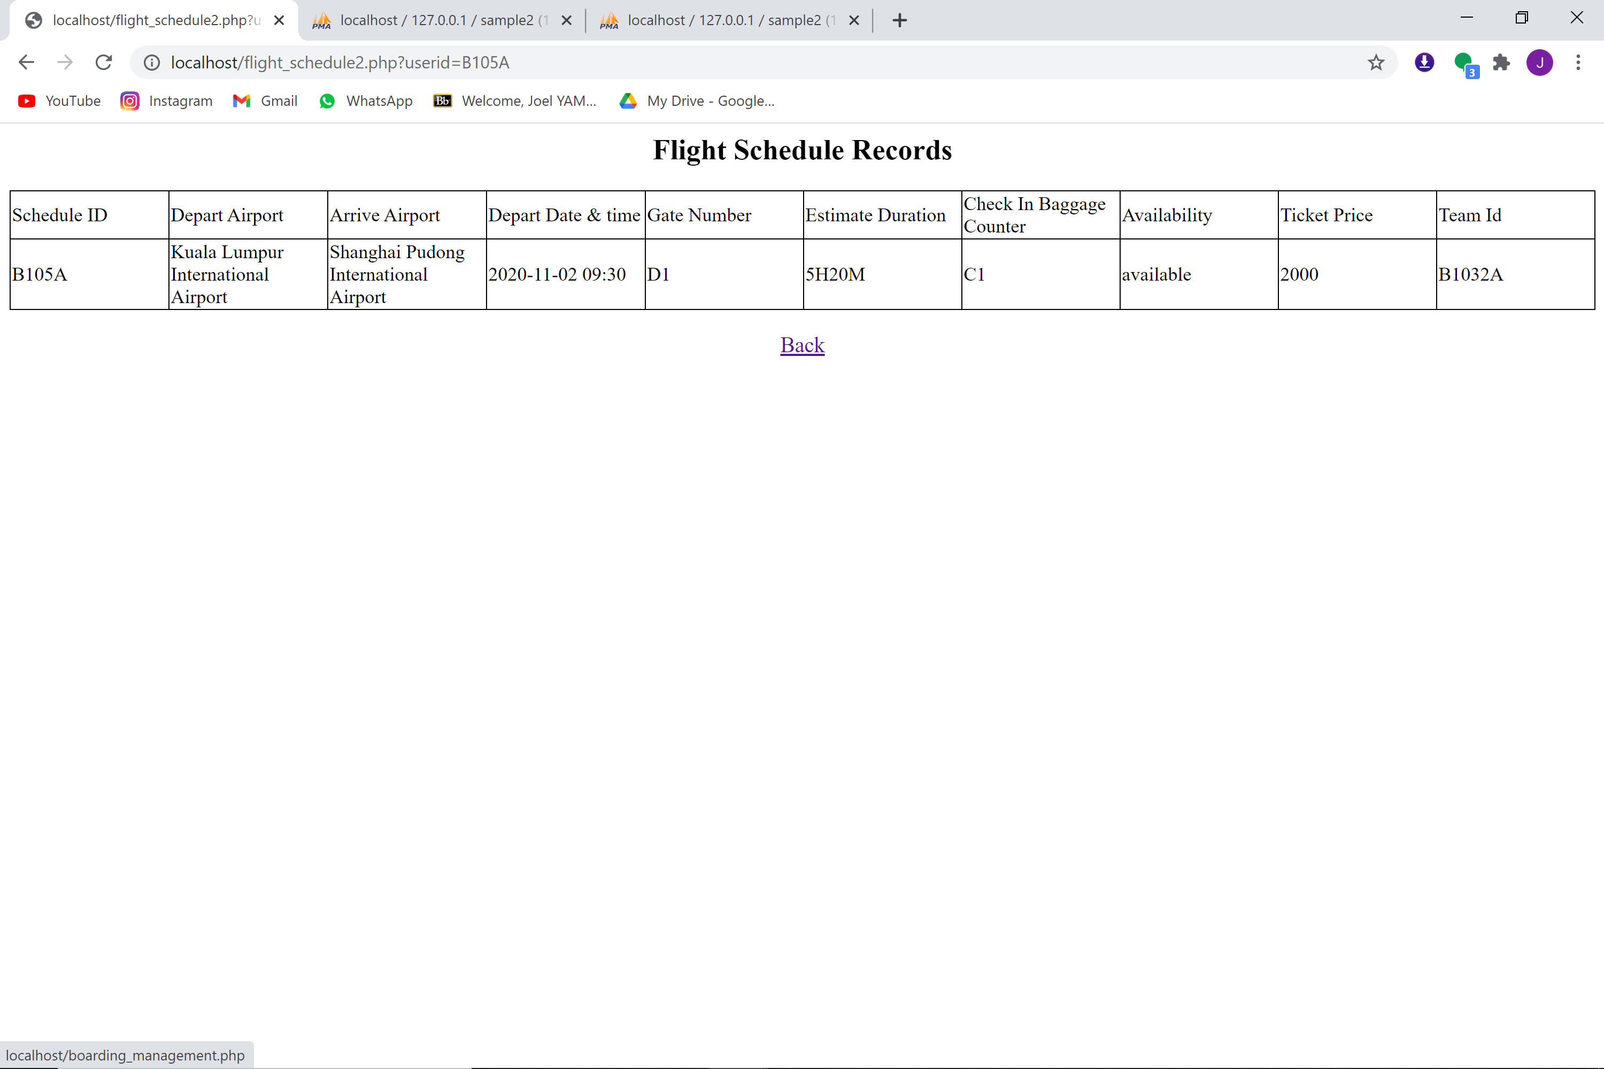

**Figure 14.4B** Specific schedule details with a back button

Lastly, there is a log out button for staffs at the bottom of the boarding management main page, it will bring them back to the sign in page.

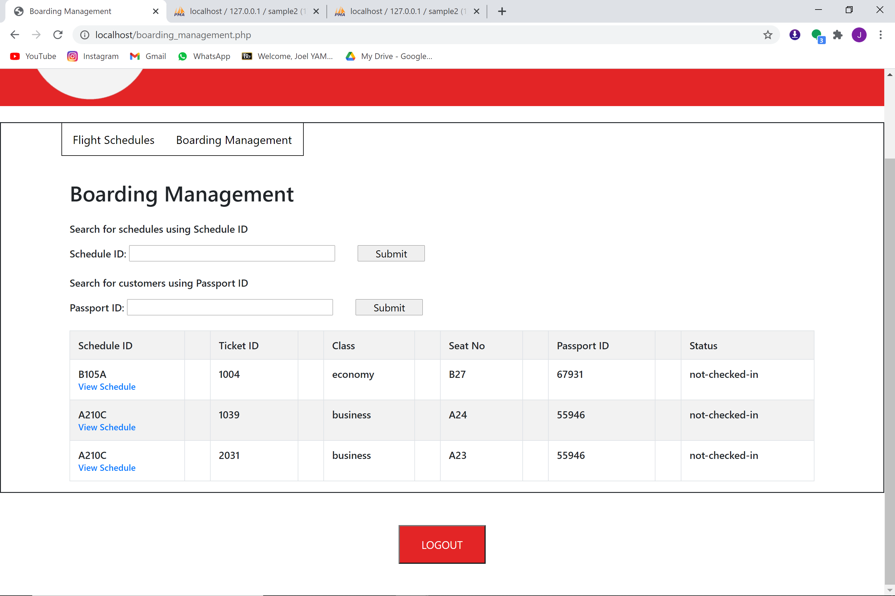

**Figure 14.5** Log out button

**Conclusion**

In conclusion, we just want to thank Mr.Tang for giving us this opportunity to complete this task together with our other group members. We truly learn a lot through the process of putting each lines of codes and pages of codes together and finally finish up with one completed program.

Through this experience, we learned more about php codes. Moreover, the teamwork between each group members is highly valued by each and every one of us.

Lastly, I also want to give thanks to all my group members for being participative to finish up this completed airline program together.

**Reference**

UKEssays.com. 2020. *Introduction To Air Asia Company*. [online] Available at: <https://www.ukessays.com/essays/tourism/introduction-to-air-asia-company-tourism-essay.php> [Accessed 27 November 2020].

**Appendices**

**Appendice A (index.html)**

<!-- Sign in page UI -->

<!DOCTYPE html>

<html>

<head>

<style>

body{

margin: 0;

padding: 0;

font-family: sans-serif;

background-image: url('3416459.jpg');

background-repeat: no-repeat;

background-attachment: fixed;

background-size: cover;

}

.loginbox{

width: 450px;

height: 450px;

background: #000;

color: #fff;

top:50%;

left:50%;

position: absolute;

transform: translate(-50%,-50%);

box-sizng: border-box;

}

.login-box{

position: absolute;

top: 18%;

left: 54%;

transform: translate(-50%,50%);

color: white;

}

.textbox{

width: 80%;

overflow: hidden;

font-size: 20px;

padding: 8px 0;

margin: 8px 0;

border-bottom: 1px solid #4caf50;

}

.textbox input{

border: none;

outline: none;

background: none;

color: white;

font-size: 18px;

width: 80%;

float: left;

margin: 0 10px;

}

btn{

width: 100%;

background: none;

border: 2px solid #4caf50;

color: white;

padding: 5px;

font-size: 18px;

cursor: pointer;

margin: 12px 0;

}

</style>

<title>AirAisia Login </title>

</head>

<body>

<div clss="login-box">

<form action="login (customer).php" method="post">

<div class="loginbox">

<h1 style="margin-top:90px"><center>Welcome to Airaisa </center></h1>

<div class="login-box">

<!-- For users to choose customer or staff account -->

<input type="radio" name="capital" value="customer">Customer

<input type="radio" name="capital" value="STAFF">Staff<br>

<!-- Input for ID and password -->

<div class="textbox">

<input type ="text" placeholder="Passport ID" name="username">

</div>

<div class="textbox">

<input type ="password" placeholder="Password" name="password">

</div>

<!-- Sign in button -->

<div class="textbox i">

<input type ="submit" name="submit" value="Sign in">

</div>

</form>

<a href="Signup.html" style="color:white">Need an account?</a>

</div>

</table>

</body>

</html>

**Appendice B (bm_search.php)**

<!DOCTYPE html>

<!-- Search result for schedule -->

<head>

<meta name="viewport" content="width=device-width, initial-scale=1, shrink-to-fit=no">

<title>Boarding Management</title>

<link rel="stylesheet" href="https://fonts.googleapis.com/css?family=Roboto|Varela+Round|Open+Sans">

<link rel="stylesheet" href="https://fonts.googleapis.com/icon?family=Material+Icons">

<link rel="stylesheet" href="https://stackpath.bootstrapcdn.com/bootstrap/4.3.1/css/bootstrap.min.css">

<script src="https://ajax.googleapis.com/ajax/libs/jquery/3.3.1/jquery.min.js"></script>

<script src="https://stackpath.bootstrapcdn.com/bootstrap/4.3.1/js/bootstrap.min.js"></script>

<style type="text/css">

.bs-example{

margin: 20px 20px 0 0;

}

.box{

max-width:100%;

padding:30px;

border:1px solid black;

margin: auto;

}

</style>

<script type="text/javascript">

$(document).ready(function(){

$('[data-toggle="tooltip"]').tooltip();

});

</script>

</head>

<body>

<div class="bs-example">

<div class="container">

<div class="row">

<div class="col-md-12">

<div class="page-header clearfix">

</div>

<?php

//store the selected schedule ID in a variable

$scheduleid = $_POST["scheduleid"];

$conn = mysqli_connect("localhost", "root", "", "sample2 (1)");

// Check connection

if ($conn->connect_error) {

die("Connection failed: " . $conn->connect_error);

}

else {

//query all data from flight_tickets that matches the selected schedule ID

$result = mysqli_query($conn,"SELECT * FROM flight_tickets WHERE Schedule_ID='$scheduleid'");

?>

<?php

if (mysqli_num_rows($result) > 0) {

?>

<!-- Display the data in a table -->

<h2 style="text-align:center">Search Result</h2> <br>

<table class='table table-bordered table-striped'>

<tr>

<td>Schedule ID </td><td>

<td>Ticket ID</td><td>

<td>Class</td><td>

<td>Seat No</td><td>

<td>Passport ID</td><td>

<td>Status</td>

</tr>

<?php

$i=0;

while($row = mysqli_fetch_array($result)) {

?>

<tr>

<td><?php echo $row["Schedule_ID"]; ?> </td><td>

<td><?php echo $row["Ticket_ID"]; ?></td><td>

<td><?php echo $row["Class"]; ?></td><td>

<td><?php echo $row["Seat_No"]; ?></td><td>

<td><?php echo $row["Passport_ID"]; ?></td><td>

<td><?php echo $row["Status"]; ?></td>

</tr>

<?php

$i++;

}

?>

</table><br>

<!-- Back button -->

<div style="text-align:center">

<a href="boarding_management.php" style="font-size:18px">Back</a>

</div>

<?php

}

else{

//If the schedule ID is not in the database, display error message

echo "<div class='box'>";

echo "<div style='text-align:center;font-size:30px'><b> No results found! </b></div><br><br>";

?>

<div style="text-align:center">

<a href="boarding_management.php" style="font-size:18px">Back</a>

</div>

</div>

<?php

}

}

?>

</div>

</div>

</div>

</div>

</body>

</html>

**Appendice C (boarding_management.php)**

<html>

<body>

<style>

p2 {

position: absolute;

margin-left:20px;

top: 8px;

right: 10px;

font-size: 18px;

color:white;

}

p3 {

font-size: 30px;

color:#e32526;

margin-left:20px;

}p4{

font-size: 15px;

margin-left:20px;

}

p5 {

text-align: center;

font-size: 30px;

color:#e32526;

margin-left:20px;

}

.header {

background: #e32526;

}

</style>

<div class="header">

<img src="AirAsia_logo.png" alt="Airasia Logo" width:"200" height="200">

</div>

<form action="purchase3.php" method="POST">

<h1 style="font-size:40px;color:#e32526;"><center> Confirmation Page </center></h1>

<p2><b><?php

date_default_timezone_set("Asia/Kuala_Lumpur");

$date=date('Y/m/d h:ia');

echo "Today's Date & Time: ".$date;

?></b></p2>

<table style="margin-left:20px">

<?php

// Using POST method to get data from previous page which is purchase.php

$ic=$_POST["IC_Number"];

$name=$_POST["Cust_Name"];

// Display IC Number and Name

echo "<tr><td><b>IC Number: </td></b><td>$ic</td></tr>";

echo "<tr><td><b>Name: </td></b><td>$name</td></tr>";

$seat=$_POST["seat"];

// Connect to Database

$conn = new mysqli("localhost", "root", "", "sample2 (1)");

if ($conn->connect_error) {

die("Connection failed: " . $conn->connect_error);

}

// Session Started to store data

session_start();

$_SESSION["date"]=$date;

$passport=$_SESSION["Passport_ID"];

echo "<tr><td><b>Passport ID: </td></b><td>$passport</td></tr>";

$id=$_SESSION["schedule_ID"];

$depart=$_SESSION["depart_airport"];

$arrive=$_SESSION["arrive_airport"];

echo "<tr><td><b>Depart from: </td></b><td>$depart</td></tr>";

echo "<tr><td><b>Arrive at: </td></b><td>$arrive</td></tr>";

// Use the function of randomize number to create ticket ID

$fourRandomDigit = rand(0,9999);

echo "<br><br><p3>Ticket ID: ".$fourRandomDigit."</p3>";

echo "<tr><td><b>Purchase Date & Time: </td></b><td>$date</td></tr>";

$conn = mysqli_connect("localhost","root","","sample2 (1)");

if($conn==false) echo " No database Connected. ";

// Find the same Schedule ID from the Database

$result= mysqli_query($conn,"SELECT * FROM flight_schedule WHERE Schedule_ID = '$id'");

// If there is same Schedule ID from the Database then display the Estimate Duration

while($row = mysqli_fetch_array($result))

{

echo "<tr><td><b> Estimate Duration: </b> </td><td>".$row['est_duration']."</td> </tr> ";

}

// Connection of Database Closed

$conn->close();

// If user choose Business Class from the previous page

if(isset($_POST["business"])){

$conn = mysqli_connect("localhost","root","","sample2 (1)");

if($conn==false) echo " No database Connected. ";

$result= mysqli_query($conn,"SELECT * FROM flight_schedule WHERE Schedule_ID LIKE '%{$id}%'");

// Display ticket price from the database and add another RM500 for business class

while($row = mysqli_fetch_array($result))

{

$totalprice=$row['ticket_price']+500;

}

$conn->close();

$class = "Business Class" ;

echo "<tr><td><b>Type of Class: </td></b><td>$class</td></tr><br>";

// If user choose economy class from the previous page

}else if(isset($_POST["economy"])){

$conn = mysqli_connect("localhost","root","","sample2 (1)");

if($conn==false) echo " No database Connected. ";

$result= mysqli_query($conn,"SELECT * FROM flight_schedule WHERE Schedule_ID LIKE '%{$id}%'");

// Display the ticket price

while($row = mysqli_fetch_array($result))

{

$totalprice=$row['ticket_price'];

}

// Connection of Database Closed.

$conn->close();

// Displaying the data of economy class

$class = "Economy Class" ;

echo "<tr><td><b>Type of Class: </td></b><td>$class</td></tr><br>";

}else{

// If user didnt choose any class it will be shows no class selected.

echo " No Class Selected ";

}

$_SESSION["ticketprice"]=$totalprice;

// Display Seat ID

echo "<tr><td><b>Seat ID: </td></b><td>$seat</td></tr><br>";

// If user choose Online Banking from the previous page then Display Online Banking

if(isset($_POST["online"])){

$payment = "Online Banking " ;

echo "<tr><td><b>Payment Option: </td></b><td>$payment</td></tr><br>";

// If user choose Pay by Card from the previous page then Display Credit / Debit Card

}else if(isset($_POST["card"])){

$payment = "Credit / Debit Card" ;

echo "<tr><td><b>Payment Option: </td></b><td>$payment</td></tr><br>";

}else{

echo " No Payment Selected ";

}

echo"</table>";

echo "<br><br><p5>Total Price: RM".$totalprice."</p5>";

// Store All of the Data to Session

$_SESSION["Digit"]=$fourRandomDigit;

$_SESSION["Class"]=$class;

$_SESSION["Seat"]=$seat;

$_SESSION["TotalPrice"]=$totalprice;

$_SESSION["Payment"]=$payment;

$_SESSION["IC"]=$ic;

$_SESSION["Name"]=$name;

?>

<br>

<br>

<a href="Homepage.php" style="text-decoration:none; color: white;text-align: center;padding: 15px 32px;background-color: #e32526;">CANCEL</a>

<button style="border:none;color: white;text-align: center;padding: 17px 34px;background-color: #e32526;">CONFIRM</button>

</form>

</body>

</html>

**Appendice D (checkin.php)**

<!DOCTYPE html>

<!-- Check in page that shows all the ticket details -->

<head>

<meta name="viewport" content="width=device-width, initial-scale=1, shrink-to-fit=no">

<title>Check In</title>

<link rel="stylesheet" href="https://fonts.googleapis.com/css?family=Roboto|Varela+Round|Open+Sans">

<link rel="stylesheet" href="https://fonts.googleapis.com/icon?family=Material+Icons">

<link rel="stylesheet" href="https://stackpath.bootstrapcdn.com/bootstrap/4.3.1/css/bootstrap.min.css">

<script src="https://ajax.googleapis.com/ajax/libs/jquery/3.3.1/jquery.min.js"></script>

<script src="https://stackpath.bootstrapcdn.com/bootstrap/4.3.1/js/bootstrap.min.js"></script>

<style type="text/css">

.bs-example{

margin: 20px 20px 0 0;

}

.box{

max-width:100%;

padding:30px;

border:1px solid black;

margin: auto;

}

</style>

<script type="text/javascript">

$(document).ready(function(){

$('[data-toggle="tooltip"]').tooltip();

});

</script>

</head>

<body>

<div class="bs-example">

<div class="container">

<div class="row">

<div class="col-md-12">

<div class="page-header clearfix">

<div class="box">

<?php

//store the selected schedule id and ticket id in two variables

$scheduleid = $_GET ['scheduleid'];

$ticketid = $_GET ['ticketid'];

$conn = mysqli_connect("localhost", "root", "", "sample2 (1)");

// Check connection

if ($conn->connect_error) {

die("Connection failed: " . $conn->connect_error);

}

//Display the selected data from flight tickets

$result2 = mysqli_query($conn,"SELECT * FROM flight_tickets WHERE Ticket_ID='$ticketid'");

if (mysqli_num_rows($result2) > 0) {

echo "<p align=center style='font-size:30px'><b>Check in Details:</b></p><br>";

while($row=mysqli_fetch_array($result2)) {

echo "<b>Ticket ID: </b>".$row['Ticket_ID']."<br><br>";

echo "<b>Name: </b>".$row['Full_name']."<br><br>";

echo "<b>IC number: </b>".$row['IC_number']."<br><br>";

echo "<b>Class: </b>".$row['Class']."<br><br>";

echo "<b>Seat Number: </b>".$row['Seat_No']."<br><br>";

}

}

//Display the selected data from flight schedule

$result = mysqli_query($conn,"SELECT * FROM flight_schedule WHERE Schedule_ID='$scheduleid'");

if (mysqli_num_rows($result) > 0) {

while($row=mysqli_fetch_array($result)) {

echo "<b>Depart airport: </b>".$row['depart_airport']."<br><br>";

echo "<b>Arrive airport: </b>".$row['arrive_airport']."<br><br>";

echo "<b>Depart date and time: </b>".$row['depart_datetime']."<br><br>";

echo "<b>Gate number: </b>".$row['gate_no']."<br><br>";

echo "<b>Est duration: </b>".$row['est_duration']."<br><br>";

echo "<b>Check in baggage counter: </b>".$row['CheckinBaggage_counter']."<br><br>";

}

}

?>

<br>

<!-- Confirm check in Button -->

<a href="checkinCompleted.php?ticketid=<?php echo $ticketid;?>" style="text-decoration:none; color:white;position:absolute;right:50px;bottom:20;

text-align: center;padding: 15px 32px;background-color: #e32526;">Check In Now</a>

<!-- Back button -->

<a href="purchasedtickets.php" style="text-decoration:none; color:white;position:absolute;bottom:20;text-align:center;padding: 15px 32px;background-color: #e32526;">BACK</a>

<br>

</table><br>

</div>

</div>

</div>

</div>

</div>

</div>

</body>

</html>

**Appendice E (checkinCompleted.php)**

<html>

<body>

<style>

p2 {

position: absolute;

margin-left:20px;

top: 8px;

right: 10px;

font-size: 18px;

color:white;

}

p3 {

font-size: 30px;

color:#e32526;

margin-left:20px;

}p4{

font-size: 15px;

margin-left:20px;

}

p5 {

text-align: center;

font-size: 30px;

color:#e32526;

margin-left:20px;

}

.header {

background: #e32526;

}

</style>

<div class="header">

<img src="AirAsia_logo.png" alt="Airasia Logo" width:"200" height="200">

</div>

<form action="purchase3.php" method="POST">

<h1 style="font-size:40px;color:#e32526;"><center> Confirmation Page </center></h1>

<p2><b><?php

date_default_timezone_set("Asia/Kuala_Lumpur");

$date=date('Y/m/d h:ia');

echo "Today's Date & Time: ".$date;

?></b></p2>

<table style="margin-left:20px">

<?php

// Using POST method to get data from previous page which is purchase.php

$ic=$_POST["IC_Number"];

$name=$_POST["Cust_Name"];

// Display IC Number and Name

echo "<tr><td><b>IC Number: </td></b><td>$ic</td></tr>";

echo "<tr><td><b>Name: </td></b><td>$name</td></tr>";

$seat=$_POST["seat"];

// Connect to Database

$conn = new mysqli("localhost", "root", "", "sample2 (1)");

if ($conn->connect_error) {

die("Connection failed: " . $conn->connect_error);

}

// Session Started to store data

session_start();

$_SESSION["date"]=$date;

$passport=$_SESSION["Passport_ID"];

echo "<tr><td><b>Passport ID: </td></b><td>$passport</td></tr>";

$id=$_SESSION["schedule_ID"];

$depart=$_SESSION["depart_airport"];

$arrive=$_SESSION["arrive_airport"];

echo "<tr><td><b>Depart from: </td></b><td>$depart</td></tr>";

echo "<tr><td><b>Arrive at: </td></b><td>$arrive</td></tr>";

// Use the function of randomize number to create ticket ID

$fourRandomDigit = rand(0,9999);

echo "<br><br><p3>Ticket ID: ".$fourRandomDigit."</p3>";

echo "<tr><td><b>Purchase Date & Time: </td></b><td>$date</td></tr>";

$conn = mysqli_connect("localhost","root","","sample2 (1)");

if($conn==false) echo " No database Connected. ";

// Find the same Schedule ID from the Database

$result= mysqli_query($conn,"SELECT * FROM flight_schedule WHERE Schedule_ID = '$id'");

// If there is same Schedule ID from the Database then display the Estimate Duration

while($row = mysqli_fetch_array($result))

{

echo "<tr><td><b> Estimate Duration: </b> </td><td>".$row['est_duration']."</td> </tr> ";

}

// Connection of Database Closed

$conn->close();

// If user choose Business Class from the previous page

if(isset($_POST["business"])){

$conn = mysqli_connect("localhost","root","","sample2 (1)");

if($conn==false) echo " No database Connected. ";

$result= mysqli_query($conn,"SELECT * FROM flight_schedule WHERE Schedule_ID LIKE '%{$id}%'");

// Display ticket price from the database and add another RM500 for business class

while($row = mysqli_fetch_array($result))

{

$totalprice=$row['ticket_price']+500;

}

$conn->close();

$class = "Business Class" ;

echo "<tr><td><b>Type of Class: </td></b><td>$class</td></tr><br>";

// If user choose economy class from the previous page

}else if(isset($_POST["economy"])){

$conn = mysqli_connect("localhost","root","","sample2 (1)");

if($conn==false) echo " No database Connected. ";

$result= mysqli_query($conn,"SELECT * FROM flight_schedule WHERE Schedule_ID LIKE '%{$id}%'");

// Display the ticket price

while($row = mysqli_fetch_array($result))

{

$totalprice=$row['ticket_price'];

}

// Connection of Database Closed.

$conn->close();

// Displaying the data of economy class

$class = "Economy Class" ;

echo "<tr><td><b>Type of Class: </td></b><td>$class</td></tr><br>";

}else{

// If user didnt choose any class it will be shows no class selected.

echo " No Class Selected ";

}

$_SESSION["ticketprice"]=$totalprice;

// Display Seat ID

echo "<tr><td><b>Seat ID: </td></b><td>$seat</td></tr><br>";

// If user choose Online Banking from the previous page then Display Online Banking

if(isset($_POST["online"])){

$payment = "Online Banking " ;

echo "<tr><td><b>Payment Option: </td></b><td>$payment</td></tr><br>";

// If user choose Pay by Card from the previous page then Display Credit / Debit Card

}else if(isset($_POST["card"])){

$payment = "Credit / Debit Card" ;

echo "<tr><td><b>Payment Option: </td></b><td>$payment</td></tr><br>";

}else{

echo " No Payment Selected ";

}

echo"</table>";

echo "<br><br><p5>Total Price: RM".$totalprice."</p5>";

// Store All of the Data to Session

$_SESSION["Digit"]=$fourRandomDigit;

$_SESSION["Class"]=$class;

$_SESSION["Seat"]=$seat;

$_SESSION["TotalPrice"]=$totalprice;

$_SESSION["Payment"]=$payment;

$_SESSION["IC"]=$ic;

$_SESSION["Name"]=$name;

?>

<br>

<br>

<a href="Homepage.php" style="text-decoration:none; color: white;text-align: center;padding: 15px 32px;background-color: #e32526;">CANCEL</a>

<button style="border:none;color: white;text-align: center;padding: 17px 34px;background-color: #e32526;">CONFIRM</button>

</form>

</body>

</html>

**Appendice F (custViewSchedule.php)**

<!DOCTYPE html>

<!-- View schedule for customers that wants to check in -->

<head>

<meta name="viewport" content="width=device-width, initial-scale=1, shrink-to-fit=no">

<title>Schedule details</title>

<link rel="stylesheet" href="https://fonts.googleapis.com/css?family=Roboto|Varela+Round|Open+Sans">

<link rel="stylesheet" href="https://fonts.googleapis.com/icon?family=Material+Icons">

<link rel="stylesheet" href="https://stackpath.bootstrapcdn.com/bootstrap/4.3.1/css/bootstrap.min.css">

<script src="https://ajax.googleapis.com/ajax/libs/jquery/3.3.1/jquery.min.js"></script>

<script src="https://stackpath.bootstrapcdn.com/bootstrap/4.3.1/js/bootstrap.min.js"></script>

<style type="text/css">

.bs-example{

margin: 20px 20px 0 0;

}

.box{

max-width:100%;

padding:30px;

border:1px solid black;

margin: auto;

}

</style>

<script type="text/javascript">

$(document).ready(function(){

$('[data-toggle="tooltip"]').tooltip();

});

</script>

</head>

<body>

<div class="bs-example">

<div class="container">

<div class="row">

<div class="col-md-12">

<div class="page-header clearfix">

<div class="box">

<?php

//store the selected schedule ID in a variable

$scheduleid = $_GET["scheduleid"];

$conn = mysqli_connect("localhost", "root", "", "sample2 (1)");

// Check connection

if ($conn->connect_error) {

die("Connection failed: " . $conn->connect_error);

}

//query all data from flight schedule that matches the selected schedule id

$result = mysqli_query($conn,"SELECT * FROM flight_schedule WHERE Schedule_ID='$scheduleid'");

?>

<?php

//Display all the data

if (mysqli_num_rows($result) > 0) {

echo "<p align=center style='font-size:30px'><b>Schedule Details:</b></p><br>";

while($row=mysqli_fetch_array($result)) {

echo "<b>Depart airport: </b>".$row['depart_airport']."<br><br>";

echo "<b>Arrive airport: </b>".$row['arrive_airport']."<br><br>";

echo "<b>Depart date and time: </b>".$row['depart_datetime']."<br><br>";

echo "<b>Gate number: </b>".$row['gate_no']."<br><br>";

echo "<b>Est duration: </b>".$row['est_duration']."<br><br>";

echo "<b>Check in baggage counter: </b>".$row['CheckinBaggage_counter']."<br><br>";

}

?>

</table><br>

<!-- Back button -->

<div style="text-align:center">

<a href="purchasedtickets.php" style="font-size:18px">Back</a>

</div>

<?php

}

else {

//If the schedule ID is not in the database, display error message

echo "<div style='text-align:center;font-size:30px'><b> No results found! </b></div><br><br>";

?>

<div style="text-align:center">

<a href="purchasedtickets.php" style="font-size:18px">Back</a>

</div>

<?php

}

?>

</div>

</div>

</div>

</div>

</div>

</div>

</body>

</html>

**Appendice G (delete_schedule.php)**

<!-- PHP codes to delete desired schedule from database -->

<html>

<head>

<style>

a {

text-decoration: none;

}

.box{

max-width:100%;

padding:30px;

border:1px solid black;

margin: auto;

}

</style>

</head>

<body>

<?php

session_start ();

$conn=mysqli_connect("localhost", "admin", null, "sample2 (1)");

$manID = $_POST ['manager_id'];

$manPass = $_POST ['manager_password'];

$idsearch = "SELECT Manager_ID FROM manager WHERE Manager_ID = '$manID'";

$result1=mysqli_query($conn, $idsearch);

//if else to check the validity of manager ID

if(mysqli_num_rows($result1)>0) {

$passsearch = "SELECT Password FROM manager WHERE Password = '$manPass'";

$result2=mysqli_query($conn, $passsearch);

//if else to check the validity of manager Password

if(mysqli_num_rows($result2)>0) {

// session's data is saved in a variable

$scheduleid = $_SESSION ['scheduleid'];

//delete schedule from database

$query="delete from flight_schedule where Schedule_ID='$scheduleid'";

$result=mysqli_query($conn, $query);

?>

<div class='box'>

<!-- Message shown for deleted schedule -->

<div style='text-align:center;font-size:30px'><b>Schedule <?php echo $scheduleid;?>

deleted! </b> <br><br>

<!-- Button for staff to go back to schedule home page -->

<a href="flight_schedule.php" style="font-size:25px">Back</a>

</div>

</div>

<?php

}

//if manager password is invalid, show an error message and allow staff to retype

else {

?>

<div class='box'>

<div style='text-align:center;font-size:30px'><b>Are you sure you want to delete

Schedule <?php echo $_SESSION ['scheduleid'] ; ?>?</b> <br>

<p align=center style='font-size:15px;color:red'>Manager Password is not valid!</p>

<form action="delete_schedule.php" method="post">

<label style="font-size:20px">Manager ID:</label>

<input type="text" name="manager_id" required>

<br><br>

<label style="font-size:20px">Manager Password:</label>

<input type="password" name="manager_password" required> <br><br>

<!-- No button, it will lead staff back to the record -->

<a href="flight_schedule.php" style="font-size:25px;margin-right:40px;">No</a>

<!-- Yes button, it will delete the particular script -->

<input type="submit" value="Yes" style="font-size:25px;background-color:white;border:none;" >

</form>

</div>

</div>

<?php

}

}

else{

?>

<div class='box'>

<div style='text-align:center;font-size:30px'><b>Are you sure you want to delete

Schedule <?php echo $_SESSION ['scheduleid'] ; ?>?</b> <br>

<p align=center style='font-size:15px;color:red'>Manager ID is not valid!</p>

<form action="delete_schedule.php" method="post">

<label style="font-size:20px">Manager ID:</label>

<input type="text" name="manager_id" required>

<br><br>

<label style="font-size:20px">Manager Password:</label>

<input type="password" name="manager_password" required> <br><br>

<!-- No button, it will lead staff back to the record -->

<a href="flight_schedule.php" style="font-size:25px;margin-right:40px;">No</a>

<!-- Yes button, it will delete the particular script -->

<input type="submit" value="Yes" style="font-size:25px;background-color:white;border:none;" >

</form>

</div>

</div>

<?php

}

?>

</body>

</html>

**Appendice H (flight_customer.php)**

<!DOCTYPE html>

<!-- Search result for customer -->

<head>

<meta name="viewport" content="width=device-width, initial-scale=1, shrink-to-fit=no">

<title>Boarding Management</title>

<link rel="stylesheet" href="https://fonts.googleapis.com/css?family=Roboto|Varela+Round|Open+Sans">

<link rel="stylesheet" href="https://fonts.googleapis.com/icon?family=Material+Icons">

<link rel="stylesheet" href="https://stackpath.bootstrapcdn.com/bootstrap/4.3.1/css/bootstrap.min.css">

<script src="https://ajax.googleapis.com/ajax/libs/jquery/3.3.1/jquery.min.js"></script>

<script src="https://stackpath.bootstrapcdn.com/bootstrap/4.3.1/js/bootstrap.min.js"></script>

<style type="text/css">

.bs-example{

margin: 20px 20px 0 0;

}

.box{

max-width:100%;

padding:30px;

border:1px solid black;

margin: auto;

}

</style>

<script type="text/javascript">

$(document).ready(function(){

$('[data-toggle="tooltip"]').tooltip();

});

</script>

</head>

<body>

<div class="bs-example">

<div class="container">

<div class="row">

<div class="col-md-12">

<div class="page-header clearfix">

<div class="box">

<?php

//store the selected passport ID in a variable

$customerid = $_POST["passportid"];

$conn = mysqli_connect("localhost", "root", "", "sample2 (1)");

// Check connection

if ($conn->connect_error) {

die("Connection failed: " . $conn->connect_error);

}

//query all data from customer that matches the selected passport ID

$result = mysqli_query($conn,"SELECT * FROM customer WHERE Passport_ID='$customerid'");

?>

<?php

//Display all the data

if (mysqli_num_rows($result) > 0) {

echo "<p align=center style='font-size:30px'><b>Customer Details:</b></p><br>";

while($row=mysqli_fetch_array($result)) {

echo "<b>Passport ID: </b>".$row['Passport_ID']."<br><br>";

echo "<b>Customer Name: </b>".$row['Cust_Name']."<br><br>";

echo "<b>Nationality: </b>".$row['nationality']."<br><br>";

echo "<b>Contact Number: </b>".$row['contact']."<br><br>";

echo "<b>Email: </b>".$row['email']."<br><br>";

echo "<b>Address: </b>".$row['address']."<br><br>";

echo "<b>Relationship status: </b>".$row['Relationship_status']."<br><br>";

echo "<b>Age: </b>".$row['Age']."<br><br>";

echo "<b>Account Password: </b>".$row['Password']."<br><br>";

echo "<b>IC number: </b>".$row['IC_number']."<br><br>";

}

?>

</table><br>

<!-- Back button -->

<div style="text-align:center">

<a href="boarding_management.php" style="font-size:18px">Back</a>

</div>

<?php

}

else {

//If the passport ID is not in the database, display error message

echo "<div style='text-align:center;font-size:30px'><b> No results found! </b></div><br><br>";

?>

<div style="text-align:center">

<a href="boarding_management.php" style="font-size:18px">Back</a>

</div>

<?php

}

?>

</div>

</div>

</div>

</div>

</div>

</div>

</body>

</html>

**Appendice I (flight_schedule.php)**

<!DOCTYPE html>

<!-- Flight Schedule Home Page -->

<head>

<meta name="viewport" content="width=device-width, initial-scale=1, shrink-to-fit=no">

<title>Flight Schedule Records</title>

<link rel="stylesheet" href="https://fonts.googleapis.com/css?family=Roboto|Varela+Round|Open+Sans">

<link rel="stylesheet" href="https://fonts.googleapis.com/icon?family=Material+Icons">

<link rel="stylesheet" href="https://stackpath.bootstrapcdn.com/bootstrap/4.3.1/css/bootstrap.min.css">

<script src="https://ajax.googleapis.com/ajax/libs/jquery/3.3.1/jquery.min.js"></script>

<script src="https://stackpath.bootstrapcdn.com/bootstrap/4.3.1/js/bootstrap.min.js"></script>

<style type="text/css">

form {

display: inline-block;

margin-right: 10px;

}

h3{

border-style: solid;

margin: auto;

width: 100%;

height: 100%;

font-size: 15px;

}

.headerlogo {

background: #e32526;

}

.header{

color: white;

font-size:30px;

position:absolute;

top:10%;

right:50%;

width:500px;

left:43%;

}

.tab {

overflow: hidden;

width: 361px;

margin-left: 90px;

border-bottom: 1px solid black;

border-left: 1px solid black;

border-right: 1px solid black;

}

.tab button {

background-color: white;

float: left;

border-right: 1px solid black;

border: none;

outline: none;

cursor: pointer;

padding: 14px 16px;

transition: 0.3s;

font-size: 17px;

}

.tab2 {

background-color: red;

float: left;

cursor: pointer;

padding: 14px 16px;

transition: 0.3s;

font-size: 17px;

}

.tabcontent {

display: none;

padding: 6px 12px;

border: 1px solid #ccc;

border-top: none;

}

.tab button:hover {

background-color: #ddd;

}

.tab button.active {

background-color: #ccc;

}

</style>

<script type="text/javascript">

$(document).ready(function(){

$('[data-toggle="tooltip"]').tooltip();

});

</script>

</head>

<body>

<div class="headerlogo">

<img src="AirAsia_logo.png" alt="Airasia Logo" width:"200" height="200">

<div class="header">Welcome <?php

session_start();

echo $_SESSION ['Staff_name']?></div>

</div ><br>

<h3>

<!-- Buttons to switch between two main pages -->

<div class="tab">

<a href="flight_schedule.php"><button class="tablinks" onclick="openCity(event, 'flightschedule')">Flight Schedules</button></a>

<a href="boarding_management.php"><button class="tablinks" onclick="openCity(event, 'boardingmanagement')">Boarding Management</button></a>

</div>

<div class="container">

<div class="row">

<div class="col-md-12">

<div class="page-header clearfix">

<div class="pull-left">

<h2 style="margin-top:34px">Flight Schedule Records</h2> <br>

<!-- Add new schedule button -->

<form method="post" action="flight_schedule_add.php">

<input style="width:180px;height:30px;" type="submit" value="Add a new schedule">

</form>

<!-- Add new team button -->

<form method="post" action="flight_team_add.php">

<input style="width:180px;height:30px;" type="submit" value="Add a new flight team">

</form>

</div> <br>

<?php

$conn = mysqli_connect("localhost", "root", "", "sample2 (1)");

// Check connection

if ($conn->connect_error) {

die("Connection failed: " . $conn->connect_error);

}

//query all data from flight schedule table

$result = mysqli_query($conn,"SELECT * FROM flight_schedule");

?>

<?php

if (mysqli_num_rows($result) > 0) {

?>

<!-- Display all schedule record in a table -->

<table class='table table-bordered table-striped'>

<tr>

<td>Schedule ID</td>

<td>Depart Airport</td>

<td>Arrive Airport</td>

<td>Depart Date & time</td>

<td>Gate Number</td>

<td>Estimate Duration</td>

<td>Check In Baggage Counter</td>

<td>Availability</td>

<td>Ticket Price</td>

<td>Team Id</td>

<td>Action</td>

</tr>

<?php

$i=0;

while($row = mysqli_fetch_array($result)) {

?>

<tr>

<td><?php echo $row["Schedule_ID"]; ?></td>

<td><?php echo $row["depart_airport"]; ?></td>

<td><?php echo $row["arrive_airport"]; ?></td>

<td><?php echo $row["depart_datetime"]; ?></td>

<td><?php echo $row["gate_no"]; ?></td>

<td><?php echo $row["est_duration"]; ?></td>

<td><?php echo $row["CheckinBaggage_counter"]; ?></td>

<td><?php echo $row["availability"]; ?></td>

<td><?php echo $row["ticket_price"]; ?></td>

<td><?php echo $row["Team_ID"]; ?><br><br>

<!-- Button for staff to view the particular flight team's details-->

<a style="font-size:11px" href="flight_teams1.php?teamid=<?php echo $row["Team_ID"]; ?>">Edit Team</a></td>

<td>

<!-- Button for staff to update a particular flight schedule -->

<a href="flight_schedule1.php?userid=<?php echo $row["Schedule_ID"]; ?>">Update</a><br><br>

<!-- Button for staff to delete a particular flight schedule -->

<a href="schedule_delete_confirmation.php?userid=<?php echo $row["Schedule_ID"]; ?>">Delete</a></td>

</tr>

<?php

$i++;

}

?>

</table>

<?php

}

else{

echo "No result found";

}

?>

</div>

</div>

</div>

</div>

</h2>

<br><br>

<center>

<form action="logout.php" method="POST">

<a href="Logout.php"><button style="color: white;padding: 15px 32px;background-color: #e32526;">LOGOUT</button>

</form>

</center>

<br>

<br>

</body>

</html>

**Appendice J (flight_schedule_add.php)**

<!DOCTYPE html>

<!-- HTML form for staff to add new schedule -->

<html lang="en">

<head>

<meta charset="UTF-8">

<title>New Flight Schedule Record</title>

<link rel="stylesheet" href="https://maxcdn.bootstrapcdn.com/bootstrap/3.3.7/css/bootstrap.css">

<style type="text/css">

.wrapper{

width: 500px;

margin: 0 auto;

}

label {

width: 185px;

display: inline-block;

margin-right: 1px;

margin-bottom: 5px;

}

</style>

</head>

<body>

<form style="text-align:center" method="post" action="process_schedule.php">

<div class="wrapper">

<div class="container-fluid">

<div class="row">

<div class="col-md-12">

<div class="page-header">

<h2>Add Flight Schedule Record</h2>

</div>

<p>Please enter a new record.</p>

<p>Please enter the correct manager ID and manager password.</p><br>

<!-- Input form for new schedule -->

<form action="<?php echo htmlspecialchars(basename($_SERVER['REQUEST_URI']));?>" method="post">

<label>Manager ID:</label>

<input type="text" name="manager_id" required>

<br><br>

<label>Manager Password:</label>

<input type="password" name="manager_password" required>

<br><br>

<label>Schedule ID:</label>

<input type="text" name="Schedule_ID" required>

<br><br>

<label>Depart Airport:</label>

<input type="text" name="depart_airport" required>

<br><br>

<label>Arrive Airport:</label>

<input type="text" name="arrive_airport" required>

<br><br>

<label>Depart Date & Time:</label>

<input type="text" name="depart_datetime" placeholder="dd/mm/yy hh:mm am/pm" required>

<br><br>

<label>Gate Number:</label>

<input type="text" name="gate_no" required>

<br><br>

<label>Estimate Duration:</label>

<input type="text" name="est_duration" required>

<br><br>

<label>Check In Baggage Counter:</label>

<input type="text" name="CheckinBaggage_counter" required>

<br><br>

<label>Availability:</label>

<input type="text" onfocus="this.value='available'" name="availability" required>

<br><br>

<label>Team ID:</label>

<input type="text" name="team_id" required>

<br><br>

<label>Ticket Price:</label>

<input type="text" name="ticket_price" required>

<br><br>

<input type="submit" name="save" value="Add" class="btn btn-primary">

<!-- Back button -->

<a href="flight_schedule.php" class="btn btn-default">Cancel</a>

</form><br><br>

</body>

</html>

**Appendice K (flight_schedule1.php)**

<!-- Update particular schedule from database-->

<!DOCTYPE html>

<html lang="en">

<head>

<meta charset="UTF-8">

<title>Update Flight Schedule Record</title>

<link rel="stylesheet" href="https://maxcdn.bootstrapcdn.com/bootstrap/3.3.7/css/bootstrap.css">

<style type="text/css">

.wrapper{

width: 500px;

margin: 0 auto;

}

</style>

</head>

<body>

<div class="wrapper">

<div class="container-fluid">

<div class="row">

<div class="col-md-12">

<div class="page-header">

<h2>Update Flight Schedule Record</h2>

</div>

<p>Please input management id and password to update!</p>

<p>Please edit the input values and submit to update the record.</p><br>

<?php

$conn = mysqli_connect("localhost", "root", "", "sample2 (1)");

// Check connection

if ($conn->connect_error) {

die("Connection failed: " . $conn->connect_error);

}

if(count($_POST)>0) {

$manID = $_POST ['manager_id'];

$manPass = $_POST ['manager_password'];

//if else to check the validity of manager ID

$idsearch = "SELECT Manager_ID FROM manager WHERE Manager_ID = '$manID'";

$result1=mysqli_query($conn, $idsearch);

if(mysqli_num_rows($result1)>0) {

$passsearch = "SELECT Password FROM manager WHERE Password = '$manPass'";

$result2=mysqli_query($conn, $passsearch);

//if else to check the validity of manager Password

if(mysqli_num_rows($result2)>0) {

//if manager ID and password are valid, updated input will be updated in database

mysqli_query($conn,"UPDATE flight_schedule set Schedule_ID='" . $_POST['Schedule_ID'] . "', depart_airport='" . $_POST['depart_airport'] . "'

,arrive_airport='" . $_POST['arrive_airport'] . "', depart_datetime='" . $_POST['depart_datetime'] . "',gate_no='" . $_POST['gate_no'] . "'

, est_duration='" . $_POST['est_duration'] . "',CheckinBaggage_counter='" . $_POST['CheckinBaggage_counter'] . "'

, availability='" . $_POST['availability'] . "'

, ticket_price='" . $_POST['ticket_price'] . "' WHERE Schedule_ID='" . $_POST['Schedule_ID'] . "'");

//message is shown if schedule is updated succesfully in database

$message = "<p align=center style='color:teal'>Record Modified Successfully!</p><br>";

echo $message;

}

else {

//if manager Password is invalid, error message is shown

echo "<p align=center style='color:red'>Manager Password is not valid!</p><br>";

}

}

else {

//if manager ID is invalid, error message is shown

echo "<p align=center style='color:red'>Manager ID is not valid!</p><br>";

}

}

/* Data that are queried from the database about a particular schedule will be

shown in a table, for staff to update */

$scheduleid = $_GET['userid'];

$result = mysqli_query($conn,"SELECT Schedule_ID,depart_airport,arrive_airport,

depart_datetime,gate_no,est_duration,CheckinBaggage_counter,availability,

ticket_price,team_id FROM flight_schedule WHERE Schedule_ID='$scheduleid'");

$row= mysqli_fetch_array($result);

?>

<form action="<?php echo htmlspecialchars(basename($_SERVER['REQUEST_URI']));?>" method="post">

<div>

<label>Manager ID</label>

<input type="text" name="manager_id" class="form-control" required>

</div>

<div class="form-group">

<label>Manager Password</label>

<input type="password" name="manager_password" class="form-control" required>

</div>

<div class="form-group">

<label>Schedule ID</label>

<input type="text" name="Schedule_ID" class="form-control" value="<?php echo $row["Schedule_ID"];?>">

</div>

<div class="form-group">

<label>Depart Airport</label>

<input type="text" name="depart_airport" class="form-control" value="<?php echo $row["depart_airport"];?>">

</div>

<div class="form-group ">

<label>Arrive Airport</label>

<input type="text" name="arrive_airport" class="form-control" value="<?php echo $row["arrive_airport"];?>">

</div>

<div class="form-group ">

<label>Depart Date & Time</label>

<input type="text" name="depart_datetime" class="form-control" value="<?php echo $row["depart_datetime"];?>">

</div>

<div class="form-group ">

<label>Gate Number</label>

<input type="text" name="gate_no" class="form-control" value="<?php echo $row["gate_no"];?>">

</div>

<div class="form-group ">

<label>Estimate Duration</label>

<input type="text" name="est_duration" class="form-control" value="<?php echo $row["est_duration"];?>">

</div>

<div class="form-group ">

<label>Check In Baggage Counter</label>

<input type="text" name="CheckinBaggage_counter" class="form-control" value="<?php echo $row["CheckinBaggage_counter"];?>">

</div>

<div class="form-group ">

<label>Availability</label>

<input type="text" name="availability" class="form-control" value="<?php echo $row["availability"];?>">

</div>

<div class="form-group ">

<label>Ticket Price</label>

<input type="text" name="ticket_price" class="form-control" value="<?php echo $row["ticket_price"];?>">

</div>

<input type="hidden" name="Schedule_ID" value="<?php echo $row["Schedule_ID"]; ?>"/>

<input type="submit" class="btn btn-primary" value="Submit">

<!-- Back button -->

<a href="flight_schedule.php" class="btn btn-default">Cancel</a> <br> <br> <br>

</form>

</div>

</div>

</div>

</div>

</body>

</html>

**Appendice L (flight_schedule2.php)**

<!-- View selected schedule from boarding management -->

<html>

<head>

<h2 align="center">Flight Schedule Records</h2>

<style>

table, th, td {

border-collapse: collapse;

border: 1px solid black;

table-layout: fixed;

width: 100%;

}

</style>

</head>

<body>

<?php

$con=mysqli_connect("localhost", "admin", null, "sample2 (1)");

//query all the data from flight_schedule that matches the schedule ID selected

$query="select * from flight_schedule where Schedule_ID ='".$_GET ["userid"]."'";

$result=mysqli_query($con, $query);

if(mysqli_num_rows($result)==0) {

echo "<p>No record in the Schedule table.</p>"; }

else {

?>

<!-- Display all the data in a table -->

<table>

<tr>

<td>Schedule ID</td>

<td>Depart Airport</td>

<td>Arrive Airport</td>

<td>Depart Date & time</td>

<td>Gate Number</td>

<td>Estimate Duration</td>

<td>Check In Baggage Counter</td>

<td>Availability</td>

<td>Ticket Price</td>

<td>Team Id</td>

</tr>

<?php

while($row=mysqli_fetch_array($result)) {

?>

<tr>

<td><?php echo $row["Schedule_ID"]; ?></td>

<td><?php echo $row["depart_airport"]; ?></td>

<td><?php echo $row["arrive_airport"]; ?></td>

<td><?php echo $row["depart_datetime"]; ?></td>

<td><?php echo $row["gate_no"]; ?></td>

<td><?php echo $row["est_duration"]; ?></td>

<td><?php echo $row["CheckinBaggage_counter"]; ?></td>

<td><?php echo $row["availability"]; ?></td>

<td><?php echo $row["ticket_price"]; ?></td>

<td><?php echo $row["Team_ID"]; ?><br></td>

</tr>

</table> <br>

<!-- Back button -->

<div style="text-align:center">

<a href="boarding_management.php" style="font-size:18px">Back</a>

</div>

<?php

}

}

?>

</body>

</html>

**Appendice M (flight_team_add.php)**

<!DOCTYPE html>

<!-- HTML form for staff to add new team -->

<html lang="en">

<head>

<meta charset="UTF-8">

<title>New Flight Team</title>

<link rel="stylesheet" href="https://maxcdn.bootstrapcdn.com/bootstrap/3.3.7/css/bootstrap.css">

<style type="text/css">

.wrapper{

width: 500px;

margin: 0 auto;

}

label {

width: 140px;

display: inline-block;

margin-right: 1px;

margin-bottom: 5px;

}

</style>

</head>

<body>

<form style="text-align:center" method="post" action="process_team.php">

<div class="wrapper">

<div class="container-fluid">

<div class="row">

<div class="col-md-12">

<div class="page-header">

<h2>Add Flight Team</h2>

</div>

<p>Please enter a new record.</p>

<p>Please enter the correct manager ID and manager password.</p><br>

<!-- Input form for new team -->

<form action="<?php echo htmlspecialchars(basename($_SERVER['REQUEST_URI']));?>" method="post">

<label>Manager ID:</label>

<input type="text" name="manager_id" required>

<br><br>

<label>Manager Password:</label>

<input type="password" name="manager_password" required>

<br><br>

<label>Team ID:</label>

<input type="text" name="Team_ID" required>

<br><br>

<label>Pilot:</label>

<input type="text" name="Pilot" required>

<br><br>

<label>Co-Pilot:</label>

<input type="text" name="Co_Pilot" required>

<br><br>

<label>Flight Attendant 1: </label>

<input type="text" name="Flight_Attendant_1" required>

<br><br>

<label>Flight Attendant 2:</label>

<input type="text" name="Flight_Attendant_2" required>

<br><br>

<label>Flight Attendant 3:</label>

<input type="text" name="Flight_Attendant_3" required>

<br><br>

<label>Flight Attendant 4:</label>

<input type="text" name="Flight_Attendant_4" required>

<br><br>

<label>Flight Attendant 5:</label>

<input type="text" name="Flight_Attendant_5" required>

<br><br>

<input type="submit" name="save" value="Add" class="btn btn-primary">

<!-- Back button -->

<a href="flight_schedule.php" class="btn btn-default">Cancel</a>

</form><br><br>

</body>

</html>

**Appendice N (flight_teams1.php)**

<!-- Update particular team from database-->

<html lang="en">

<head>

<meta charset="UTF-8">

<title>Update Flight Teams Record</title>

<link rel="stylesheet" href="https://maxcdn.bootstrapcdn.com/bootstrap/3.3.7/css/bootstrap.css">

<style type="text/css">

.wrapper{

width: 500px;

margin: 0 auto;

}

.box{

max-width:100%;

padding:30px;

border:1px solid black;

margin: auto;

}

</style>

</head>

<body>

<div class="wrapper">

<div class="container-fluid">

<div class="row">

<div class="col-md-12">

<div class="page-header">

<h2>Update Flight Teams Record</h2>

</div>

<p>Please edit the input values and submit to update the record.</p>

<p>Please input management id and password to update!</p><br>

<?php

$conn= mysqli_connect("localhost", "root", "", "sample2 (1)");

// Check connection

if ($conn->connect_error) {

die("Connection failed:" . $conn->connect_error);

}

if(count($_POST)>0) {

$manID = $_POST ['manager_id'];

$manPass = $_POST ['manager_password'];

$idsearch = "SELECT Manager_ID FROM manager WHERE Manager_ID = '$manID'";

$result1=mysqli_query($conn, $idsearch);

//if else to check the validity of manager ID

if(mysqli_num_rows($result1)>0) {

$passsearch = "SELECT Password FROM manager WHERE Password = '$manPass'";

$result2=mysqli_query($conn, $passsearch);

//if else to check the validity of manager Password

if(mysqli_num_rows($result2)>0) {

//if manager ID and password are valid, updated input will be updated in database

mysqli_query($conn,"UPDATE flight_team set Team_ID='" . $_POST['Team_ID'] . "',

Pilot='" . $_POST['Pilot'] . "', Co_Pilot='" . $_POST['Co_Pilot'] . "',

Flight_Attendant_1='" . $_POST['Flight_Attendant_1'] . "',

Flight_Attendant_2='" . $_POST['Flight_Attendant_2'] . "',

Flight_Attendant_3='" . $_POST['Flight_Attendant_3'] . "',

Flight_Attendant_4='" . $_POST['Flight_Attendant_4'] . "',

Flight_Attendant_5='" . $_POST['Flight_Attendant_5'] . "'WHERE Team_ID='".$_POST['Team_ID']."'");

//message is shown if team record is updated succesfully in database

$message = "<p align=center style='color:teal'>Record Modified Successfully!</p><br>";

echo $message;

}

else {

//if manager Password is invalid, error message is shown

echo "<p align=center style='color:red'>Manager Password is not valid!</p><br>";

}

}

else {

//if manager ID is invalid, error message is shown

echo "<p align=center style='color:red'>Manager ID is not valid!</p><br>";

}

}

/* Data that are queried from the database about a particular team will be

shown in a table, for staff to update */

$query = "SELECT Team_ID, Pilot, Co_Pilot, Flight_Attendant_1,

Flight_Attendant_2, Flight_Attendant_3, Flight_Attendant_4, Flight_Attendant_5

FROM flight_team WHERE Team_ID='".$_GET['teamid']."'";

$result = mysqli_query($conn,$query);

if(mysqli_num_rows($result)>0) {

$row= mysqli_fetch_array($result);

?>

<form action="<?php echo htmlspecialchars(basename($_SERVER['REQUEST_URI']));?>" method="post">

<div>

<label>Manager ID</label>

<input type="text" name="manager_id" class="form-control" required>

</div>

<div class="form-group">

<label>Manager Password</label>

<input type="password" name="manager_password" class="form-control" required>

</div>

<div class="form-group">

<label>Team ID</label>

<input type="text" name="Team_ID" class="form-control" value="<?php echo $row["Team_ID"];?>">

</div>

<div class="form-group">

<label>Pilot</label>

<input type="text" name="Pilot" class="form-control" value="<?php echo $row["Pilot"];?>">

</div>

<div class="form-group">

<label>Co-Pilot</label>

<input type="text" name="Co_Pilot" class="form-control" value="<?php echo $row["Co_Pilot"];?>">

</div>

<div class="form-group">

<label>Flight Attendant 1</label>

<input type="text" name="Flight_Attendant_1" class="form-control" value="<?php echo $row["Flight_Attendant_1"];?>">

</div>

<div class="form-group">

<label>Flight Attendant 2</label>

<input type="text" name="Flight_Attendant_2" class="form-control" value="<?php echo $row["Flight_Attendant_2"];?>">

</div>

<div class="form-group">

<label>Flight Attendant 3</label>

<input type="text" name="Flight_Attendant_3" class="form-control" value="<?php echo $row["Flight_Attendant_3"];?>">

</div>

<div class="form-group">

<label>Flight Attendant 4</label>

<input type="text" name="Flight_Attendant_4" class="form-control" value="<?php echo $row["Flight_Attendant_4"];?>">

</div>

<div class="form-group">

<label>Flight Attendant 5</label>

<input type="text" name="Flight_Attendant_5" class="form-control" value="<?php echo $row["Flight_Attendant_5"];?>">

</div>

<input type="hidden" name="Team_ID" value="<?php echo $row["Team_ID"]; ?>"/>

<input type="submit" class="btn btn-primary" value="Submit">

<!-- Back button -->

<a href="flight_schedule.php" class="btn btn-default">Cancel</a>

</form>

</div>

</div>

</div>

</div>

<?php

}

else {

//if team record is not found, show an error message

echo "<div class='box'>";

echo "<div style='text-align:center;font-size:30px'><b> No teams found, go create one! </b></div><br><br>";

?>

<div style="text-align:center">

<!-- Button for staff to add a team -->

<a href="flight_team_add.php" style="font-size:18px; margin-right:30px;">Add a team!</a>

<!-- Button for staff to go back to the schedule home page -->

<a href="flight_schedule.php" style="font-size:18px">Back to record</a>

</div>

</div>

<?php

}

?>

</body>

</html>

**Appendice O (Homepage.php)**

<html>

<head>

<style type=text/css>

.header {

background: #e32526;

margin: auto;

width: 100%;

height: 200px;

}

input[type=submit] {

background-color: #ff0000;

border: none;

color: white;

padding: 16px 32px;

text-decoration: none;

margin: 4px 2px;

cursor: pointer;

}

p2 {

position: absolute;

top: 12px;

right: 10px;

font-size: 20spx;

color:white;

}

.tab {

overflow: hidden;

background-color: #f1f1f1;

width: 343px;

}

.tab button {

background-color: white;

float: left;

border: none;

outline: none;

cursor: pointer;

padding: 14px 16px;

transition: 0.3s;

font-size: 17px;

}

.tab2 {

background-color: red;

float: left;

cursor: pointer;

padding: 14px 16px;

transition: 0.3s;

font-size: 17px;

}

.tab button:hover {

background-color: #ddd;

}

.tab button.active {

background-color: #ccc;

}

.tabcontent {

display: none;

padding: 6px 12px;

border: 1px solid #ccc;

border-top: none;

}

table,th,td{

padding: 10px;

border: 2px solid black;

border-collapse: collapse;

padding-right: 130px;

}

</style>

</head>

<body>

<p2><b><?php

// Display Date

date_default_timezone_set("Asia/Kuala_Lumpur");

$date=date('Y/m/d');

echo "Today's Date: ".$date;

?></b></p2>

<div class="header">

<img src="AirAsia_logo.png" alt="Airasia Logo" width:"200" height="200">

</div >

<h1 style="font-size:40px;color:red;"><center>Welcome

<?php

// Session Start to store data

session_start();

$name=$_SESSION["Cust_Name"];

echo $name;

?> </center></h1>

<div class="tab">

<a href="Homepage.php"><button class="tablinks" onclick="openCity(event, 'availableSchedule')">Available Schedule</button></a>

<a href="purchasedtickets.php"><button class="tablinks" onclick="openCity(event, 'purchasedtickets')">Purchased tickets</button></a>

</div>

<form action="purchase.php" method="POST">

<table>

<br><tr><td>Depart Airport</td><td>Arrive Airport</td><td>Depart Datetime</td><td>Estimate Duration</td>

<td>Availability</td><td></td></tr>

<?php

// Connect to Database

$conn = mysqli_connect("localhost","root","","sample2 (1)");

if($conn==false) echo " No database Connected. ";

// Select Data from the table of Flight_Schedule

$result= mysqli_query($conn,"SELECT * FROM flight_schedule");

// Using While Loop to Display all of the data from the database

while($row = mysqli_fetch_array($result))

{

echo "<tr><td>".$row['depart_airport']." </td><td> ".$row['arrive_airport']."</td><td>".$row['depart_datetime']."</td><td>".$row['est_duration'].

"</td><td>".$row['availability']."</td><td>";

if($row["availability"] == "available"){

echo "<a href=purchase.php?scheduleid=".$row['Schedule_ID'].">Purchase Now!</a></td></tr>";

}else if($row["availability"] == "not available"){

echo " ";

}

}

// Connection database closed

$conn->close();

?>

</form>

</table>

<br><br>

<center>

<form action="logout.php" method="POST">

<a href="Logout.php"><button style="border:none;color: white;padding: 15px 32px;background-color: #e32526;">LOGOUT</button>

</form>

</center>

<br>

<br>

</body></html>

**Appendice P (login (customer).php)**

<!-- Log in program logic -->

<?php

//start session

session_start();

$user_name = "root";

$password = "";

$database = "sample2 (1)";

$server = "localhost";

$con = mysqli_connect($server,$user_name,$password,$database);

// Check connection

if (mysqli_connect_errno())

{

echo "Failed to connect to MySQL: " . mysqli_connect_error();

}

$error ='<span aglin:center style="color:red;text-align:center;">Plese Enter the correct detail </span>';

$type =$_POST["capital"];

$username = $_POST['username'];

$password = $_POST['password'];

//connect to the customer page

if ($type === "customer") {

$query = "SELECT * FROM `customer` WHERE Passport_ID ='".$username."' AND Password='".$password."'limit 1";

$result = mysqli_query($con, $query);

if (mysqli_num_rows($result) ==1) {

$row = $result->fetch_assoc();

$_SESSION["Passport_ID"]=$row["Passport_ID"];

$_SESSION["Cust_Name"]=$row["Cust_Name"];

header("Location: http://localhost/Homepage.php");

exit();

}

}

else{

echo"";

}

//connect to the staff page

if ($type === "STAFF"){

$query = "SELECT * FROM `staff` WHERE Staff_ID ='".$username."' AND Password='".$password."'limit 1";

$result = mysqli_query($con, $query);

if (mysqli_num_rows($result) == 1) {

$row = $result->fetch_assoc();

$_SESSION["Staff_name"]=$row["Staff_name"];

header("Location: http://localhost/flight_schedule.php");

exit();

}

}

else {

echo " ";

}

?>

<html>

<head>

<style>

body{

margin: 0;

padding: 0;

font-family: sans-serif;

background-image: url('3416459.jpg');

background-repeat: no-repeat;

background-attachment: fixed;

background-size: cover;

}

.loginbox{

width: 450px;

height: 450px;

background: #000;

color: #fff;

top:50%;

left:50%;

position: absolute;

transform: translate(-50%,-50%);

box-sizng: border-box;

}

.login-box{

position: absolute;

top: 18%;

left: 54%;

transform: translate(-50%,50%);

color: white;

}

.textbox{

width: 80%;

overflow: hidden;

font-size: 20px;

padding: 8px 0;

margin: 8px 0;

border-bottom: 1px solid #4caf50;

}

.textbox input{

border: none;

outline: none;

background: none;

color: white;

font-size: 18px;

width: 80%;

float: left;

margin: 0 10px;

}

btn{

width: 100%;

background: none;

border: 2px solid #4caf50;

color: white;

padding: 5px;

font-size: 18px;

cursor: pointer;

margin: 12px 0;

}

</style>

<title>AirAisia Login </title>

</head>

<body>

<div clss="login-box">

<form action="login (customer).php" method="post">

<div class="loginbox">

<h1 style="margin-top:90px"><center>Welcome to Airaisa </center></h1>

<p><center>

<?php

//output the error massage

echo $error;

?></center></p>

<div class="login-box">

<input type="radio" name="capital" value="customer"required>Customer

<input type="radio" name="capital" value="STAFF"required>Staff<br>

<div class="textbox">

<input type ="text" placeholder="Passport ID" name="username"required>

</div>

<div class="textbox">

<input type ="password" placeholder="Password" name="password"required>

</div>

<div class="textbox i">

<input type ="submit" name="submit" value="Sign in">

</div>

</form>

<a href="Signup.html" style="color:white">Need an account?</a>

</div>

</table>

</body>

</html>

**Appendice Q (Logout.php)**

<!-- Log out program logic -->

<?php

session_start();

session_destroy();

header ("Location: http://localhost/index.html");

?>

**Appendice R (process_schedule.php)**

<!-- Server page to add a new schedule into database -->

<html lang="en">

<head>

<meta charset="UTF-8">

<title>New Schedule Record</title>

<link rel="stylesheet" href="https://maxcdn.bootstrapcdn.com/bootstrap/3.3.7/css/bootstrap.css">

<style>

.box{

max-width:100%;

padding:30px;

border:1px solid black;

margin: auto;

}

.wrapper{

width: 500px;

margin: 0 auto;

}

label {

width: 140px;

display: inline-block;

margin-right: 1px;

margin-bottom: 5px;

}

</style>

<body>

<?php

$conn = mysqli_connect("localhost", "root", "", "sample2 (1)");

// Check connection

if ($conn->connect_error) {

die("Connection failed: " . $conn->connect_error);

}

if($_POST['save'])

{

$manID = $_POST ['manager_id'];

$manPass = $_POST ['manager_password'];

$Schedule_ID=$_POST['Schedule_ID'];

$depart_airport=$_POST['depart_airport'];

$arrive_airport=$_POST['arrive_airport'];

$depart_datetime=$_POST['depart_datetime'];

$gate_no=$_POST['gate_no'];

$est_duration=$_POST['est_duration'];

$CheckinBaggage_counter=$_POST['CheckinBaggage_counter'];

$availability=$_POST['availability'];

$ticket_price=$_POST['ticket_price'];

$team_id=$_POST['team_id'];

$idsearch = "SELECT Manager_ID FROM manager WHERE Manager_ID = '$manID'";

$result1=mysqli_query($conn, $idsearch);

//if else to check the validity of manager ID

if(mysqli_num_rows($result1)>0) {

$passsearch = "SELECT Password FROM manager WHERE Password = '$manPass'";

$result2=mysqli_query($conn, $passsearch);

//if else to check the validity of manager Password

if(mysqli_num_rows($result2)>0) {

//if both ID and Password are correct, save the record in database

$sql = "INSERT INTO flight_schedule (Schedule_ID,depart_airport,arrive_airport,

depart_datetime,gate_no,est_duration,CheckinBaggage_counter,availability,

ticket_price,team_id) VALUES ('$Schedule_ID','$depart_airport',

'$arrive_airport','$depart_datetime','$gate_no','$est_duration',

'$CheckinBaggage_counter','$availability','$ticket_price','$team_id')";

//Message shown if schedule is added, a back button is also provided

if (mysqli_query($conn, $sql)) {

echo "<div class='box'>";

echo "<div style='text-align:center;font-size:30px'><b> New Schedule Added! </b></div><br><br>";

?>

<br><br>

<div style="text-align:center">

<a href="flight_schedule.php" style="font-size:18px">Back to record</a>

</div>

</div>

<?php

}

else {

echo "Error: " . $sql . "

" . mysqli_error($conn);

}

}

//if manager password is invalid, show an error message and allow staff to retype

else {

?>

<form style="text-align:center" method="post" action="process_schedule.php">

<div class="wrapper">

<div class="container-fluid">

<div class="row">

<div class="col-md-12">

<div class="page-header">

<h2>Add Flight Schedule Record</h2>

</div>

<p>Please enter a new record.</p>

<p>Please enter the correct manager ID and manager password.</p><br>

<?php

echo "<p align=center style='color:red'>Manager Password is not valid!</p><br>";

?>

<form action="<?php echo htmlspecialchars(basename($_SERVER['REQUEST_URI']));?>" method="post">

<label>Manager ID:</label>

<input type="text" name="manager_id" required>

<br><br>

<label>Manager Password:</label>

<input type="password" name="manager_password" required>

<br><br>

<label>Schedule ID:</label>

<input type="text" name="Schedule_ID" value="<?php echo $Schedule_ID;?>" required>

<br><br>

<label>Depart Airport:</label>

<input type="text" name="depart_airport" value="<?php echo $depart_airport;?>" required>

<br><br>

<label>Arrive Airport:</label>

<input type="text" name="arrive_airport" value="<?php echo $arrive_airport;?>" required>

<br><br>

<label>Depart Date & Time:</label>

<input type="text" name="depart_datetime" value="<?php echo $depart_datetime;?>" placeholder="dd/mm/yy hh:mm am/pm" required>

<br><br>

<label>Gate Number:</label>

<input type="text" name="gate_no" value="<?php echo $gate_no;?>" required>

<br><br>

<label>Estimate Duration:</label>

<input type="text" name="est_duration" value="<?php echo $est_duration;?>" required>

<br><br>

<label>Check In Baggage Counter:</label>

<input type="text" name="CheckinBaggage_counter" value="<?php echo $CheckinBaggage_counter;?>" required>

<br><br>

<label>Availability:</label>

<input type="text" onfocus="this.value='available'" value="<?php echo $availability;?>" name="availability" required>

<br><br>

<label>Team ID:</label>

<input type="text" name="team_id" value="<?php echo $ticket_price;?>" required>

<br><br>

<label>Ticket Price:</label>

<input type="text" name="ticket_price" value="<?php echo $team_id;?>" required>

<br><br>

<input type="submit" name="save" value="Add" class="btn btn-primary">

<a href="flight_schedule.php" class="btn btn-default">Cancel</a>

</form><br><br>

<?php

}

}

//if manager ID is invalid, show an error message and allow staff to retype

else {

?>

<form style="text-align:center" method="post" action="process_schedule.php">

<div class="wrapper">

<div class="container-fluid">

<div class="row">

<div class="col-md-12">

<div class="page-header">

<h2>Add Flight Schedule Record</h2>

</div>

<p>Please enter a new record.</p>

<p>Please enter the correct manager ID and manager password.</p><br>

<?php

echo "<p align=center style='color:red'>Manager ID is not valid!</p><br>";

?>

<form action="<?php echo htmlspecialchars(basename($_SERVER['REQUEST_URI']));?>" method="post">

<label>Manager ID:</label>

<input type="text" name="manager_id" required>

<br><br>

<label>Manager Password:</label>

<input type="password" name="manager_password" required>

<br><br>

<label>Schedule ID:</label>

<input type="text" name="Schedule_ID" value="<?php echo $Schedule_ID;?>" required>

<br><br>

<label>Depart Airport:</label>

<input type="text" name="depart_airport" value="<?php echo $depart_airport;?>" required>

<br><br>

<label>Arrive Airport:</label>

<input type="text" name="arrive_airport" value="<?php echo $arrive_airport;?>" required>

<br><br>

<label>Depart Date & Time:</label>

<input type="text" name="depart_datetime" value="<?php echo $depart_datetime;?>" placeholder="dd/mm/yy hh:mm am/pm" required>

<br><br>

<label>Gate Number:</label>

<input type="text" name="gate_no" value="<?php echo $gate_no;?>" required>

<br><br>

<label>Estimate Duration:</label>

<input type="text" name="est_duration" value="<?php echo $est_duration;?>" required>

<br><br>

<label>Check In Baggage Counter:</label>

<input type="text" name="CheckinBaggage_counter" value="<?php echo $CheckinBaggage_counter;?>" required>

<br><br>

<label>Availability:</label>

<input type="text" onfocus="this.value='available'" value="<?php echo $availability;?>" name="availability" required>

<br><br>

<label>Team ID:</label>

<input type="text" name="team_id" value="<?php echo $ticket_price;?>" required>

<br><br>

<label>Ticket Price:</label>

<input type="text" name="ticket_price" value="<?php echo $team_id;?>" required>

<br><br>

<input type="submit" name="save" value="Add" class="btn btn-primary">

<a href="flight_schedule.php" class="btn btn-default">Cancel</a>

</form><br><br>

<?php

}

}

?>

</body>

</html>

**Appendice S (process_team.php)**

<!-- Server page to add a new team into database -->

<html lang="en">

<head>

<meta charset="UTF-8">

<title>New Flight Team</title>

<link rel="stylesheet" href="https://maxcdn.bootstrapcdn.com/bootstrap/3.3.7/css/bootstrap.css">

<style>

.box{

max-width:100%;

padding:30px;

border:1px solid black;

margin: auto;

}

.wrapper{

width: 500px;

margin: 0 auto;

}

label {

width: 140px;

display: inline-block;

margin-right: 1px;

margin-bottom: 5px;

}

</style>

<body>

<?php

$conn = mysqli_connect("localhost", "root", "", "sample2 (1)");

// Check connection

if ($conn->connect_error) {

die("Connection failed: " . $conn->connect_error);

}

if($_POST['save'])

{

$manID = $_POST ['manager_id'];

$manPass = $_POST ['manager_password'];

$teamid=$_POST['Team_ID'];

$pilot=$_POST['Pilot'];

$copilot=$_POST['Co_Pilot'];

$attendant1=$_POST['Flight_Attendant_1'];

$attendant2=$_POST['Flight_Attendant_2'];

$attendant3=$_POST['Flight_Attendant_3'];

$attendant4=$_POST['Flight_Attendant_4'];

$attendant5=$_POST['Flight_Attendant_5'];

$idsearch = "SELECT Manager_ID FROM manager WHERE Manager_ID = '$manID'";

$result1=mysqli_query($conn, $idsearch);

//if else to check the validity of manager ID

if(mysqli_num_rows($result1)>0) {

$passsearch = "SELECT Password FROM manager WHERE Password = '$manPass'";

$result2=mysqli_query($conn, $passsearch);

//if else to check the validity of manager Password

if(mysqli_num_rows($result2)>0) {

//if both ID and Password are correct, save the record in database

$sql = "INSERT INTO flight_team (Team_ID,Pilot,Co_Pilot,Flight_Attendant_1,

Flight_Attendant_2, Flight_Attendant_3, Flight_Attendant_4, Flight_Attendant_5)

VALUES ('$teamid', '$pilot', '$copilot', '$attendant1', '$attendant2', '$attendant3'

, '$attendant4', '$attendant5')";

//Message shown if team is added, a back button is also provided

if (mysqli_query($conn, $sql)) {

echo "<div class='box'>";

echo "<div style='text-align:center;font-size:30px'><b> New Team Added! </b></div><br><br>";

?>

<br><br>

<div style="text-align:center">

<a href="flight_schedule.php" style="font-size:18px">Back to record</a>

</div>

</div>

<?php

}

else {

echo "Error: " . $sql . "

" . mysqli_error($conn);

}

}

else {

//if manager password is invalid, show an error message and allow staff to retype

?>

<form style="text-align:center" method="post" action="process_team.php">

<div class="wrapper">

<div class="container-fluid">

<div class="row">

<div class="col-md-12">

<div class="page-header">

<h2>Add Flight Team</h2>

</div>

<p>Please enter a new record.</p>

<p>Please enter the correct manager ID and manager password.</p><br>

<?php

echo "<p align=center style='color:red'>Manager Password is not valid!</p><br>";

?>

<form action="<?php echo htmlspecialchars(basename($_SERVER['REQUEST_URI']));?>" method="post">

<label>Manager ID:</label>

<input type="text" name="manager_id" required>

<br><br>

<label>Manager Password:</label>

<input type="password" name="manager_password" required>

<br><br>

<label>Team ID:</label>

<input type="text" name="Team_ID" value="<?php echo $teamid;?>" required>

<br><br>

<label>Pilot:</label>

<input type="text" name="Pilot" value="<?php echo $pilot;?>" required>

<br><br>

<label>Co-Pilot:</label>

<input type="text" name="Co_Pilot" value="<?php echo $copilot;?>" required>

<br><br>

<label>Flight Attendant 1: </label>

<input type="text" name="Flight_Attendant_1" value="<?php echo $attendant1;?>" required>

<br><br>

<label>Flight Attendant 2:</label>

<input type="text" name="Flight_Attendant_2" value="<?php echo $attendant2;?>" required>

<br><br>

<label>Flight Attendant 3:</label>

<input type="text" name="Flight_Attendant_3" value="<?php echo $attendant3;?>" required>

<br><br>

<label>Flight Attendant 4:</label>

<input type="text" name="Flight_Attendant_4" value="<?php echo $attendant4;?>" required>

<br><br>

<label>Flight Attendant 5:</label>

<input type="text" name="Flight_Attendant_5" value="<?php echo $attendant5;?>" required>

<br><br>

<input type="submit" name="save" value="Add" class="btn btn-primary">

<a href="flight_schedule.php" class="btn btn-default">Cancel</a>

</form><br><br>

<?php

}

}

else {

//if manager ID is invalid, show an error message and allow staff to retype

?>

<form style="text-align:center" method="post" action="process_team.php">

<div class="wrapper">

<div class="container-fluid">

<div class="row">

<div class="col-md-12">

<div class="page-header">

<h2>Add Flight Team</h2>

</div>

<p>Please enter a new record.</p>

<p>Please enter the correct manager ID and manager password.</p><br>

<?php

echo "<p align=center style='color:red'>Manager ID is not valid!</p><br>";

?>

<form action="<?php echo htmlspecialchars(basename($_SERVER['REQUEST_URI']));?>" method="post">

<label>Manager ID:</label>

<input type="text" name="manager_id" required>

<br><br>

<label>Manager Password:</label>

<input type="password" name="manager_password" required>

<br><br>

<label>Team ID:</label>

<input type="text" name="Team_ID" value="<?php echo $teamid;?>" required>

<br><br>

<label>Pilot:</label>

<input type="text" name="Pilot" value="<?php echo $pilot;?>" required>

<br><br>

<label>Co-Pilot:</label>

<input type="text" name="Co_Pilot" value="<?php echo $copilot;?>" required>

<br><br>

<label>Flight Attendant 1: </label>

<input type="text" name="Flight_Attendant_1" value="<?php echo $attendant1;?>" required>

<br><br>

<label>Flight Attendant 2:</label>

<input type="text" name="Flight_Attendant_2" value="<?php echo $attendant2;?>" required>

<br><br>

<label>Flight Attendant 3:</label>

<input type="text" name="Flight_Attendant_3" value="<?php echo $attendant3;?>" required>

<br><br>

<label>Flight Attendant 4:</label>

<input type="text" name="Flight_Attendant_4" value="<?php echo $attendant4;?>" required>

<br><br>

<label>Flight Attendant 5:</label>

<input type="text" name="Flight_Attendant_5" value="<?php echo $attendant5;?>" required>

<br><br>

<input type="submit" name="save" value="Add" class="btn btn-primary">

<a href="flight_schedule.php" class="btn btn-default">Cancel</a>

</form><br><br>

<?php

}

}

?>

</body>

</html>

**Appendice T (purchase.php)**

<html>

<body>

<style>

p2 {

position: absolute;

top: 10px;

right: 9px;

font-size: 18px;

color:white;

}

p3 {

font-size: 30px;

color:#e32526;

}

.header {

background: #e32526;

}

</style>

<div class="header">

<img src="AirAsia_logo.png" alt="Airasia Logo" width:"200" height="200">

</div>

<h1 style="font-size:40px;color:#e32526;"><center> Purchase Page </center></h1>

<p2><b><?php

// Display Date

date_default_timezone_set("Asia/Kuala_Lumpur");

$date=date('Y/m/d');

echo "Today's Date: ".$date;

?></b></p2>

<table>

<?php

// Connect to Database

$conn = mysqli_connect("localhost","root","","sample2 (1)");

session_start();

if($conn==false) echo " No database Connected. ";

// Get Schedule ID from the Homepage.php

$_SESSION["schedule_ID"]=$_GET["scheduleid"];

$scheduleid = $_SESSION["schedule_ID"];

// Select data from flight schedule and check with the same shcedule ID from the Homepage.php

$result= mysqli_query($conn,"SELECT * FROM flight_schedule WHERE Schedule_ID = '$scheduleid'");

// if there is data in the database

if($result->num_rows > 0){

// Then Use the while loop function to display depart airport and arrive airport from the database

while($row = mysqli_fetch_array($result))

{

echo "<br><p3><center>".$row['depart_airport']." ==> ".$row['arrive_airport']."</center></p3>";

$_SESSION["depart_airport"]=$row['depart_airport'];

$_SESSION["arrive_airport"]=$row['arrive_airport'];

}

$conn->close();

}

?>

</table>

<form action="purchase2.php" method="POST">

<table>

<br><br><tr><td><b> Choose a Class </b></td></tr>

<tr><td> Business Class </td><td><input type="radio" name="business" ></td></tr>

<tr><td> Economy Class </td><td><input type="radio" name="economy"></td></tr>

</table>

<table>

<br><br><tr><td><b>Choose a Seat</b></td></tr>

<tr><td><input type="text" maxlength="3" name="seat" placeholder="A-Z,1-30 ie: 'B28'"required></td></tr>

</table>

<table>

<br><br><tr><td><b> Payment Option </b></td></tr>

<tr><td> Online Banking </td><td><input type="radio" name="online"></td></tr>

<tr><td> Credit Card/ Debit Card </td><td><input type="radio" name="card"></td></tr>

</table>

<table>

<br><br><tr><td><b> IC Number </b></td></tr>

<tr><td><input type="text" name="IC_Number"></td></tr>

</table>

<table>

<br><br><tr><td><b> Name </b></td></tr>

<tr><td><input type="text" name="Cust_Name"></td></tr>

</table>

<br>

<a href="Homepage.php"style="text-decoration:none;border:none;color: white;padding: 15px 32px;background-color: #e32526;">BACK</a>

<button style="border:none;color: white;padding: 15px 32px;background-color: #e32526;">NEXT</button>

</form>

</body>

</html>

**Appendice U (purchase2.php)**

<html>

<body>

<style>

p2 {

position: absolute;

margin-left:20px;

top: 8px;

right: 10px;

font-size: 18px;

color:white;

}

p3 {

font-size: 30px;

color:#e32526;

margin-left:20px;

}p4{

font-size: 15px;

margin-left:20px;

}

p5 {

text-align: center;

font-size: 30px;

color:#e32526;

margin-left:20px;

}

.header {

background: #e32526;

}

</style>

<div class="header">

<img src="AirAsia_logo.png" alt="Airasia Logo" width:"200" height="200">

</div>

<form action="purchase3.php" method="POST">

<h1 style="font-size:40px;color:#e32526;"><center> Confirmation Page </center></h1>

<p2><b><?php

date_default_timezone_set("Asia/Kuala_Lumpur");

$date=date('Y/m/d h:ia');

echo "Today's Date & Time: ".$date;

?></b></p2>

<table style="margin-left:20px">

<?php

// Using POST method to get data from previous page which is purchase.php

$ic=$_POST["IC_Number"];

$name=$_POST["Cust_Name"];

// Display IC Number and Name

echo "<tr><td><b>IC Number: </td></b><td>$ic</td></tr>";

echo "<tr><td><b>Name: </td></b><td>$name</td></tr>";

$seat=$_POST["seat"];

// Connect to Database

$conn = new mysqli("localhost", "root", "", "sample2 (1)");

if ($conn->connect_error) {

die("Connection failed: " . $conn->connect_error);

}

// Session Started to store data

session_start();

$_SESSION["date"]=$date;

$passport=$_SESSION["Passport_ID"];

echo "<tr><td><b>Passport ID: </td></b><td>$passport</td></tr>";

$id=$_SESSION["schedule_ID"];

$depart=$_SESSION["depart_airport"];

$arrive=$_SESSION["arrive_airport"];

echo "<tr><td><b>Depart from: </td></b><td>$depart</td></tr>";

echo "<tr><td><b>Arrive at: </td></b><td>$arrive</td></tr>";

// Use the function of randomize number to create ticket ID

$fourRandomDigit = rand(0,9999);

echo "<br><br><p3>Ticket ID: ".$fourRandomDigit."</p3>";

echo "<tr><td><b>Purchase Date & Time: </td></b><td>$date</td></tr>";

$conn = mysqli_connect("localhost","root","","sample2 (1)");

if($conn==false) echo " No database Connected. ";

// Find the same Schedule ID from the Database

$result= mysqli_query($conn,"SELECT * FROM flight_schedule WHERE Schedule_ID = '$id'");

// If there is same Schedule ID from the Database then display the Estimate Duration

while($row = mysqli_fetch_array($result))

{

echo "<tr><td><b> Estimate Duration: </b> </td><td>".$row['est_duration']."</td> </tr> ";

}

// Connection of Database Closed

$conn->close();

// If user choose Business Class from the previous page

if(isset($_POST["business"])){

$conn = mysqli_connect("localhost","root","","sample2 (1)");

if($conn==false) echo " No database Connected. ";

$result= mysqli_query($conn,"SELECT * FROM flight_schedule WHERE Schedule_ID LIKE '%{$id}%'");

// Display ticket price from the database and add another RM500 for business class

while($row = mysqli_fetch_array($result))

{

$totalprice=$row['ticket_price']+500;

}

$conn->close();

$class = "Business Class" ;

echo "<tr><td><b>Type of Class: </td></b><td>$class</td></tr><br>";

// If user choose economy class from the previous page

}else if(isset($_POST["economy"])){

$conn = mysqli_connect("localhost","root","","sample2 (1)");

if($conn==false) echo " No database Connected. ";

$result= mysqli_query($conn,"SELECT * FROM flight_schedule WHERE Schedule_ID LIKE '%{$id}%'");

// Display the ticket price

while($row = mysqli_fetch_array($result))

{

$totalprice=$row['ticket_price'];

}

// Connection of Database Closed.

$conn->close();

// Displaying the data of economy class

$class = "Economy Class" ;

echo "<tr><td><b>Type of Class: </td></b><td>$class</td></tr><br>";

}else{

// If user didnt choose any class it will be shows no class selected.

echo " No Class Selected ";

}

$_SESSION["ticketprice"]=$totalprice;

// Display Seat ID

echo "<tr><td><b>Seat ID: </td></b><td>$seat</td></tr><br>";

// If user choose Online Banking from the previous page then Display Online Banking

if(isset($_POST["online"])){

$payment = "Online Banking " ;

echo "<tr><td><b>Payment Option: </td></b><td>$payment</td></tr><br>";

// If user choose Pay by Card from the previous page then Display Credit / Debit Card

}else if(isset($_POST["card"])){

$payment = "Credit / Debit Card" ;

echo "<tr><td><b>Payment Option: </td></b><td>$payment</td></tr><br>";

}else{

echo " No Payment Selected ";

}

echo"</table>";

echo "<br><br><p5>Total Price: RM".$totalprice."</p5>";

// Store All of the Data to Session

$_SESSION["Digit"]=$fourRandomDigit;

$_SESSION["Class"]=$class;

$_SESSION["Seat"]=$seat;

$_SESSION["TotalPrice"]=$totalprice;

$_SESSION["Payment"]=$payment;

$_SESSION["IC"]=$ic;

$_SESSION["Name"]=$name;

?>

<br>

<br>

<a href="Homepage.php" style="text-decoration:none; color: white;text-align: center;padding: 15px 32px;background-color: #e32526;">CANCEL</a>

<button style="border:none;color: white;text-align: center;padding: 17px 34px;background-color: #e32526;">CONFIRM</button>

</form>

</body>

</html>

**Appendice V (purchase3.php)**

<html>

<body>

<style>

p2 {

position: absolute;

top: 10px;

right: 10px;

font-size: 18px;

color:white;

}

p3 {

font-size:60px;color:darkred;

}

h2{

border-style: solid;

margin: auto;

width: 100%;

height: 450px;

font-size: 15px;

}

.header {

background: #e32526;

}

</style>

<div class="header">

<img src="AirAsia_logo.png" alt="Airasia Logo" width:"200" height="200">

</div >

<?php

// Session Start

session_start();

$passport=$_SESSION["Passport_ID"]; $date=$_SESSION["date"]; $ticketprice=$_SESSION["ticketprice"];$digit=$_SESSION['Digit'];

?>

<p2><b><?php

// Display Date

echo "Today's Date : ".$date;

?></b></p2>

<?xml version="1.0" ?>

<CustomerInfo>

<Passport></Passport>

<PaymentDate></PaymentDate>

<TicketPrice></TicketPrice>

</CustomerInfo>

<h1 style="font-size:40px;color:#e32526;"><center> Confirmation Page </center></h1>

<?php

$filename = 'customerspayment.xml';

// If customerspayment.xml is exist

if (file_exists($filename)) {

$xdoc=new DomDocument();

// Load customerspayment.xml

$xdoc->Load('customerspayment.xml');

// Get root

$Customerinfo=$xdoc->getElementsByTagName("CustomerInfo")->item(0);

// Create Level 1 Element

$Customer=$xdoc->createElement('Customer');

$Customerinfo->appendChild($Customer);

// Create attribute for passport

$attr=$xdoc->createAttribute('Passport_ID');

$attr->value=$passport;

$Customer->appendChild($attr);

// Create Level 2 Element

$ticketid=$xdoc->createElement('Ticket_ID');

$ticketid->appendChild($xdoc->createTextNode($digit));

$Customer->appendChild($ticketid);

// Create Level 3 Element

$datetime=$xdoc->createElement('Purchased_Date');

$datetime->appendChild($xdoc->createTextNode($date));

$Customer->appendChild($datetime);

// Create Level 4 Element

$ticket=$xdoc->createElement('Ticket_Price');

$ticket->appendChild($xdoc->createTextNode($ticketprice));

$Customer->appendChild($ticket);

// Save all of the data to the customerspayment.xml

$xdoc->save("customerspayment.xml");

} else {

// If customerspayment.xml is doesn't exist

$dom=new DomDocument();

$Customerinfo=$dom->createElement("CustomerInfo"); // Create a Root level

$dom->appendChild($Customerinfo);

$Customer=$dom->createElement('Customer'); // Create Level 1

$Customerinfo->appendChild($Customer);

$attr=$dom->createAttribute('Passport_ID');// Create Level 1 Attribute

$attr->value=$passport;

$Customer->appendChild($attr);

$ticketid=$dom->createElement('Ticket_ID');// Create Level 2

$ticketid->appendChild($dom->createTextNode($digit));

$Customer->appendChild($ticketid);

$datetime=$dom->createElement('Purchased_Date');// Create Level 3

$datetime->appendChild($dom->createTextNode($date));

$Customer->appendChild($datetime);

$ticket=$dom->createElement('Ticket_Price');// Create Level 4

$ticket->appendChild($dom->createTextNode($ticketprice));

$Customer->appendChild($ticket);

// Save all of the data to the customerspayment.xml

$dom->save("customerspayment.xml");

}

// Calling data from the Session

$id=$_SESSION['schedule_ID'];

$class=$_SESSION['Class'];

$seat=$_SESSION['Seat'];

$payment=$_SESSION['Payment'];

$ic=$_SESSION['IC'];

$name=$_SESSION['Name'];

// Connect to the Database

$conn = mysqli_connect("localhost","root","","sample2 (1)");

if($conn==false) echo " No database Connected. ";

// Insert all of the data from the Session into the Database which is the table of flight_ticket

$sql = "INSERT INTO flight_tickets (Ticket_ID,Purchase_Date,Schedule_ID,Class,Seat_No,Ticket_price,Payment_option,Passport_ID,IC_Number,Full_name)

VALUES ('$digit','$date','$id','$class','$seat','$ticketprice','$payment','$passport',

'$ic','$name')";

if (mysqli_query($conn, $sql)) {

} else {

echo "Error: " . $sql . "

" . mysqli_error($conn);

}

// Connection of database closed

$conn->close();

?>

<h2><p3><center>Purchase Is Completed</center></p3>

<center><img src="done1.jpg" alt="Airasia Logo" width:"300" height="350"></center>

</a>

</h2>

<br>

<center>

<a href="Homepage.php"><button style="color: white;padding: 15px 32px;background-color: #e32526;">BACK TO THE HOMEPAGE</button>

</center>

</body></html>

**Appendice W (purchasedtickets.php)**

<!-- Purchased ticket (check in) Home page -->

<html>

<body>

<style>

form {

display: inline-block;

margin-right: 10px;

}

.header {

background: #e32526;

margin: auto;

width: 100%;

height: 200px;

}

input[type=submit] {

background-color: #ff0000;

border: none;

color: white;

padding: 16px 32px;

text-decoration: none;

margin: 4px 2px;

cursor: pointer;

}

p2 {

position: absolute;

top: 12px;

right: 10px;

font-size: 20spx;

color:white;

}

.tab {

overflow: hidden;

background-color: #f1f1f1;

width: 343px;

}

.tab button {

background-color: white;

float: left;

border: none;

outline: none;

cursor: pointer;

padding: 14px 16px;

transition: 0.3s;

font-size: 17px;

}

.tab2 {

background-color: red;

float: left;

cursor: pointer;

padding: 14px 16px;

transition: 0.3s;

font-size: 17px;

}

.tab button:hover {

background-color: #ddd;

}

.tab button.active {

background-color: #ccc;

}

.tabcontent {

display: none;

padding: 6px 12px;

border: 1px solid #ccc;

border-top: none;

}

table,th,td{

padding: 10px;

border: 2px solid black;

border-collapse: collapse;

padding-right: 90px;

}

</style>

<p2><b><?php

//date shown

date_default_timezone_set("Asia/Kuala_Lumpur");

$date=date('Y/m/d');

echo "Today's Date: ".$date;

?></b></p2>

<div class="header">

<img src="AirAsia_logo.png" alt="Airasia Logo" width:"200" height="200">

</div >

<h1 style="font-size:40px;color:red;"><center>Welcome

<?php

session_start();

//saved the passport id and name of the customer that signed in

$passportid = $_SESSION["Passport_ID"];

$name=$_SESSION["Cust_Name"];

//show the name of the customer that is signed in

echo $name;

?> </center></h1>

<div class="tab">

<a href="Homepage.php"><button class="tablinks" onclick="openCity(event, 'availableSchedule')">Available Schedule</button></a>

<a href="purchasedtickets.php"><button class="tablinks" onclick="openCity(event, 'purchasedtickets')">Purchased tickets</button></a>

</div>

<form action="checkin.php" method="POST">

<table>

<br><tr><td>Ticket ID</td><td>Class</td><td>Seat</td><td>IC Number</td><td>Full Name</td>

<td>Schedule</td><td>Status</td><td>Action</td></tr>

<?php

$conn = mysqli_connect("localhost","root","","sample2 (1)");

if($conn==false) echo " No database Connected. ";

$i=0;

//query all the data from the flight ticket table that matches the passport id of the signed in user

$result= mysqli_query($conn,"SELECT * FROM flight_tickets WHERE Passport_ID='$passportid'");

//show all the tickets that are queried from the database

while($row = mysqli_fetch_array($result))

{

echo "<tr><td>".$row['Ticket_ID']."</td>

<td>".$row['Class']."</td><td>".$row['Seat_No']."</td><td>".$row['IC_number']."</td><td>".$row['Full_name']."</td>"

?>

<!-- Button for customer to view the schedule details of their purchased ticket -->

<td><a href="custViewSchedule.php?scheduleid=<?php echo $row['Schedule_ID'];?> ">View Schedule!</a></td>

<?php

echo "<td>".$row['Status']."</td>";

//if customer havent check in, it will show a check in button, if they checked in, the button wont appear

if ($row['Status'] == 'not-checked-in'){

?>

<!-- Check in button -->

<td> <a href="checkin.php?scheduleid=<?php echo $row['Schedule_ID'];?>&

ticketid=<?php echo $row['Ticket_ID'];?>">Check In</a></td></td></tr>

<?php

}

else if ($row['Status'] == 'checked-in'){

echo "<td> </td> </td></tr>";

}

}

$conn->close();

?>

</form>

</table>

<br><br>

<!-- Logout button -->

<center>

<form action="logout.php" method="POST">

<a href="Logout.php"><button style="border:none;color: white;padding: 15px 32px;background-color: #e32526;">LOGOUT</button>

</form>

</center>

<br>

<br>

</body></html>

**Appendice X (schedule_delete_confirmation.php)**

<!-- HTML page to ask if staff is confirmed to delete a particular schedule -->

<html>

<head>

<style>

.box{

max-width:100%;

padding:30px;

border:1px solid black;

margin: auto;

}

a {

text-decoration: none;

}

</style>

</head>

<body>

<?php

/* Session started and the particular schedule ID that is desired to be

deleted is stored in a session */

session_start ();

$_SESSION ['scheduleid'] = $_GET ['userid'];

?>

<div class='box'>

<div style='text-align:center;font-size:30px'><b>Are you sure you want to delete

Schedule <?php echo $_SESSION ['scheduleid'] ; ?>?</b> <br><br>

<form action="delete_schedule.php" method="post">

<label style="font-size:20px">Manager ID:</label>

<input type="text" name="manager_id" required>

<br><br>

<label style="font-size:20px">Manager Password:</label>

<input type="password" name="manager_password" required> <br><br>

<!-- No button, it will lead staff back to the record -->

<a href="flight_schedule.php" style="font-size:25px;margin-right:40px;">No</a>

<!-- Yes button, it will delete the particular script -->

<input type="submit" value="Yes" style="font-size:25px;background-color:white;border:none;" >

</form>

</div>

</div>

</body>

</html>

**Appendice Y (sign up.php)**

<?php

//start session

session_start();

$user_name = "root";

$password = "";

$database = "sample2 (1)";

$server = "localhost";

$con = mysqli_connect($server,$user_name,$password,$database);

$massage2 ='<span align:center style="color:red;text-align:center;">Passport idalready registered</span>';

$Cust_Name=$_POST['name'];

$Passport_ID =$_POST['passport'];

$nationality=$_POST['nationality'];

$contact=$_POST['contact'];

$email=$_POST['email'];

$address=$_POST['address'];

$Relationship_status=$_POST['status'];

$Age=$_POST['age'];

$IC_number=$_POST['ic_number'];

$Password=$_POST['password'];

// To make sure the customer fill-up all the requests

if (!empty($Cust_Name) || !empty($Passport_ID) || !empty($nationality) || !empty($contact) || !empty($email) || !empty($address)|| !empty($Relationship_status)|| !empty($Age)|| !empty($IC_number)|| !empty($Password)){

$user_name = "root";

$password = "";

$database = "sample2 (1)";

$server = "localhost";

$con = mysqli_connect($server,$user_name,$password,$database);

// Check connection

if (mysqli_connect_errno())

{

echo "Failed to connect to MySQL: " . mysqli_connect_error();

}else{

$SELECT = "SELECT Passport_ID From customer Where Passport_ID = ? Limit 1";

$INSERT = "INSERT Into customer (Cust_Name, Passport_ID , nationality, contact, email, address,Relationship_status,Age,Password,IC_number) values(?, ?, ?, ?, ?, ?,?, ?, ?, ?)";

//To make sure the passport ID is unique

$stmt = $con->prepare($SELECT);

$stmt->bind_param("s", $Passport_ID);

$stmt->execute();

$stmt->bind_result($Passport_ID);

$stmt->store_result();

$stmt->store_result();

$stmt->fetch();

$rnum = $stmt->num_rows;

//Upload customer detail into the database

if ($rnum==0) {

$stmt->close();

$stmt = $con->prepare($INSERT);

$stmt->bind_param("sssisssiss", $Cust_Name, $Passport_ID, $nationality, $contact, $email, $address,$Relationship_status,$Age,$Password,$IC_number);

$stmt->execute();

header("Location: http://localhost/sign up2.php");

} else {

echo "";

}

$stmt->close();

$con->close();

}

}

else {

echo "All field are required";

die();

}

?>

<html>

<head>

<title>AirAisia Sign up</title>

<style>

body{

margin: 0;

padding: 0;

font-family: sans-serif;

background-image: url('3416459.jpg');

background-repeat: no-repeat;

background-attachment: fixed;

background-size: cover;

}

.loginbox{

width: 350px;

height: 750px;

background: #000;

color: #fff;

top:50%;

left:50%;

position: absolute;

transform: translate(-50%,-50%);

box-sizng: border-box;

}

.login-box{

width: 180px;

position: absolute;

top: -19%;

left: 50%;

transform: translate(-50%,25%);

color: white;

}

.textbox{

width: 100%;

overflow: hidden;

font-size: 20px;

padding: 8px 0;

margin: 8px 0;

border-bottom: 1px solid white;

}

.textbox input{

border: none;

outline: none;

background: none;

color: white;

font-size: 18px;

width: 80%;

float: left;

margin: 0 10px;

}

</style>

</head>

<body>

<div clss="login-box">

<div class="loginbox">

<form action="sign up.php" method="post">

<body>

<div class="loginbox">

<div class="login-box">

<center>

<h1>Sign up</h1>

</center>

<!-- display out the error message when customer user are sign up are existed passport id-->

<p><center><?php echo $massage2; ?></center></p>

<div class="textbox">

<input type ="text" placeholder="Enter Your Name" name="name" required>

</div>

<div class="textbox">

<input type ="text" placeholder="Passport ID " name="passport" required>

</div>

<div class="textbox">

<input type ="text" placeholder="Nationality " name="nationality"required>

</div>

<div class="textbox">

<input type ="text" placeholder="Contact" name="contact"required>

</div>

<div class="textbox">

<input type ="text" placeholder="Email " name="email"required>

</div>

<div class="textbox">

<input type ="text" placeholder="Address " name="address"required>

</div>

<div class="textbox">

<input type ="text" placeholder="Relationship status " name="status"required>

</div>

<div class="textbox">

<input type ="text" placeholder="Age " name="age"required>

</div>

<div class="textbox">

<input type ="password" placeholder="IC number " name="ic_number"required>

</div>

<div class="textbox">

<input type ="password" placeholder="Password " name="password"required>

</div>

<div class="textbox i">

<input type ="submit" name="submit" value="Sign Up"style="color:white">

</div><br>

<!--lead to the login page -->

<center><a href="index.html" style="color:white">Back</a></center>

</div >

</div>

</table>

</form>

</body>

</html>

**Appendice Z (sign up2.php)**

<html>

<head>

<!--Sign up2.php is to display the customer users are sign up successful -->

<style>

body{

margin: 0;

padding: 0;

font-family: sans-serif;

background-image: url('3416459.jpg');

background-repeat: no-repeat;

background-attachment: fixed;

background-size: cover;

}

.loginbox{

width: 350px;

height: 250px;

background: #000;

color: #fff;

top:50%;

left:50%;

position: absolute;

transform: translate(-50%,-50%);

box-sizng: border-box;

}

.textbox{

width: 100%;

overflow: hidden;

font-size: 20px;

padding: 8px 0;

margin: 8px 0;

border-bottom: 1px solid white;

}

</style>

</head>

<body>

<div clss="login-box">

<div class="loginbox">

<form action="sign up.php" method="post">

<body>

<div class="loginbox">

<div class="login-box">

<h1 style="color:white;position:absolute;top:20%;left:4%">Sign up Successfully!</h1>

<!--lead to the login page -->

<a href="index.html" style="color:white;position:absolute;top:60%;left:39%">Back to login</a>

</div >

</div>

</table>

</form>

</body>

</html>

**Appendice AA (Signup.html)**

<!DOCTYPE html>

<!--Signup.html is user interface of registration system -->

<html>

<head>

<title>AirAisia Sign up</title>

<style>

body{

margin: 0;

padding: 0;

font-family: sans-serif;

background-image: url('3416459.jpg');

background-repeat: no-repeat;

background-attachment: fixed;

background-size: cover;

}

.loginbox{

width: 350px;

height: 750px;

background: #000;

color: #fff;

top:50%;

left:50%;

position: absolute;

transform: translate(-50%,-50%);

box-sizng: border-box;

}

.login-box{

width: 180px;

position: absolute;

top: -15%;

left: 50%;

transform: translate(-50%,25%);

color: white;

}

.textbox{

width: 100%;

overflow: hidden;

font-size: 20px;

padding: 8px 0;

margin: 8px 0;

border-bottom: 1px solid white;

}

.textbox input{

border: none;

outline: none;

background: none;

color: white;

font-size: 18px;

width: 100%;

float: left;

}

</style>

</head>

<body>

<div clss="login-box">

<div class="loginbox">

<form action="sign up.php" method="post">

<body>

<div class="loginbox">

<div class="login-box">

<center>

<h1>Sign up</h1>

</center>

<div class="textbox">

<input type ="text" placeholder="Enter Your Name" name="name" required>

</div>

<div class="textbox">

<input type ="text" placeholder="Passport ID " name="passport" required>

</div>

<div class="textbox">

<input type ="text" placeholder="Nationality " name="nationality"required>

</div>

<div class="textbox">

<input type ="text" placeholder="Contact" name="contact"required>

</div>

<div class="textbox">

<input type ="text" placeholder="Email " name="email"required>

</div>

<div class="textbox">

<input type ="text" placeholder="Address " name="address"required>

</div>

<div class="textbox">

<input type ="text" placeholder="Relationship status " name="status"required>

</div>

<div class="textbox">

<input type ="text" placeholder="Age " name="age"required>

</div>

<div class="textbox">

<input type ="text" placeholder="IC number " name="ic_number"required>

</div>

<div class="textbox">

<input type ="password" placeholder="Password " name="password"required>

</div>

<center>

<div class="textbox input">

<input type ="submit" name="submit" value="Sign Up"style="color:white">

</div></center><br>

<!--lead to the login page-->

<center><a href="index.html" style="color:white">Back</a> </center>

</div >

</div>

</table>

</form>

</body>

</html>